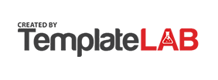



**Welcome to Eyebox HRMS User Manual**

Version 20231603



Table of Contents

1 Getting Started

1.1 Logging in

1.2 Password Reset

1.3 Dashboard

2 Self-Service Module

2.1 My Profile

- 2.1.1 Personal Information Management

- 2.1.2 Change Password

2.2 My Calendar

2.3 My Task

- 2.3.1 Add Task

2.4 My Time In/Out Record

2.5 My Time In/Out

2.6 My Time Adjustments

- 2.6.1 Authorized Access

- 2.6.2 Types of Time Adjustments

- 2.6.3 Documentation and Audit Trail

- 2.6.4 Approval Workflow

- 2.6.5 Add My Time Adjustment

- 2.6.6 Bulk Import

2.7 My Leaves

- 2.7.1 Add My Leave Applications

- 2.7.2 View My Leave Applications

- 2.7.3 Edit My Leave Applications

2.8 My Overtimes

- 2.8.1 Overtime Summary

- 2.8.2 Overtime Details

- 2.8.3 Overtime Documentation

- 2.8.4 Add My Overtimes

- 2.8.5 View My Overtimes

- 2.8.6 Edit My Overtimes

2.9 My Payslips

- 2.9.1 Payslip Accessibility

- 2.9.2 Payslip Details

- 2.9.3 Electronic Format

- 2.9.4 Historical Payslips

- 2.9.5 Security and Confidentiality

- 2.9.6 Integration with Payroll

- 2.9.7 Notification of New Payslips

- 2.9.8 Printing and Saving Options

2.10 My Support Request

- 2.10.1 Add Supports

- 2.10.2 View Supports

- 2.10.3 Edit Supports

2.11 My Complaints

- 2.11.1 Add Complaint

- 2.11.2 View Complaints

- 2.11.3 Edit Complaints

2.12 My Warnings

- 2.12.1 Add Warnings

2.13 My Notifications

2.14 My Leave Approval

- 2.14.1 View leave approval details

- 2.14.2 Approve Leave Request

- 2.14.3 Rejecting Leave Application

2.15 Overtime Approval

- 2.15.1 View Overtime Approval Details

- 2.15.2 Approving Overtime

- 2.15.3 Rejecting Overtime

2.16 Time Adjustment Approval

- 2.16.1 View Time Adjustment Approval Details

- 2.16.2 Approving Time Adjustment

- 2.16.3 Rejecting Time Adjustment

3 Company Module

3.1 About the Company

3.2 Announcements

- 3.2.1 How to add new Announcement?

- 3.2.2 How to Export or download the Announcements Table?

- 3.2.3 How to do Bulk Import Announcements?

- 3.2.4 How to Mark as Active or Mark as Inactive an Announcement?

- 3.2.5 How to see more details about the Announcements?

- 3.2.6 How to Edit Announcements?

3.3 Policies

- 3.3.1 How to Add new Policies?

- 3.3.2 How to Export or download Policies Table?

- 3.3.3 How to do Bulk Import of Policies?

- 3.3.4 How to Mark as Active or Mark as Inactive a Policies?

- 3.3.5 How to see more details about the policies?

- 3.3.6 How to Edit a Policy?

3.4 Organizational Chart

3.5 Holidays

- 3.5.1 How to Add new Holiday?

- 3.5.2 How to do Bulk Import of Holidays?

- 3.5.3 How to filter the holiday table by year?

- 3.5.4 How to see more details about the holiday?

- 3.5.5 How to edit a Holiday?

4 Employee

4.1 Employee Directory

- 4.1.1 Search Functionality

- 4.1.2 Employee Profiles

- 4.1.3 Profile Pictures

- 4.1.4 Filtering and Sorting

4.2 Taxable Allowance

- 4.2.1 Setup and Configuration

- 4.2.2 Allowance Assignment

- 4.2.3 Payroll Calculation

- 4.2.4 Tax Reporting

- 4.2.5 Compliance and Updates

4.3 Non-taxable Allowance

- 4.3.1 Setup and Configuration

- 4.3.2 Allowance Assignment

- 4.3.3 Payroll Calculation

- 4.3.4 Reporting and Documentation

- 4.3.5 Compliance and Updates

4.4 Taxable Deduction

- 4.4.1 Setup and Configuration

- 4.4.2 Deduction Assignment

- 4.4.3 Payroll Calculation

- 4.4.4 Deduction Reporting

- 4.4.5 Compliance and Updates

4.5 Non-taxable Deduction

- 4.5.1 Setup and Configuration

- 4.5.2 Deduction Assignment

- 4.5.3 Payroll Calculation

- 4.5.4 Reporting and Documentation

- 4.5.5 Compliance and Updates

4.6 Skill Assignment

- 4.6.1 Skill Database

- 4.6.2 Employee Skill Profiles

- 4.6.3 Skill Assignment

- 4.6.4 Skill Search and Matching

- 4.6.5 Training and Development

- 4.6.6 Reporting and Analysis

4.7 Salary Details

- 4.7.1 Basic Salary

- 4.7.2 Pay Frequency

- 4.7.3 Reports and Analytics

4.8 Assign Salary to employees in bulk

4.9 View Salary History

4.10 Salary Adjustment

5 HR Essentials

5.1 HR Dashboard

- 5.1.1 Overview

- 5.1.2 Key Metrics

5.2 Announcements

- 5.2.1 Adding Announcements

- 5.2.2 Bulk Importing

- 5.2.3 Viewing Announcements

- 5.2.4 Editing Announcements

- 5.2.5 Bulk Marking "Active" or "Inactive" on Announcements

5.3 Warnings

- 5.3.1 Recording Warnings

- 5.3.2 Notification

- 5.3.3 Documentation

- 5.3.4 Follow-up and Monitoring

- 5.3.5 Escalation and Further Actions

- 5.3.6 Adding Warnings

- 5.3.7 Warning Bulk Import

- 5.3.8 Viewing Warning Details

- 5.3.9 Editing Warnings

- 5.3.10 Bulk Marking "Active" or "Inactive" on Warnings

5.4 Support

- 5.4.1 Help Desk or Ticketing System

- 5.4.2 Employee Self-Service Portal

- 5.4.3 Communication and Notifications

- 5.4.4 Adding Support

- 5.4.5 Support Bulk Import

- 5.4.6 Viewing Support Details

- 5.4.7 Editing Support

- 5.4.8 Bulk Marking "Active" or "Inactive" on Support

5.5 Complaints

- 5.5.1 Complaint Submission

- 5.5.2 Case Tracking and Management

- 5.5.3 Adding Complaints

- 5.5.4 Complaint Bulk Import

- 5.5.5 Viewing Complaint Details

- 5.5.6 Editing Complaints

- 5.5.7 Bulk Marking "Active" or "Inactive" on Complaints

5.6 Survey

- 5.6.1 Adding New Survey

- 5.6.2 Importing Surveys in Bulk

- 5.6.3 Exporting Surveys

- 5.6.4 Changing the Status of Surveys

- 5.6.5 Viewing More Details about a Survey

- 5.6.6 Editing Surveys

5.7 Knowledge Bases

- 5.7.1 Adding New Knowledge Bases

- 5.7.2 Importing Knowledge Bases in Bulk

- 5.7.3 Exporting Knowledge Bases

- 5.7.4 Changing the Status of Knowledge Bases

- 5.7.5 Viewing More Details about a Knowledge Base

- 5.7.6 Editing Knowledge Bases

5.8 Policies

- 5.8.1 Adding New Policies

- 5.8.2 Exporting Policies

- 5.8.3 Bulk Importing of Policies

- 5.8.4 Changing the Status of Policies

- 5.8.5 Viewing More Details about Policies

- 5.8.6 Editing Policies

5.9 About the Company

6. Attendance Module

6.1 Attendance Records

6.1.1 Time and Attendance Tracking

6.1.2 Real-Time Updates

6.1.3 Leave and Absence Management

6.1.4 Compliance and Policy Enforcement

6.1.5 Historical Data

6.1.6 Reporting and Analytics

6.1.7 Integration with Payroll

6.1.8 Data Security and Privacy

6.2 Bulk Import

6.3 Shift Assignment

6.3.1 Assigning Shifts

6.3.2 Bulk Shift Assign

6.3.3 Bulk Import of Shift Assignment

6.4 Work Shifts

6.4.1 Shift ID

6.4.2 Shift Code

6.4.3 Shift Name

6.4.4 Shift Time in and Time Out

6.4.5 Next Day

6.4.6 Color

6.4.7 Add Work Shifts

6.4.8 Edit Work Shifts

6.5 Holidays

6.5.1 Holiday ID

6.5.2 Date

6.5.3 Name

6.5.4 Type

6.5.5 Year

6.5.6 Add a New Holiday

6.5.7 View More Details about the Holiday

6.5.8 Edit a Holiday

6.6 Overtime Requests

6.6.1 Overtime Summary

6.6.2 Overtime Details

6.6.3 Overtime Documentation

6.6.4 Add Overtimes

6.6.5 Add Overtime Requests

6.6.6 View More Details about the Overtime Requests

6.6.7 Edit Overtime Requests

6.6.8 Bulk Import of Overtime Requests

6.7 Time Adjustment List

6.7.1 Authorized Access

6.7.2 Types of Time Adjustments

6.7.3 Documentation and Audit Trail

6.7.4 Approval Workflow

6.7.5 How to Add Time Adjustment List?

6.7.6 How to See More Details about the Time Adjustment List?

6.7.7 How to Edit Time Adjustment List?

6.7.8 Bulk Import of Time Adjustment List

6.8 Overtime Approval Route

6.8.1 Update Approvers

6.8.2 Bulk Import of Overtime Approval Route

6.9 Zkteco Attendance

6.9.1 Attendance ID

6.9.2 Employee Code

6.9.3 Employee Name

6.9.4 Punch Time

6.9.5 Punch State

6.9.6 Terminal SN

7 Leave Module

7.1 Leave Requests

7.1.1 Leave Request Submission

7.1.2 Leave Application Status

7.1.3 Leave History

7.1.4 Leave Modification or Cancellation

7.1.5 Leave Documentation and Attachments

7.2 Leave Entitlement

7.2.1 How to Assign Bulk

8. Administrator Module

8.1 Access Management

8.1.1 How to Update the Access Management?

8.2 Home Settings

8.3 User Accessibility

8.3.1 How to add new User Access?

8.3.2 How to edit User Access?

8.4 Standard Settings

8.4.1 How to add new Taxable Allowance?

8.4.2 How to Bulk Import Taxable Allowances?

8.4.3 How to export or download the taxable allowances table?

8.4.4 How to change the status of the taxable allowances to Active or Inactive?

8.4.5 How to search?

8.4.6 How to see more details about the Taxable Allowance?

8.4.7 How to edit or update a Taxable Allowance data?

8.5 Company Structure Settings

8.5.1 How to change the status of the company structure settings?

8.6 IP Address

8.6.1 How to Add new IP?

8.6.2 How to delete IP Address?

8.7 General Settings

8.7.1 How to Update the general settings?

1 Getting Started

* 1. Logging in

To access the Eyebox HRMS (Human Resource Management System), you will need to follow the login process outlined below:

1. Open your preferred web browser (e.g., Google Chrome, Mozilla Firefox, etc.) on your computer or mobile device.

2. Enter the URL https://<company_name>. eyebox.app/login . This URL will direct you to the Eyebox HRMS login page.

Example:



3. On the login page, you will find two fields: one for entering your username and another for entering your password.

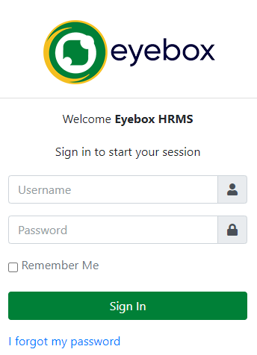

4. Enter your username in the appropriate field. Your username is usually provided to you by your HR department or system administrator. It may be your employee ID, email address, or a unique username assigned to you.

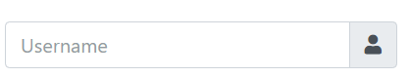

5. Next, enter your password in the password field. Your initial password is often provided to you by the HR department or system administrator. If you have already logged in before, use your previously set password.

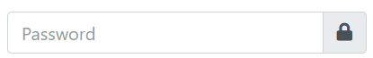

6. Once you have entered your username and password correctly, click on the "Sign In" button to proceed.



7. The system will verify your credentials and, if they are valid, you will be granted access to the HRMS.

8. After successful login, you may be directed to the HRMS dashboard, which serves as the main interface for the system. The dashboard provides an overview of relevant information and quick access to various features and modules.

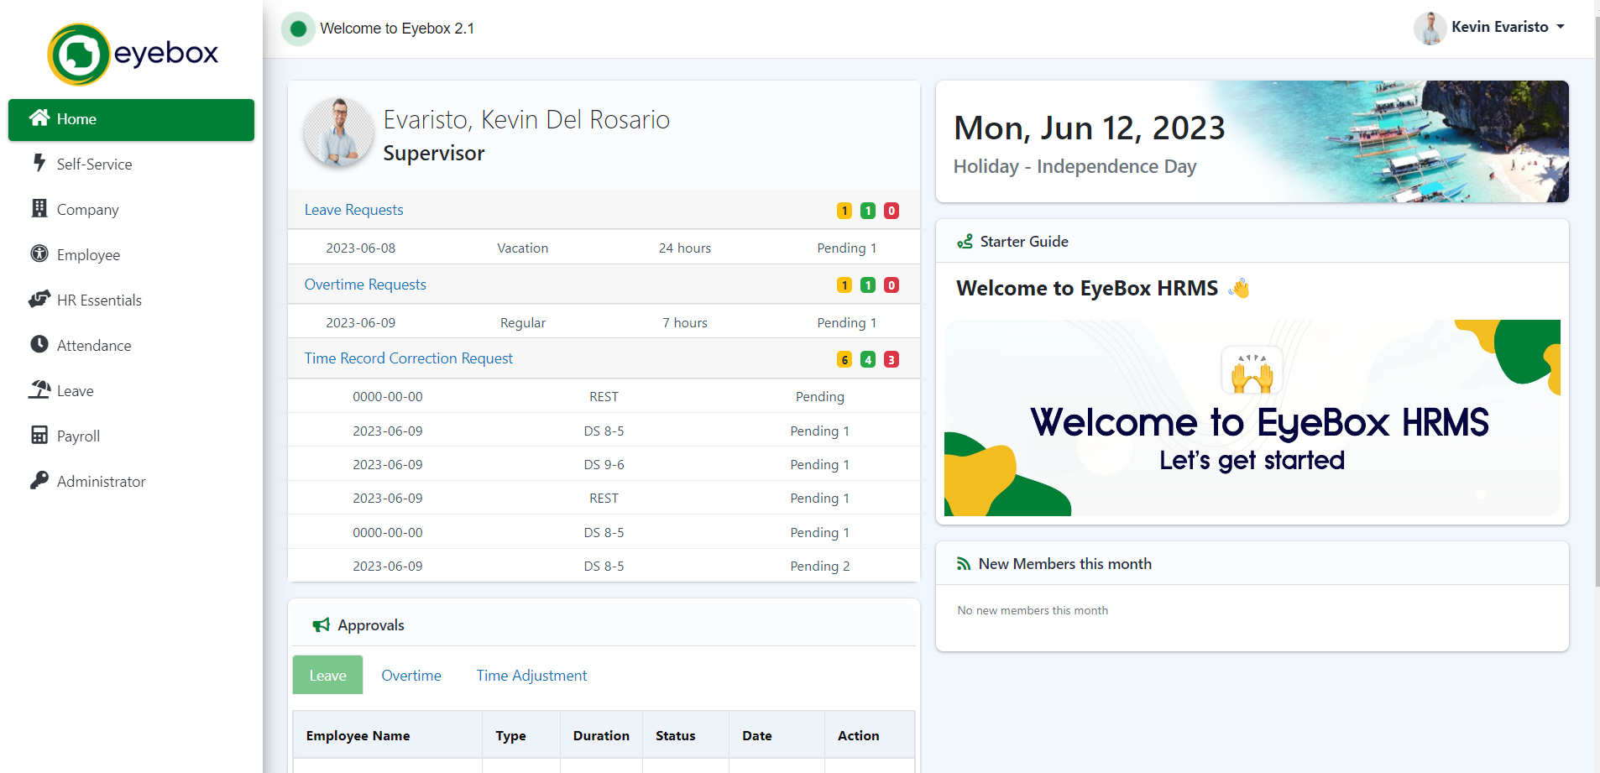

It is essential to keep your login credentials confidential and not share them with anyone. If you suspect any unauthorized access or believe your account has been compromised, inform your HR department or system administrator immediately.

**Note:**

Remember to log out of the HRMS when you have finished your session, especially when using a shared computer or a public network, to ensure the security of your account and personal information.

* 1. Password Reset

If you need to reset your password for the Eyebox HRMS (Human Resource Management System), follow the steps below:

1. On the Eyebox HRMS login page, 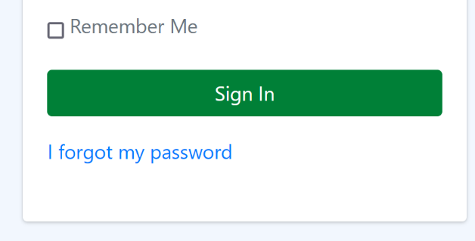click the I forgot my password link.

2. On the password reset page, you may be asked to enter your email address associated with your Eyebox HRMS account. Provide the required information accurately.

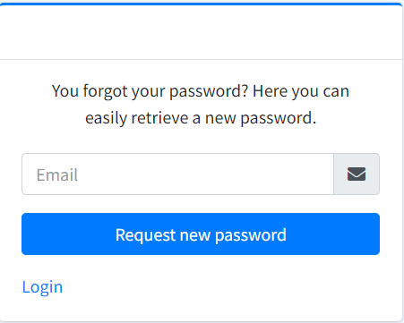

3. After entering your email address, submit the request by clicking the “Request new password” button. The system will validate the information and send a password reset link or instructions to your registered email address.

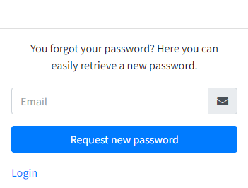

4. Check your email inbox for the password reset email.If you don't see it in your inbox, check your spam or junk folder as it may have been filtered there.

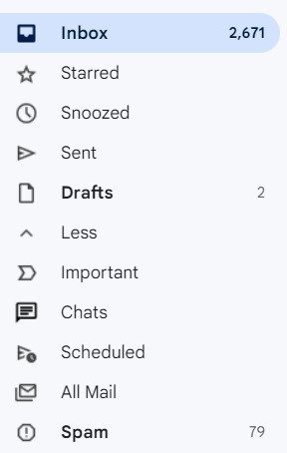

5. Open the password reset email and follow the instructions provided. It may contain a unique link to reset your password or specific steps to complete the reset process.

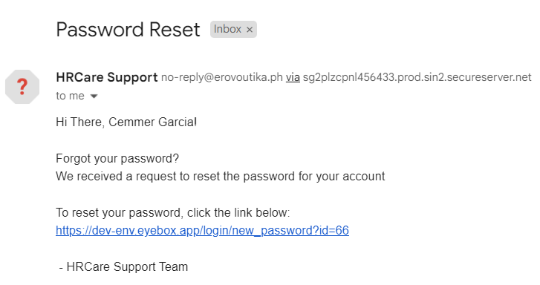

6. Click on the password reset link or follow the instructions in the email to proceed with resetting your password. This will typically direct you to a web page where you can enter a new password.

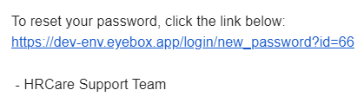

7. On the password reset page, enter your new password in the designated field. Make sure to choose a strong password that meets the specified criteria (e.g., minimum length, combination of letters, numbers, and special characters).

8. Confirm your new password by re-entering it in the designated field.

9. Once you have entered and confirmed your new password, submit the changes. The system will save your new password, and you should receive a confirmation message indicating that your password has been successfully reset.

10. Return to the Eyebox HRMS login page and enter your username along with the newly set password.

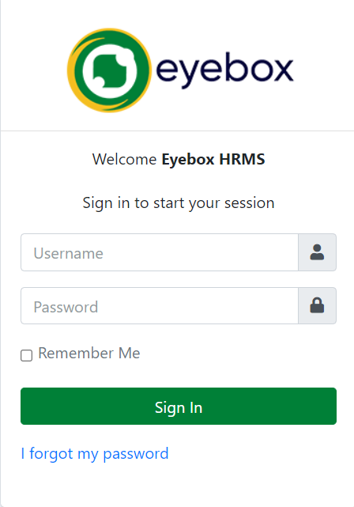

12. Click on the "Sign In" button to access the HRMS using your updated credentials.

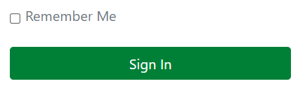

If you encounter any difficulties during the password reset process or do not receive the password reset email, contact your HR department or system administrator for assistance. They will be able to guide you through the necessary steps and ensure that you regain access to your HRMS account.

* 1. Dashboard

The Eyebox HRMS (Human Resource Management System) dashboard serves as your main interface, providing an overview of relevant information and quick access to various features and modules. Here's a guide to understanding and utilizing the HRMS dashboard effectively:

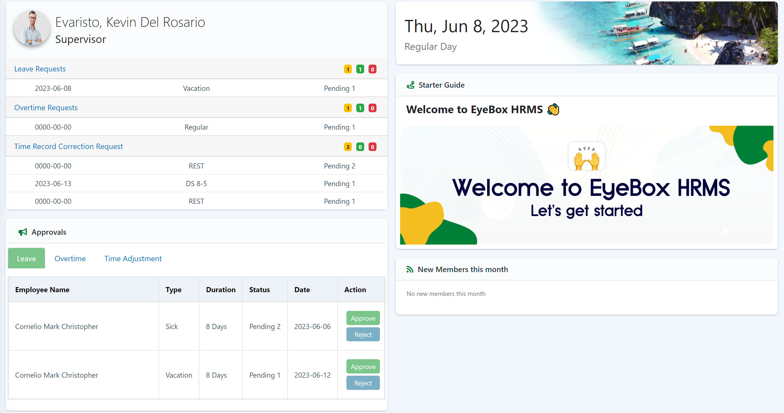

1. **Profile Summary:** The dashboard may show a summary of your personal profile information, such as your name, job title, department, and contact details. This section allows you to quickly review and verify your profile details at a glance.
2. **Approvals:** This section of the dashboard provides an overview of pending approval requests that require your attention.
3. **Calendar:** The Eyebox dashboard includes a calendar feature that provides a visual representation of important events, schedules, and the type of working day.
4. **Starter Guide:** This is a quick link for the users for accessing the Eyebox HRMS user guide.
5. **Notifications:** The dashboard includes the notification for “**new members this month”** and **“Who’s out today?”.**

2 Self-Service Module

The self-service module is a component that enables employees to manage and update their personal information, benefits, and other HR-related tasks without requiring direct assistance from HR staff. It empowers employees to take control of their own HR-related activities and reduces the administrative burden on HR personnel.

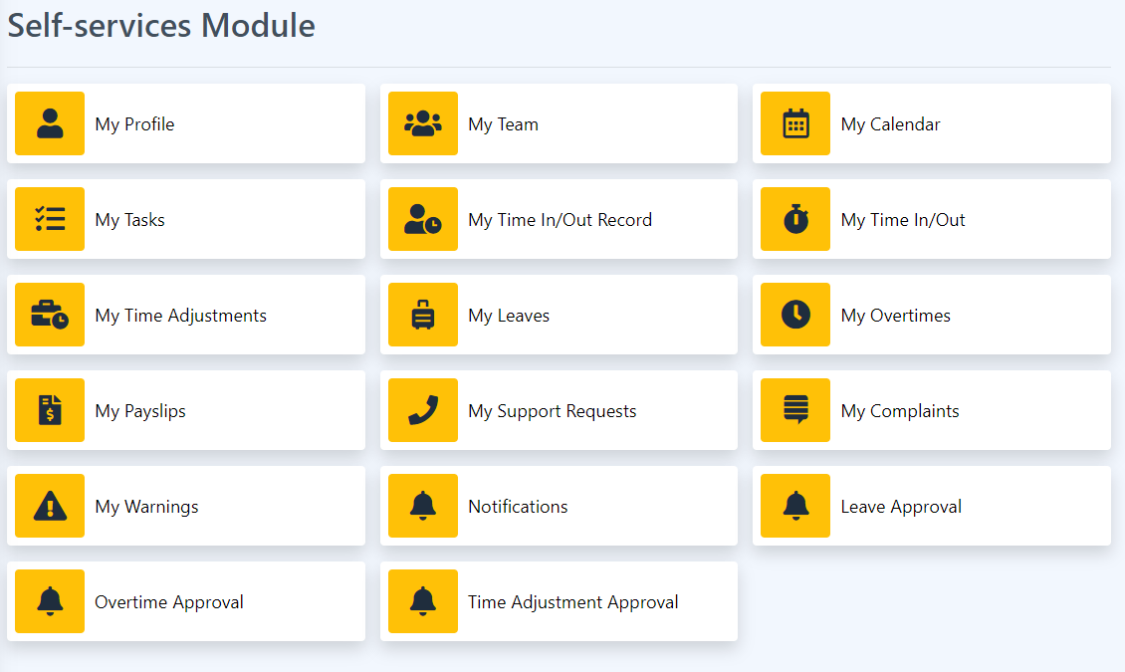

The self-service module allows employees to access and interact with various HR functions. Some common features of a self-service module in an HRMS system include:

1. My Profile
2. My Team
3. My Calendar
4. My Task
5. My Time In/Out Record
6. My Time In/Out
7. My Time Adjustments
8. My Leaves
9. My Overtimes
10. My Payslips
11. My Support Request
12. My Complaints
13. My Warnings
14. Notifications
15. Leave Approval
16. Overtime Approval
17. Time Adjustment Approval

2.1 My Profile

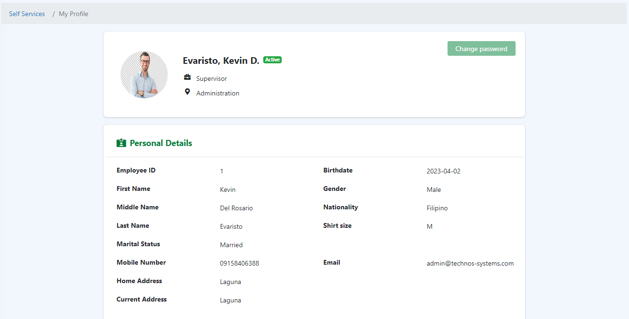

This section includes information about an employee's employment history within the organization. It includes the date of joining, job title, department, reporting manager, compensation details, employment status (full-time, part-time, contract, etc.), and any relevant employment-related dates (e.g., date of promotion, transfer, or termination).

1. **Personal Information Management**

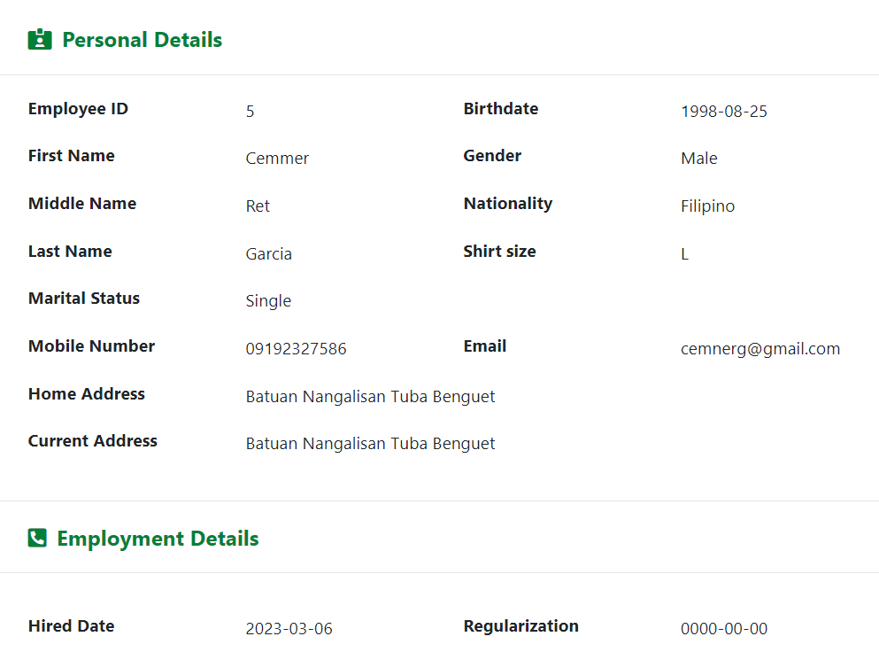

My Profile provides a centralized platform for employees to manage their information securely and accurately. Here are some key aspects of My Profile:

1. Personal Details
2. Employee ID
3. First Name, Middle Name, Last Name
4. Marital Status
5. Mobile Number
6. Home Address
7. **Change Password**

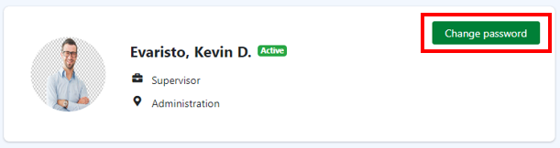

Employees are prompted to enter a new password. The system may impose certain password requirements to ensure the strength and security of the new password. Common requirements include a minimum length, a combination of uppercase and lowercase letters, numbers, and special characters.

Procedure:

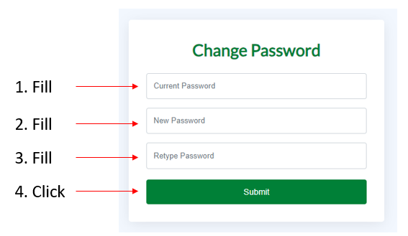

Step 1: Enter your current password.

Step 2: Enter your new password.

Step 3: Re-enter your new password and

Step 4: Click the “Submit” button.

2.2 My Calendar

Calendar module serves as a centralized tool for scheduling, tracking, and managing HR-related events, deadlines, meetings, and other important dates. It provides HR professionals, managers, and employees with a visual representation of time-bound activities and facilitates efficient planning and coordination.

2.3 My Task

Here in “My Task” module, users can monitor their Task Assignment, Task Progress Tracking, Task Deadlines and Reminders, and users’ Task Comments and Collaboration.

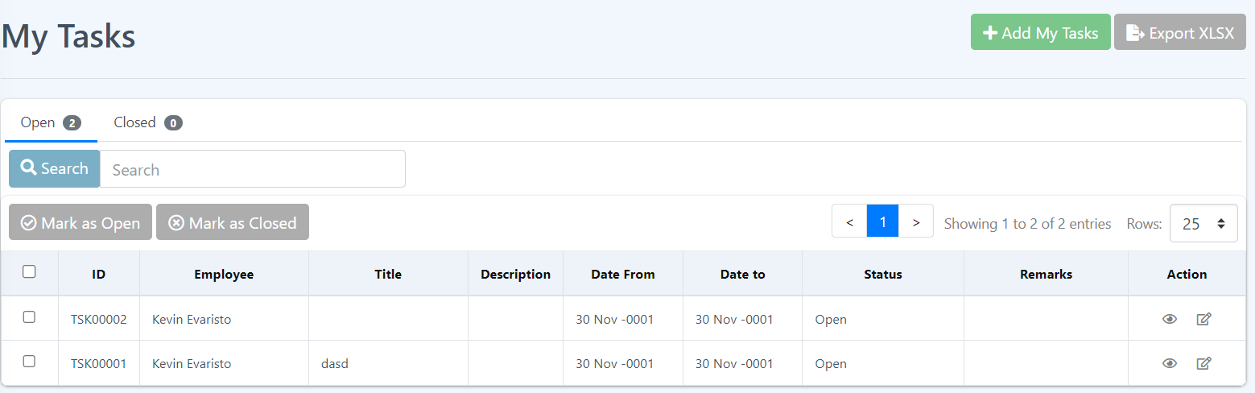

**Add Task**

This is the section where users can create tasks within the HRMS, specifying details such as task title, description, due date, priority level, and associated project or category

Procedure:

Step 1: Click the Add My Tasks

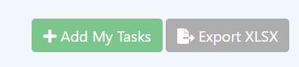

Step 2: Fill in the form and Click “Submit” button.

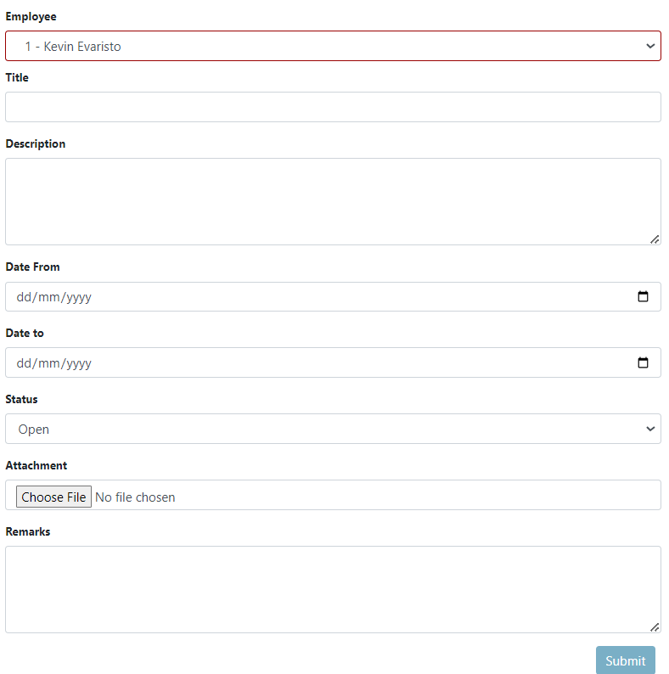

Step 3: A message will pop up that you have successfully submitted your form. Click the “Ok” button and this should redirect you to the “My Task “page.

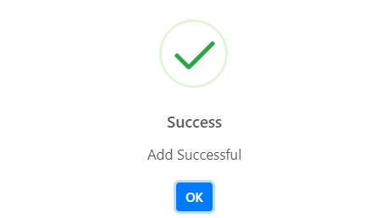

2.4 My Time In/Out Record

The “My time in/out record” module within the HRMS allows for the accurate tracking and management of employee attendance and work hours. It provides a comprehensive system to record and monitor the time employees spend on the job. The employee can track their date, time in/out the employee attended and also pinpoint the location of the employee.

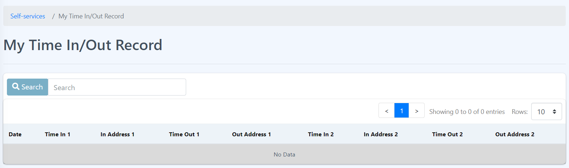

**My Time In/Out**

This section enables employees to record their clock-in and clock-out times for accurate tracking of their work hours.

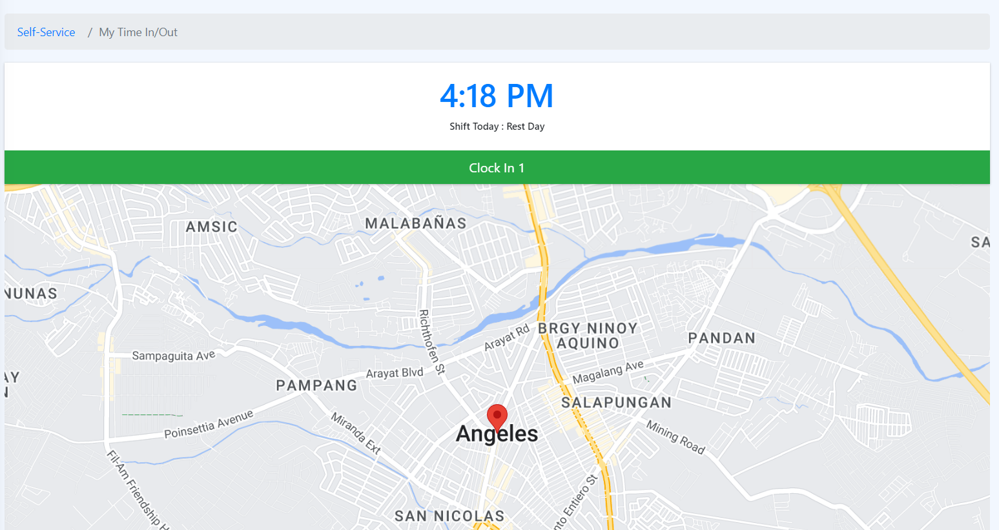

2.5 My Time Adjustments

The employee time adjustments feature within the HRMS allows authorized personnel to make changes or corrections to recorded employee time entries. These are the functionalities in the time adjustment:

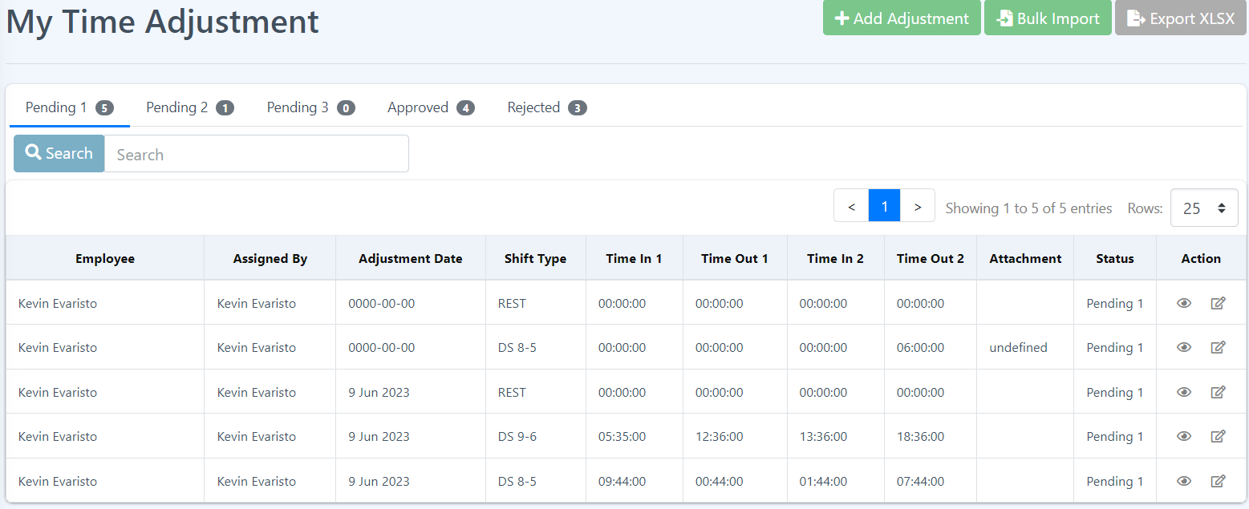

1. Authorized Access: Only designated personnel, such as HR administrators or managers, with the appropriate permissions can access and make time adjustments within the HRMS. This ensures that adjustments are made by authorized individuals.

2. Types of Time Adjustments: The HRMS provides options for different types of time adjustments, such as:

- Clock-In/Clock-Out Corrections: Authorized personnel can adjust clock-in and clock-out times if there are errors or discrepancies in the original records. This helps to reflect the actual time worked by the employee accurately.

3. Documentation and Audit Trail: The HRMS maintains a record of all time adjustments made, including details such as the date, time, reason for adjustment, and the individual who made the adjustment. This documentation serves as an audit trail for transparency and accountability purposes.

4. Approval Workflow: Depending on the organization's policies, time adjustments may require approval before they are finalized. The HRMS can incorporate an approval workflow where adjustments are reviewed and authorized by designated personnel, ensuring proper oversight.

**Add My Time Adjustment**

This section is for adding time adjustment for an employee.

Procedure:

How to Add Time Adjustment?

Step 1: Click the Add Adjustments button.

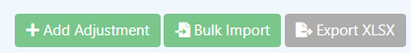

Step 2: Fill in the form and click the “Submit” button.

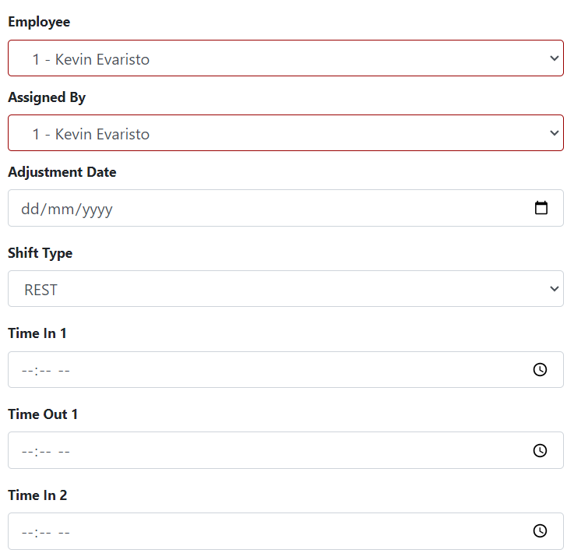

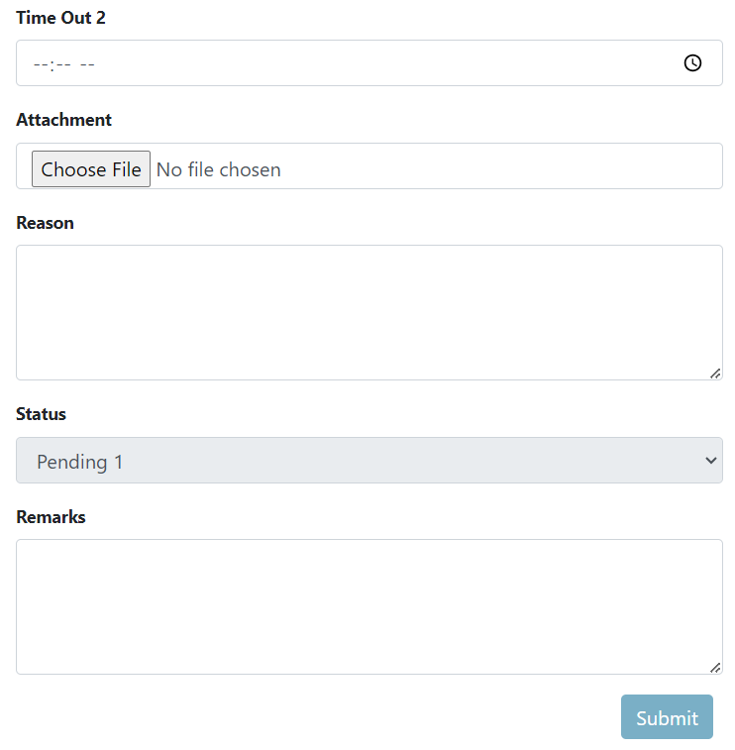

Step 3: A message will pop up that you have successfully submitted your form. Click the “Ok” button and this should redirect you to “My Time Adjustment’ page.

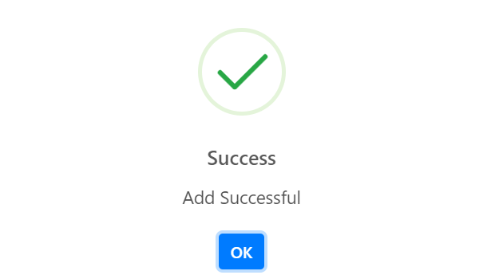

**Bulk import**

The HRMS time adjustment attachment feature allows authorized personnel to attach supporting documents or notes when adjusting employee time records.

2.6 My Leaves

The "My Leave Applications" feature within Eyebox HRMS allows employees to view and manage their leave requests and applications. It provides a centralized platform for employees to track the status of their leave applications and access important information related to their requested time off. Here’s are the functionalities of this feature:

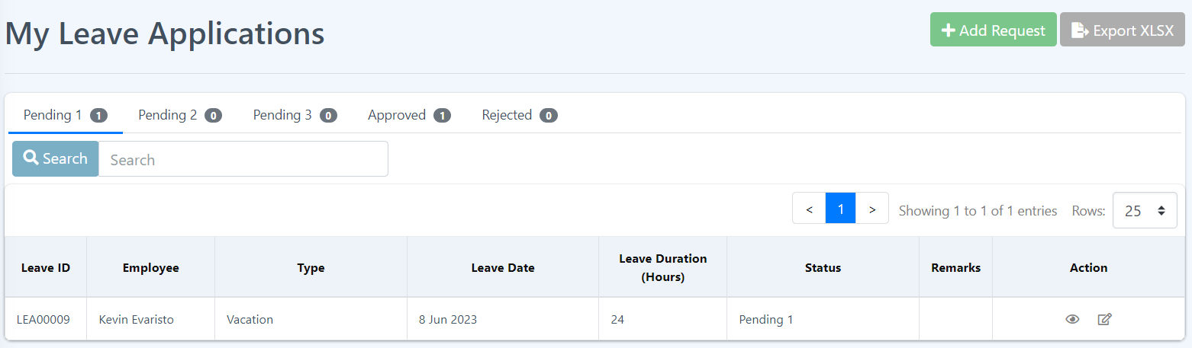

1. Leave Request Submission

2. Leave Application Status

3. Leave History

4. Leave Modification or Cancellation

5. Leave Documentation and Attachments

**Add My Leave Applications**

The "Add My Leave Applications" Eyebox HRMS enables employees to submit their leave requests electronically. It provides a user-friendly interface for employees to enter their leave details and initiate the leave application process.

How to add your Leave Application?

Step 1: Click the Add Request button.

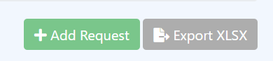

Step 2: Fill the form and click the “Submit” button.

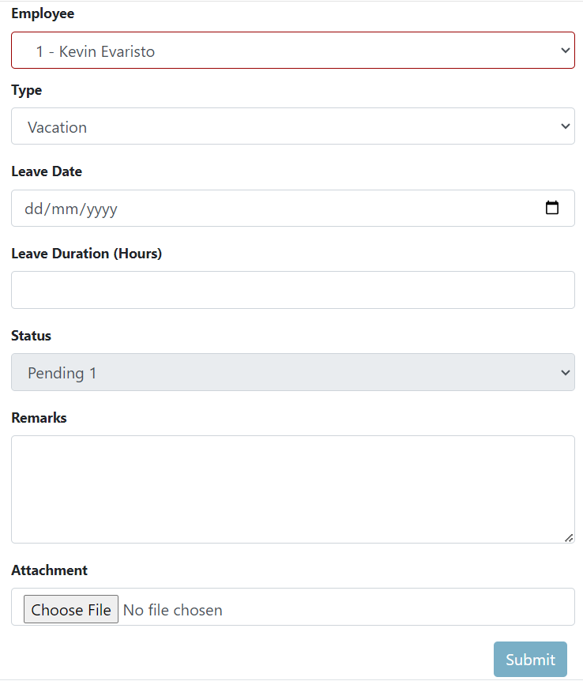

Step 3: A message will pop up that you have successfully submitted your form. Click the “Ok” button and this should redirect you to “My Leave Applications” page.



**View My Leave Applications**

This section allows users to fully view their leave application details.

To view more details about a specific data just click the eye icon under the Action column on the data you chose.

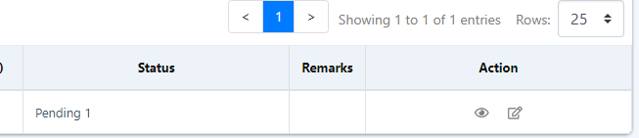

**Edit My Leave Applications**

This section allows users to fully view and adjust their leave application.

1. Click the edit icon beside the eye icon.



2. Fill the form and click Submit.

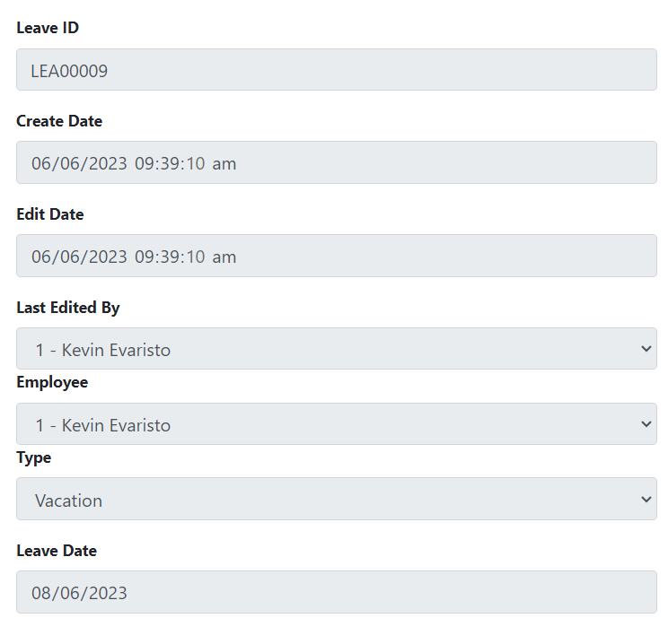

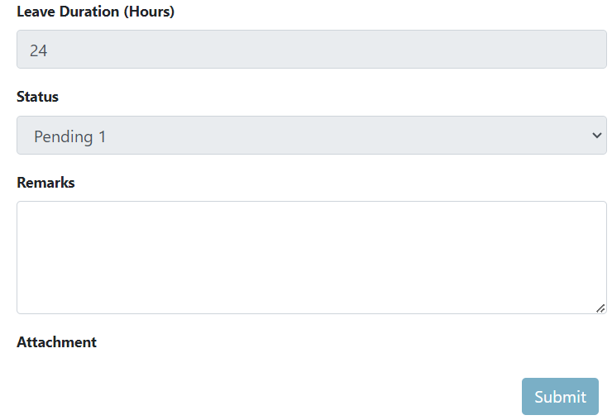

2.7 My Overtimes

The "My Overtimes" feature within Eyebox HRMS allows employees to view and manage their recorded overtime hours. It provides a centralized platform for employees to track their overtime work and access relevant information related to their overtime hours. The functionalities of this section are the following:

1. Overtime Summary: The "My Overtimes" section displays a summary of the employee's recorded overtime hours. It provides an overview of the total accumulated overtime hours, typically categorized by pay period or specific timeframes.
2. Overtime Details: Employees can access detailed information about their recorded overtime hours within the HRMS. This includes the date, time, and duration of each overtime session, as well as any associated remarks or comments.
3. Overtime Documentation: If required, employees can access any relevant documentation or supporting materials related to their recorded overtime hours. This may include timesheets, supervisor approvals, or any other evidence that justifies the overtime work performed.

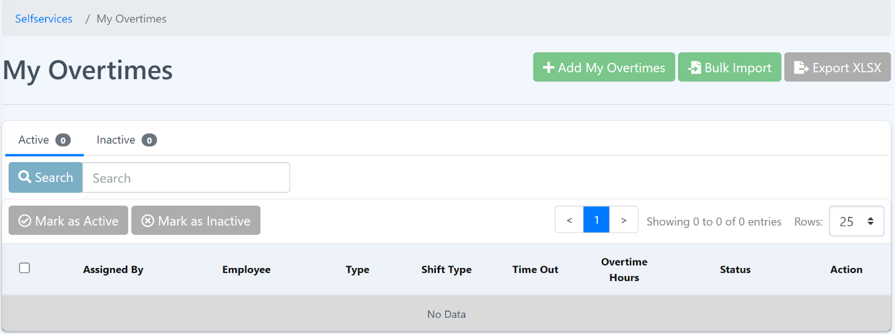

**Add My Overtimes**

The "Add My Overtimes" module in Eyebox HRMS streamlines the process of recording and managing overtime hours for employees. By providing a structured interface for entering overtime details, attaching supporting documentation, and facilitating the approval workflow, it ensures accurate tracking and proper management of additional work hours. This feature promotes transparency, compliance with labor regulations, and facilitates effective overtime management within the organization.

**Procedure:**

Step 1: Click Add My Overtimes button.

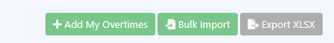

Step 2: Fill the form and click the “Submit” button.

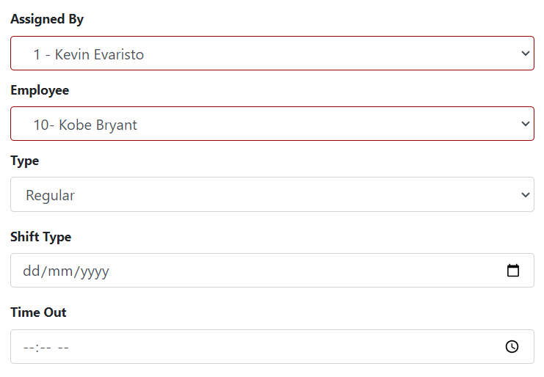

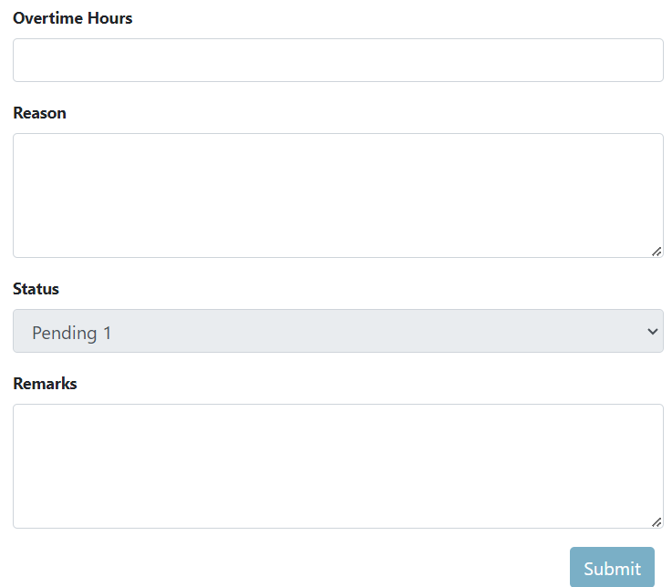

**View My Overtimes**

This allows the user to view their overtime details and remarks. To view more details about the overtime click the eye icon under the Action column.

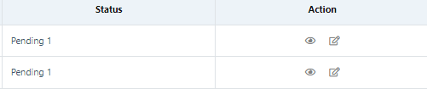

**Edit My Overtimes**

The "Edit My Overtimes" feature within Eyebox allows employees to make changes or corrections to their recorded overtime hours. Follow the steps below on how to edit.

1. Click the edit icon beside the eye icon.

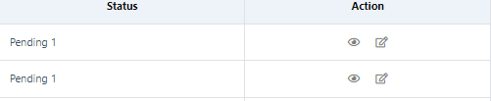

2. Fill the form and click Submit button.

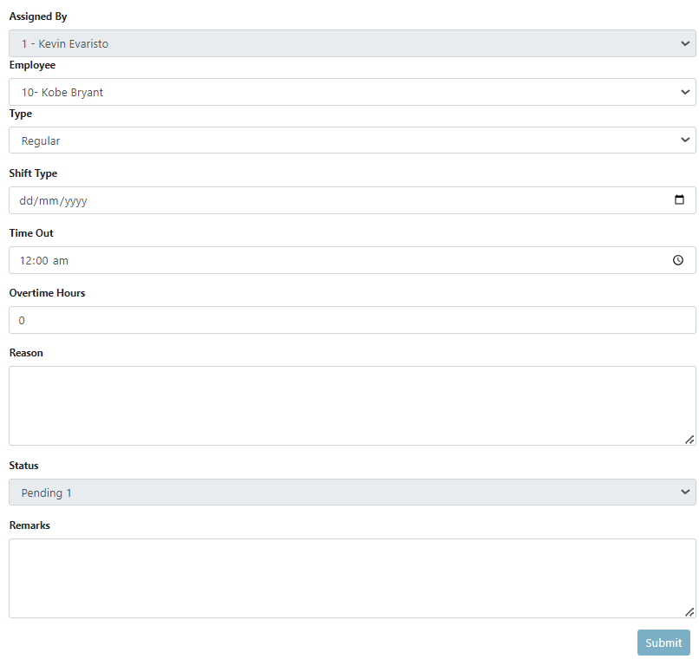

2.8 My Payslips

The "My Payslips" feature within Eyebox HRMS allows employees to access and view their payslips electronically. It provides a secure and convenient way for employees to retrieve and review their salary information. Here's the descriptions of the "My Payslips" functionality in Eyebox HRMS:

1. Payslip Accessibility: The "My Payslips" section in the HRMS allows employees to access their individual payslips securely. This can be done through a dedicated portal or dashboard within the HRMS interface, typically with login credentials specific to each employee.

2. Payslip Details: Employees can view the details of each payslip, which typically include information such as the pay period, payment date, employee details, earnings, deductions, and net pay. The HRMS displays this information in a clear and organized format for easy understanding.

3. Electronic Format: The "My Payslips" feature presents the payslips in an electronic format, such as PDF or HTML. This allows employees to conveniently view, download, or print their payslips as needed.

4. Historical Payslips: The HRMS maintains a historical record of the employees’ payslips, allowing employees to access and review past payslips. This feature enables employees to refer to previous pay periods and compare their earnings over time.

5. Security and Confidentiality: The "My Payslips" feature ensures the security and confidentiality of employees' salary information. Access to payslips is typically restricted to individual employees, ensuring that only authorized individuals can view their personal payslip data.

6. Integration with Payroll: The "My Payslips" feature is integrated with the HRMS's payroll module. This ensures that the payslips generated within the HRMS are accurate and reflect the employee's payroll data, including earnings, deductions, taxes, and other relevant information.

7. Notification of New Payslips: The HRMS may send automated notifications to employees whenever a new payslip is generated. This notifies employees of the availability of their payslip within the "My Payslips" section, ensuring that they are promptly informed about their salary information.

8. Printing and Saving Options: The "My Payslips" feature allows employees to print or save their payslips for their records. Employees can choose to keep digital copies or print hard copies of their payslips for future reference or documentation purposes.

The "My Payslips" feature in Eyebox HRMS enhances convenience, accuracy, and privacy in accessing and managing salary information. By providing employees with secure electronic access to their payslips, it streamlines the process of reviewing and retrieving salary details, ensuring transparency and promoting employee satisfaction.

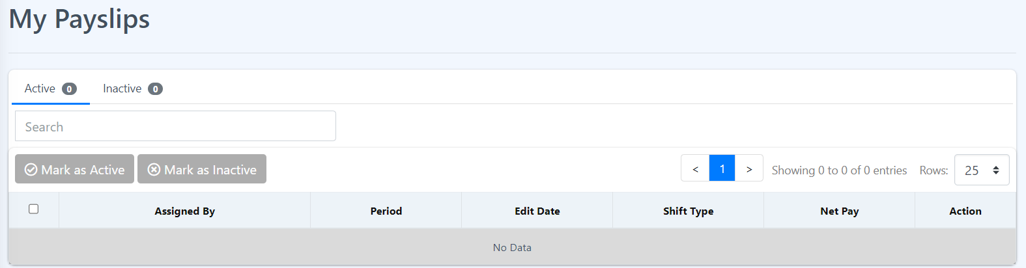

2.9 My Support Request

The "My Support Requests" feature within Eyebox HRMS (Human Resources Management System) provides employees with access to support resources and assistance related to HR-related inquiries, issues, or requests. It serves as a centralized platform for employees to seek help and obtain information.

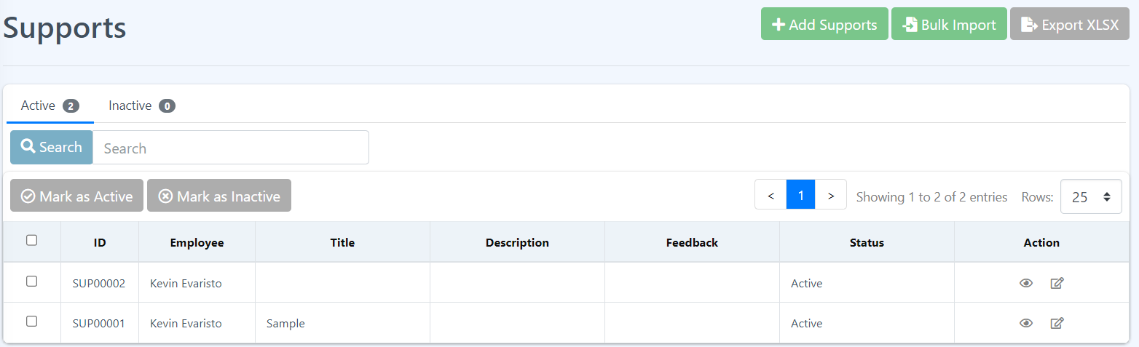

**Add Supports**

It captures relevant employee information, details of the issue or request, and any attachments or additional comments.

**Procedure:**

Step 1: Click Add Supports.

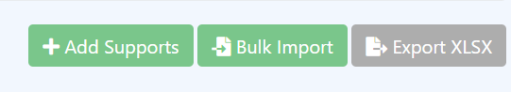

Step 2: Fill the form and click the “Submit” button.

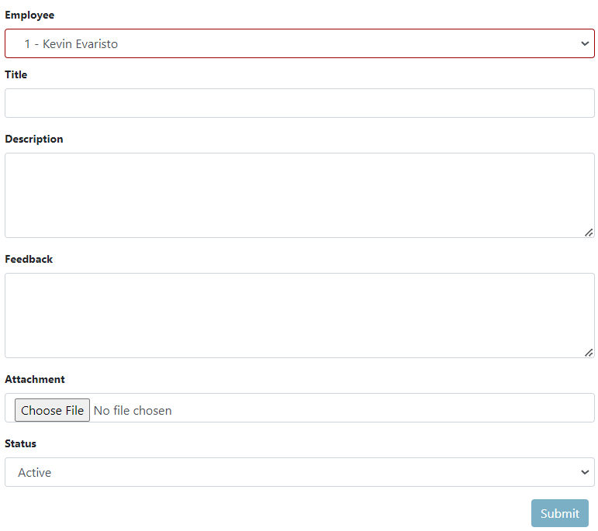Step 3: A message will pop up that you have successfully submitted your form. Click the “Ok” button and this should redirect you to “My Support Requests” page and you will be able to see your created request.

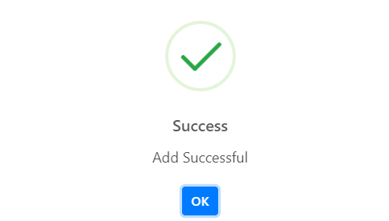

**View Supports**

The "View Supports" feature within Eyebox HRMS (Human Resources Management System) allows authorized HR personnel to access and manage support requests submitted by employees. It provides a centralized platform for HR professionals to review, track, and respond to employee inquiries, issues, or requests. To view, just click the eye icon under the Action Column.

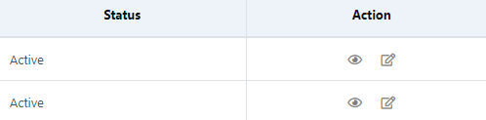

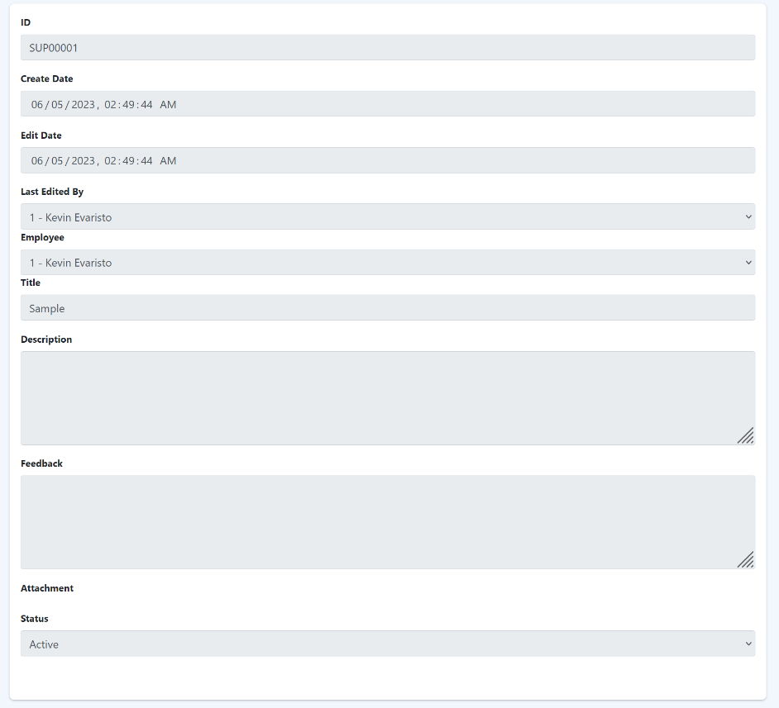

**Edit Supports**

The "Edit Supports" feature within Eyebox HRMS (Human Resources Management System) allows authorized HR personnel to make changes or updates to employee support requests. It provides a user-friendly interface for HR professionals to review, modify, and respond to employee inquiries, issues, or requests. To edit a support request, do the following steps.

1. Click the edit icon beside the eye icon.

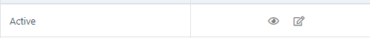

2. Fill the form and then click Submit button.

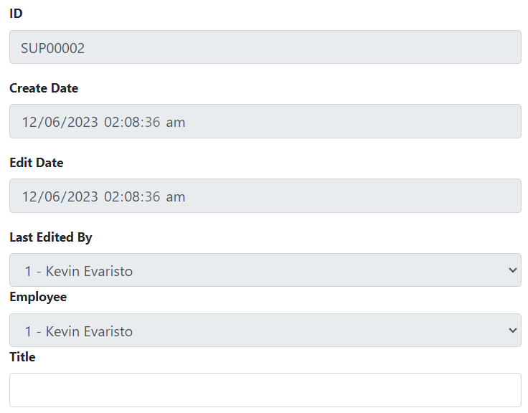

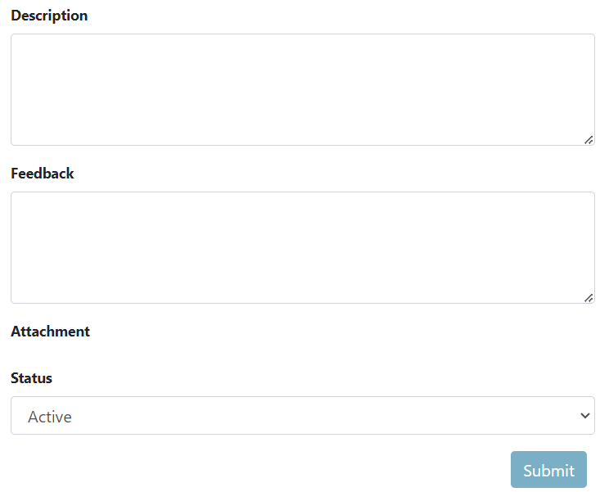

2.10 My Complaints

The "My Complaints" feature within Eyebox HRMS (Human Resources Management System) allows employees to submit and manage their complaints related to work-related issues, policies, or concerns. It provides a centralized platform for employees to express their grievances and seek resolution.

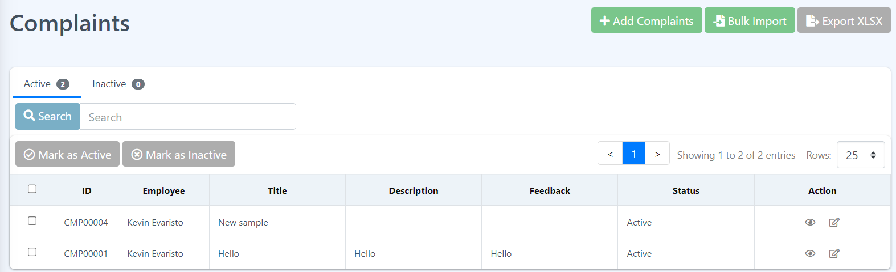

**Add Complaint**

It captures relevant employee information, details of the complaint, and any attachments or additional comments. The form can be customized based on the specific complaint categories, fields, and information that are relevant to the organization's HR processes and requirements.

**Procedure:**

Step 1: Click Add Complaints button.

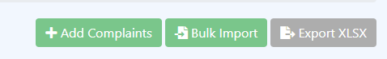

Step 2: Fill the form then click the “Submit” button.

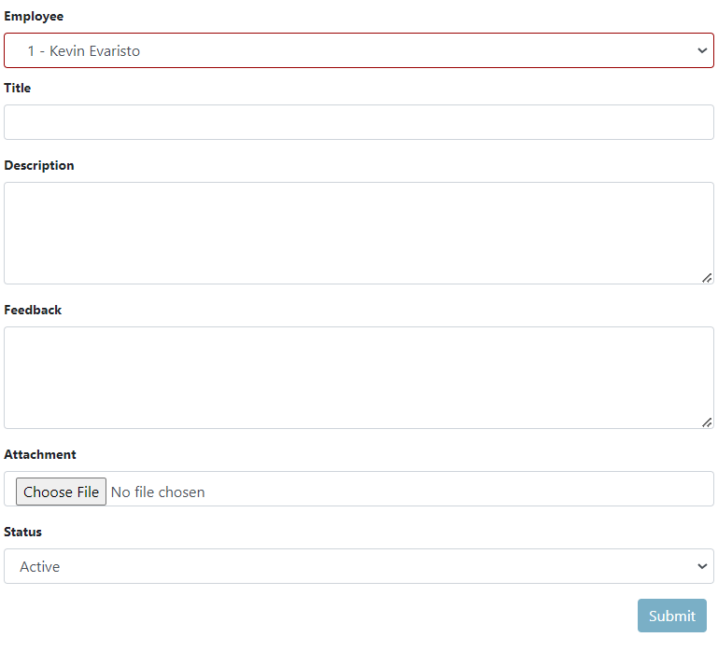

Step 3: A message will pop up that you have successfully submitted your form. Click the “Ok” button and this should redirect you to “My Complaints” page and you will be able to see your created complaint.



**Bulk Import**

Allows HR personnel to import multiple complaints simultaneously using a structured file format. This feature streamlines the process of entering complaints into the system and saves time when dealing with many complaints.

Click the Bulk Import button then follow the instructions given.

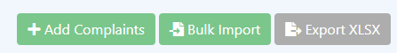

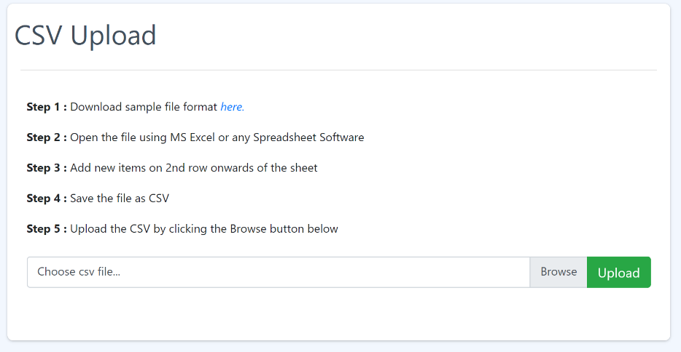

**View Complaints**

The "View Complaints" feature within the "My Complaints" module of Eyebox HRMS (Human Resources Management System) allows HR personnel to access and manage employee complaints.

Click the eye icon under the Action column to view more details about the complaint. It shows more about the selected complaint.

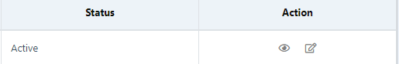

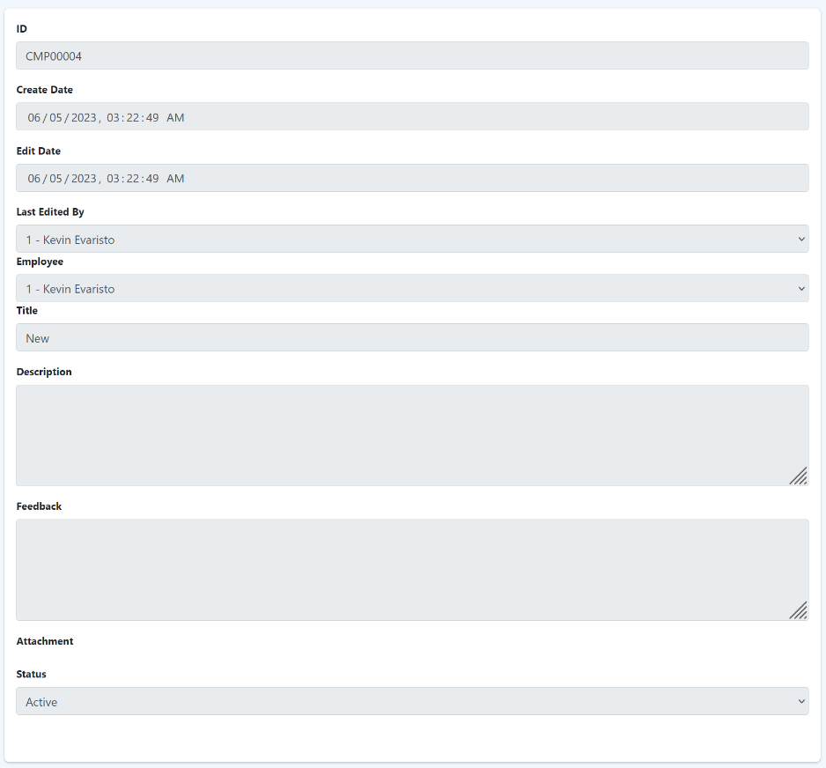

**Edit complaints**

In the "Edit Complaints" feature within the "My Complaints" module of Eyebox HRMS (Human Resources Management System), authorized HR personnel can make changes or updates to employee complaints. This functionality allows HR professionals to review, modify, and take appropriate actions to address the complaints.

To edit a selected complaint, do the following steps:

1. Click the edit icon beside the eye icon.

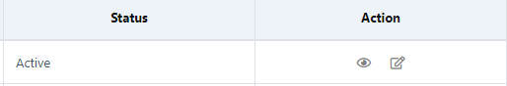

2. Fill in the form and then click Submit button.

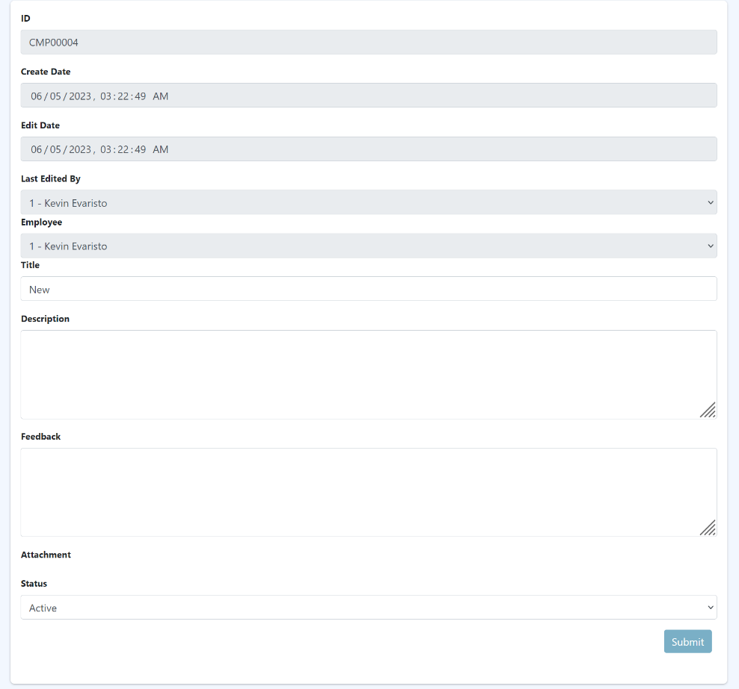

2.11 My Warnings

The "Warnings" feature within Eyebox HRMS (Human Resources Management System) provides a mechanism for HR personnel to document and track warnings issued to employees. It helps manage and monitor employee performance, conduct, or policy violations.

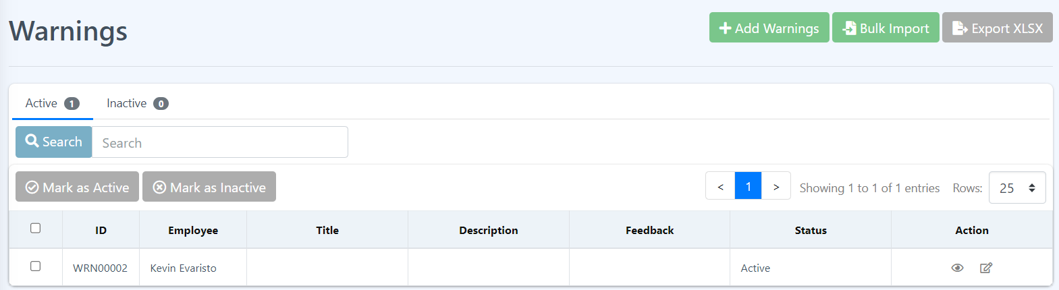

**Add Warnings**

**Procedure:**

Step 1: Click the Add Warnings button.

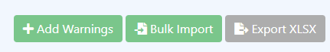

Step 2: Fill in the form the click the “Submit” button.

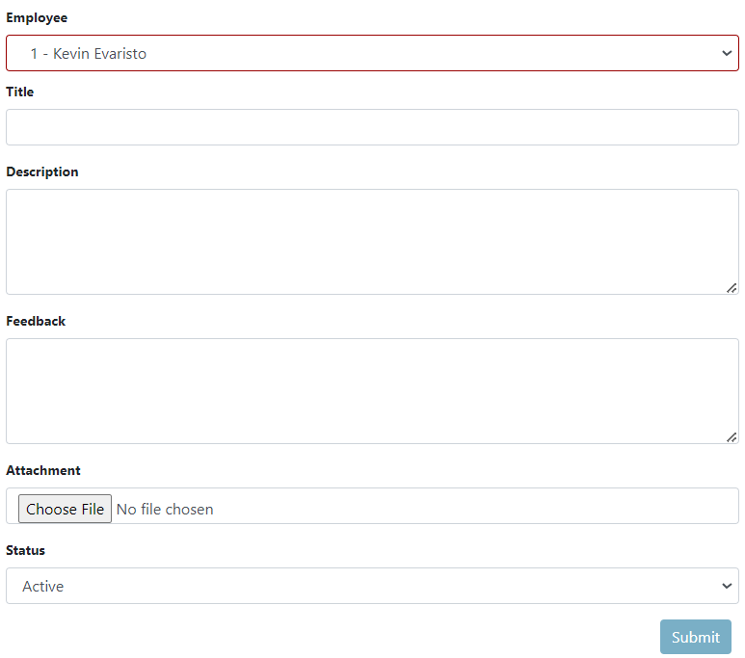

Step 3: A message will pop up that you have successfully submitted your form. Click the “Ok” button and this should redirect you to “My Warnings” page and able to see your created warning.

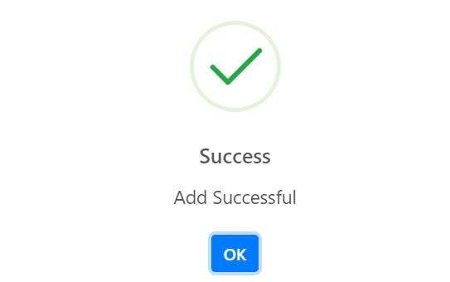

2.12 My Notifications

This section was created for employees to have greater control over their information and stay informed about relevant updates and activities. Eyebox’s HRMS notifications include reminders for upcoming performance reviews, leave approval or rejection notifications, training opportunities, policy updates, and company-wide announcements.

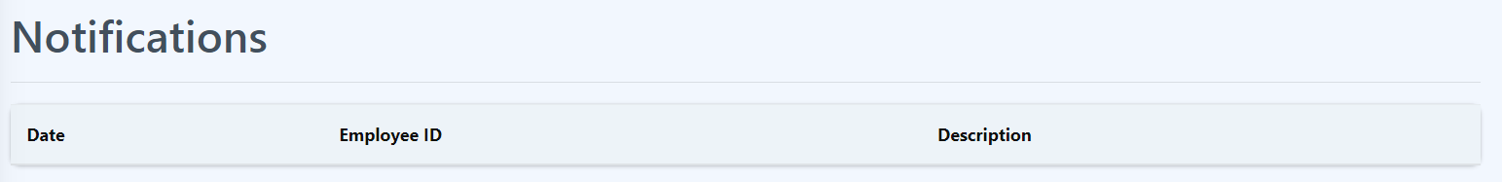

2.13 My Leave Approval

Eyebox’s HRMS leave approval is a feature that allows employees to submit their leave requests electronically and enables supervisors or managers to review and approve or reject those requests within the HRMS platform. By utilizing the HRMS leave approval functionality, organizations can streamline the leave management process, reduce manual paperwork, enhance transparency, and ensure consistent application of leave policies. It also provides a centralized record of leave requests and approvals, facilitating reporting and analysis for HR and payroll purposes.

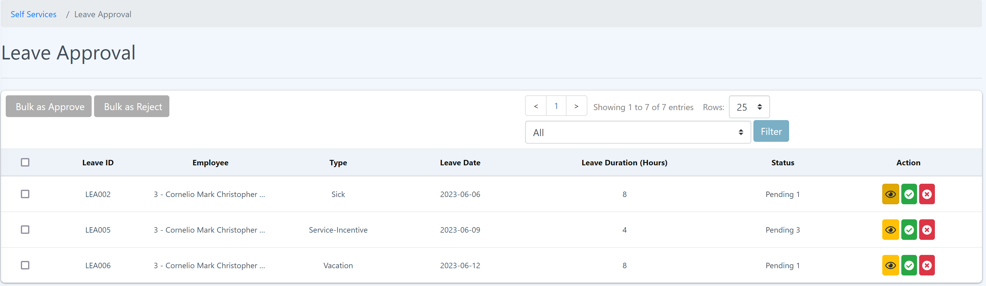

**View leave approval details.**

Step 1: Click the “Eye” icon of “Action” from the right side and you should be able to see the details in the pop up.

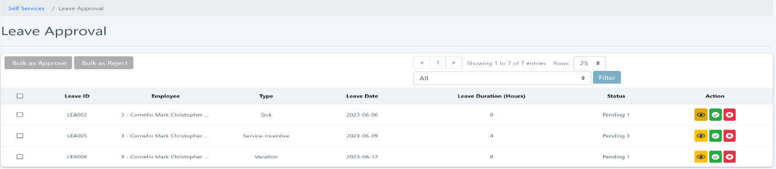

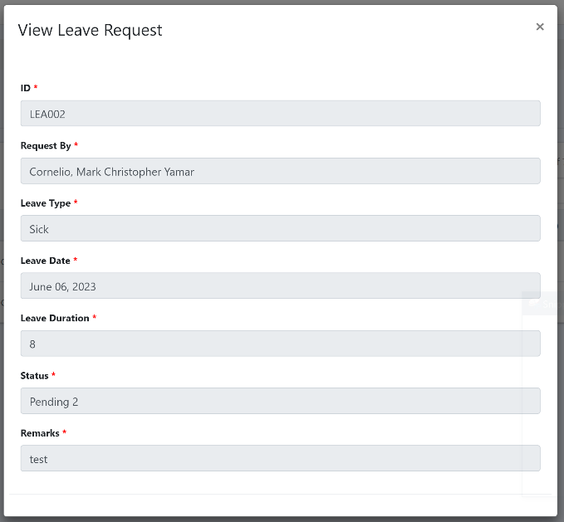

**Approve Leave Request**

**Procedure:**

Step 1: Click the “Check” icon of the Action from the right side of the table.



Step 2: A pop up will be shown to confirm your approval. Click “Approve” button to confirm and click the “Cancel” button to cancel the approval.

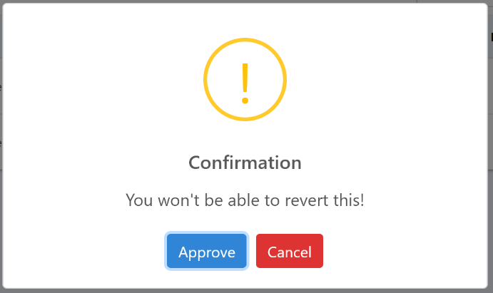

Step 3: If you want bulk approval, you can mark the checkboxes at the left side of the table and click “Bulk as Approve”.

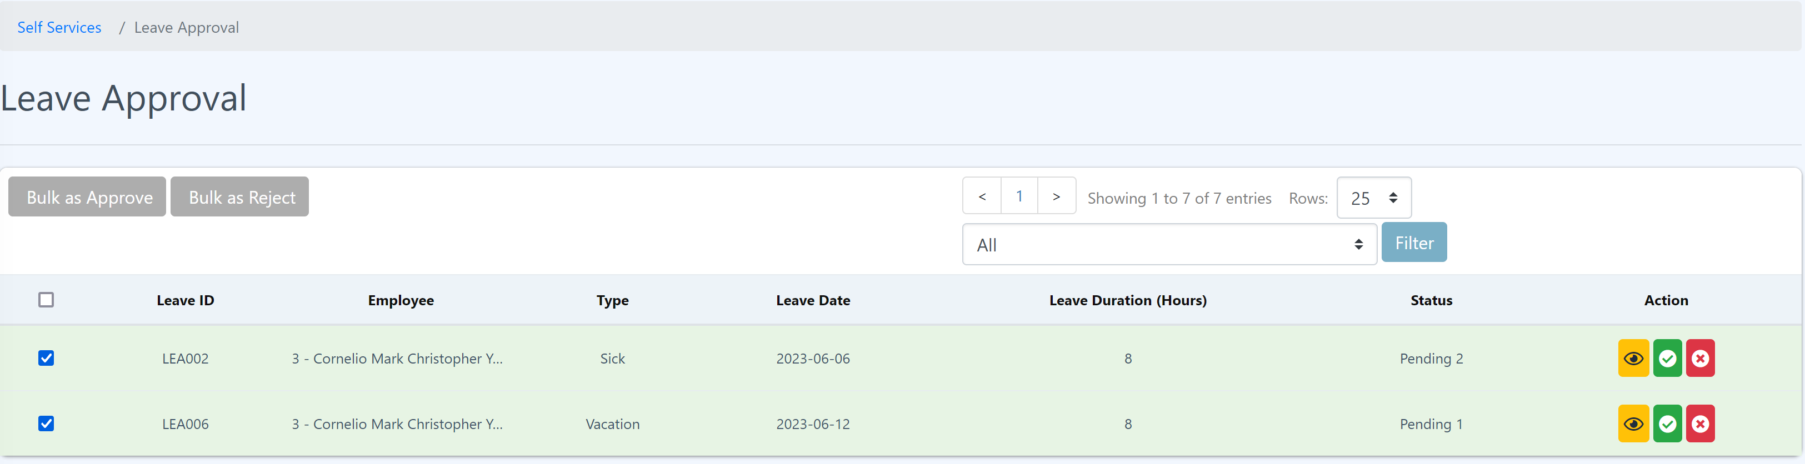

Step 4: A pop will show up with the list of leaves you have marked. Click “Save” to confirm approval.

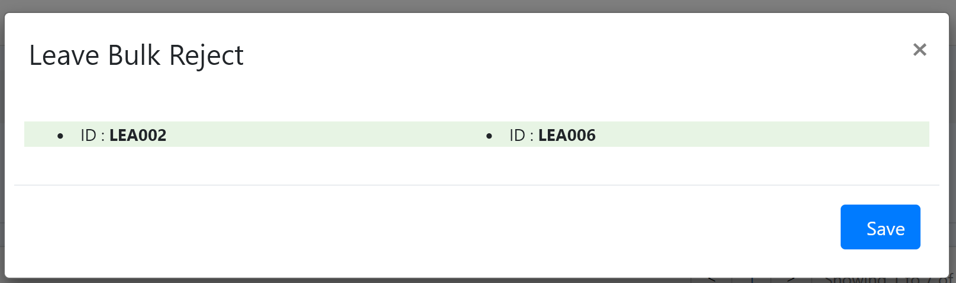

**Rejecting Leave Application**

**Procedure:**

Step 1: Click the “X” icon of the Action at the right side of the table.



Step 2: A pop up will be shown to confirm your rejection. Click “Reject” button to confirm and click the “Cancel” button to cancel the rejection.

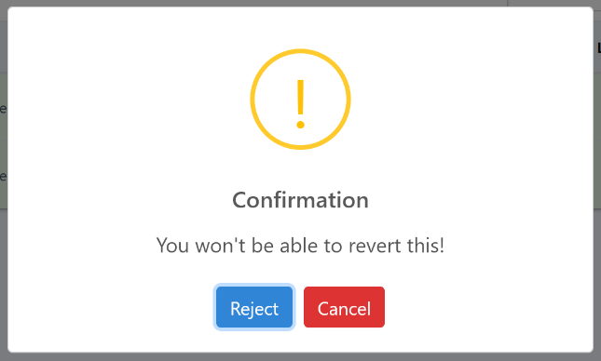

Step 3: If you want bulk reject, you can mark the checkboxes at the left side of the table and click “Bulk as Reject”.



Step 4: A pop will show up with the list of leaves you have marked. Click “Save” to confirm rejection.



2.13 Overtime Approval

Eyebox’s HRMS overtime approval is a feature that facilitates the submission, review, and approval of overtime requests within a Human Resource Management System. Here's an overview of the overtime approval process in the HRMS:

1. Overtime Request Submission: Employees can access the HRMS self-service portal and submit their overtime requests by providing details such as the date, duration, reason, and any additional information required for the overtime work.

2. Workflow Routing: Once an overtime request is submitted, the HRMS system automatically routes the request to the appropriate supervisor or manager based on predetermined rules or organizational hierarchies.

3. Review and Decision: The supervisor or manager receives a notification or task within the HRMS, alerting them to the pending overtime request. They can access the request, review the details, and decide to approve, reject, or request additional information.

4. Approval or Rejection Notification: The employee is notified of the status of their overtime request through the HRMS system. If the request is approved, the notification includes the approved date, duration, and any relevant details. In case of rejection, the notification may provide a reason for the rejection and, if applicable, suggest alternative solutions or actions.

5. Overtime Tracking and Compensation: The HRMS records the approved overtime hours and calculates the corresponding compensation based on company policies and regulations. This information can be used for payroll processing and accurate tracking of employee overtime hours.

By incorporating the overtime approval feature into Eyebox HRMS, organizations can streamline and automate the overtime management process. This helps ensure compliance with labor regulations, maintain accurate records, and facilitate fair compensation for employees working additional hours. Additionally, the HRMS provides transparency and visibility into the status of overtime requests, making it easier for employees and supervisors to track and manage overtime work.

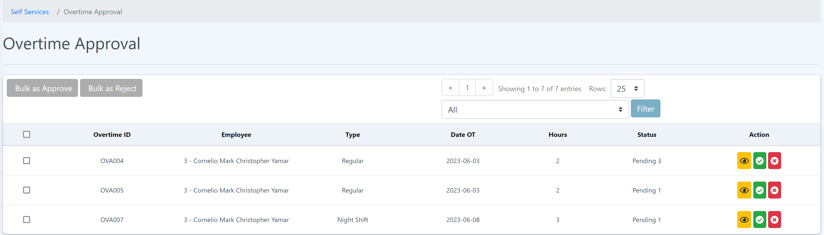

**View Overtime Approval Details**

**Procedure:**

Step 1: Click the “Eye” icon of “Action” from the right side and you should be able to see the details in the pop up.



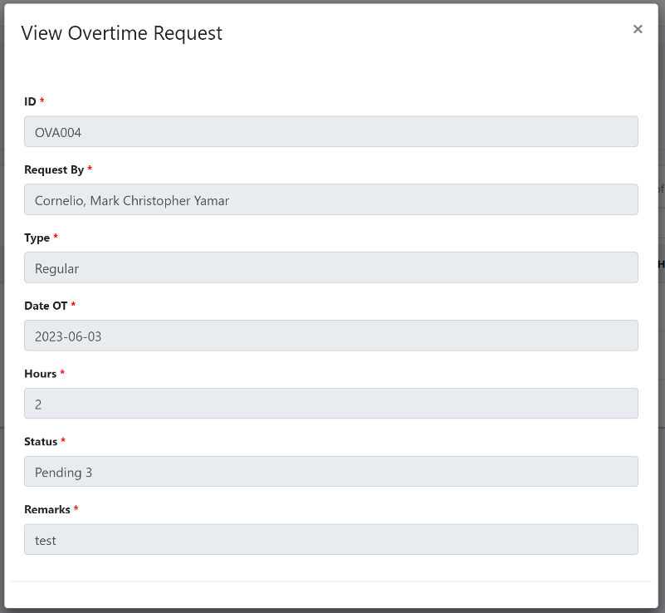

**Approving Overtime**

**Procedure:**

Step 1: Click the “Check” icon of the Action from the right side of the table.

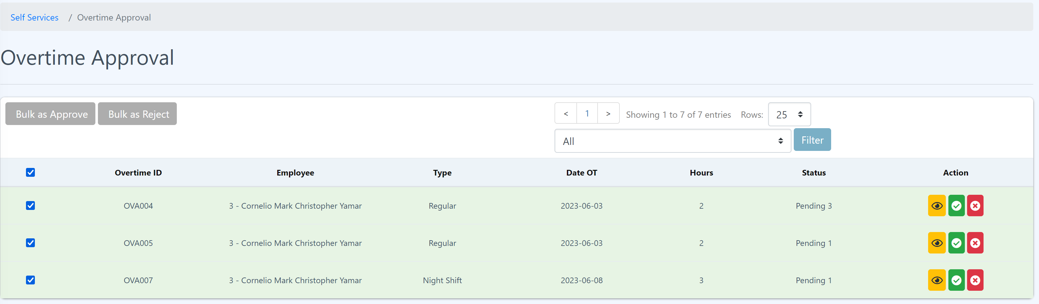

Step 2: A pop up will be shown to confirm your approval. Click “Approve” button to confirm and click the “Cancel” button to cancel the approval.



Step 3: If you want bulk approval, you can mark the checkboxes at the left side of the table and click “Bulk as Approve”.



Step 4: A pop will show up with the list of overtime you have marked. Click “Save” to confirm approval.

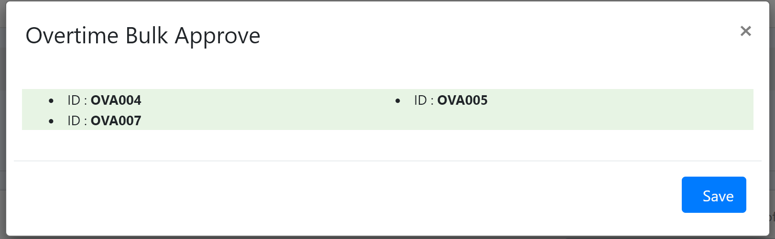

**Rejecting Overtime**

**Procedure:**

Step 1: Click the “X” icon of the Action at the right side of the table.



Step 2: A pop up will be shown to confirm your rejection. Click “Reject” button to confirm and click the “Cancel” button to cancel the rejection.

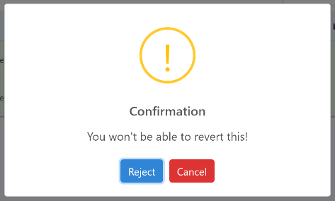

Step 3: If you want bulk reject, you can mark the checkboxes at the left side of the table and click “Bulk as Reject”.



Step 4: A pop will show up with the list of overtime you have marked. Click “Save” to confirm rejection.

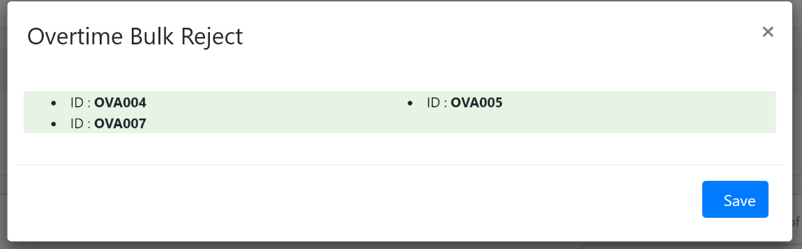

2.14 Time Adjustment Approval

Eyebox HRMS time adjustment approval is a feature that allows employees to request modifications or adjustments to their recorded time entries, such as correcting inaccuracies, adding missed punches, or adjusting time worked for various reasons. The time adjustment approval process helps ensure accuracy and consistency in time tracking and payroll calculations. Here's an overview of the time adjustment approval process in an HRMS:

1. Time Adjustment Request Submission: Employees can access the HRMS self-service portal and submit their time adjustment requests by specifying the date, time, and reason for the adjustment. They may also provide any necessary supporting documentation or explanations.

2. Workflow Routing: Once a time adjustment request is submitted, the HRMS system routes it to the designated supervisor or manager responsible for reviewing and approving time adjustments. This routing can be based on predefined rules or organizational hierarchies.

3. Review and Verification: The supervisor or manager receives a notification or task within the HRMS, alerting them to the pending time adjustment request. They can review the details provided by the employee and verify the accuracy of the requested changes. This may involve comparing the adjustments against relevant documentation or consulting with the employee if necessary.

4. Approval or Rejection: Based on their assessment, the supervisor or manager can approve or reject the time adjustment request within the HRMS system. If approved, the system updates the employee's time records accordingly. In the case of rejection, the supervisor or manager may provide a reason for the rejection or request additional information from the employee.

5. Notification of Decision: The employee receives a notification through the HRMS system informing them of the status of their time adjustment request. If approved, the notification includes the details of the adjusted time entries. If rejected, the notification may provide a reason and, if applicable, suggest alternative actions or solutions.

By utilizing the time adjustment approval feature within Eyebox HRMS, organizations can ensure accurate time tracking, maintain compliance with labor regulations, and improve payroll accuracy. It also provides a transparent and standardized process for employees to request time adjustments and for supervisors to review and approve them, enhancing efficiency and accountability in time management.

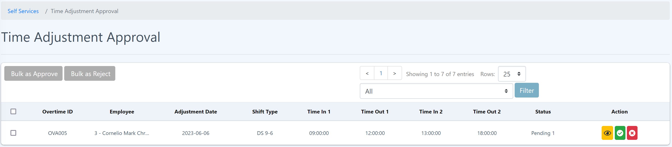

**View Time Adjustment Approval Details**

**Procedure:**

Step 1: Click the “Eye” icon of “Action” from the right side and you should be able to see the details in the pop up.



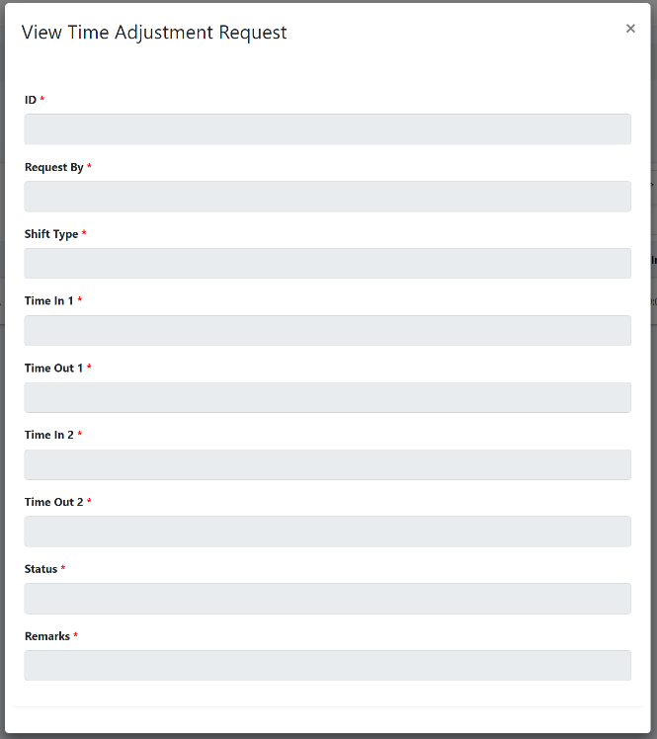

**Approving Time Adjustment**

**Procedure:**

Step 1: Click the “Check” icon of the Action from the right side of the table.



Step 2: A pop up will be shown to confirm your approval. Click “Approve” button to confirm and click the “Cancel” button to cancel the approval.



Step 3: If you want bulk approval, you can mark the checkboxes at the left side of the table and click “Bulk as Approve”.

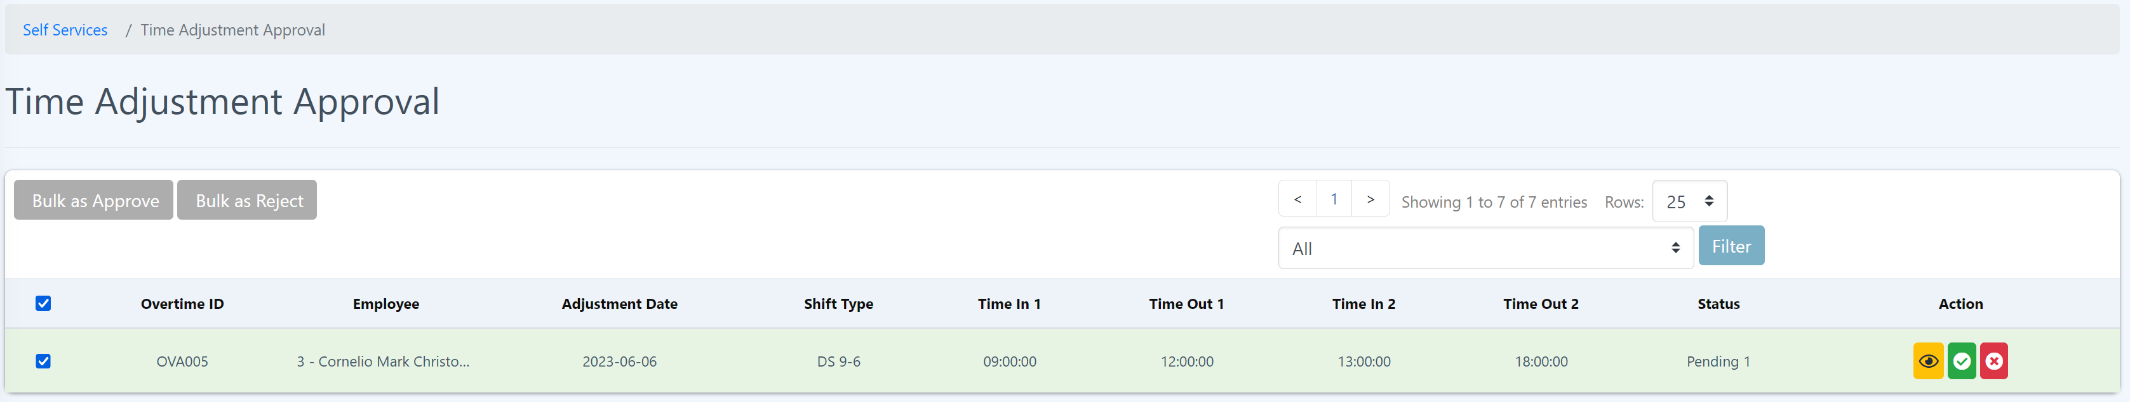

Step 4: A pop will show up with the list of time adjustment you have marked. Click “Save” to confirm approval.

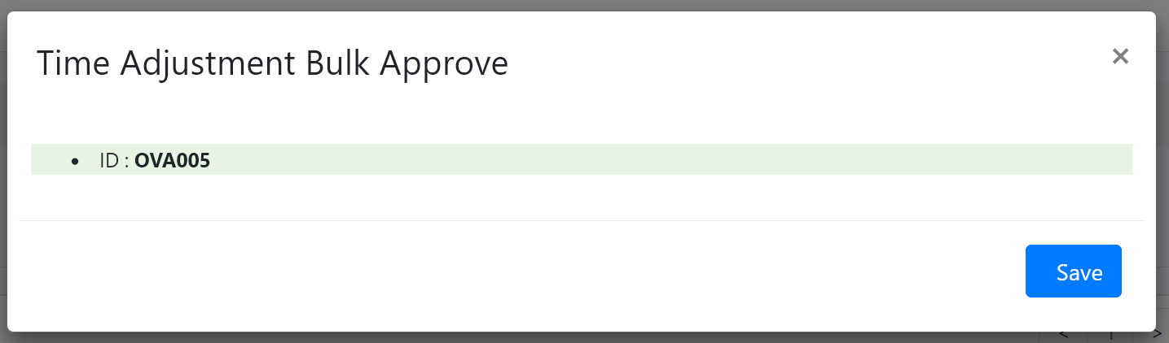

**Rejecting Time Adjustment**

**Procedure:**

Step 1: Click the “X” icon of the Action at the right side of the table.



Step 2: A pop up will show to confirm your rejection. Click “Reject” button to confirm and click the “Cancel” button to cancel the rejection.



Step 3: If you want bulk reject, you can mark the checkboxes at the left side of the table and click “Bulk as Reject”.



Step 4: A pop will show up with the list of time adjustments you have marked. Click “Save” to confirm rejection.

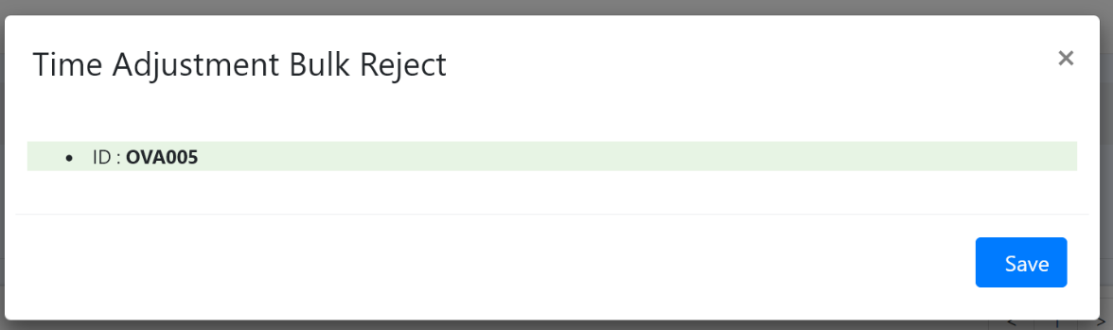

3 Company Module

Is designed to manage and streamline various aspects of the company’s operations. It serves as a central repository for storing and organizing key data related to the company’s structure, personnel, and other essential details.

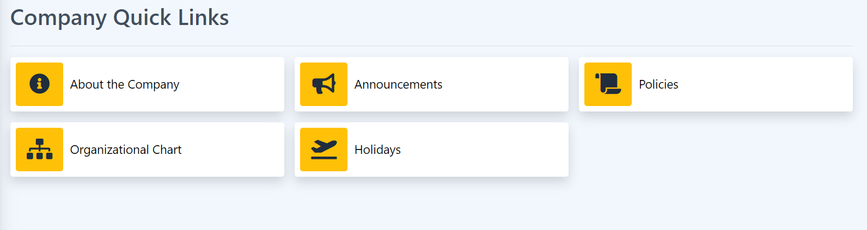

3.1 About the Company

This is where the company details, history, mission and vision are posted.

3.2 Announcements

This is where all the lists of announcements are posted including the announcement on the Home page. By delivering concise and impactful messages, announcements keep stakeholders informed and engaged, fostering transparency and effective communication.

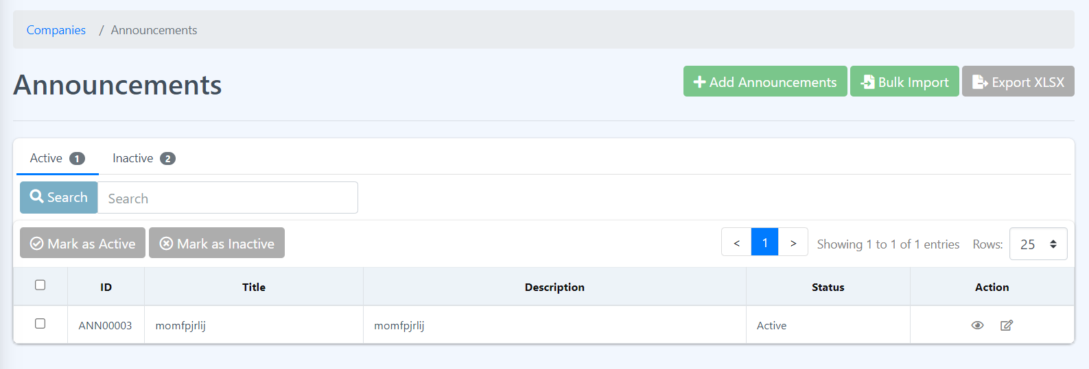

How to add new Announcement?

1. Click the Add Announcements button.

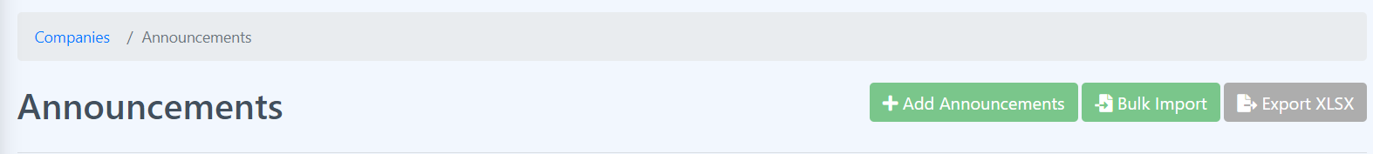

1. Fill all the required filled and click Submit.

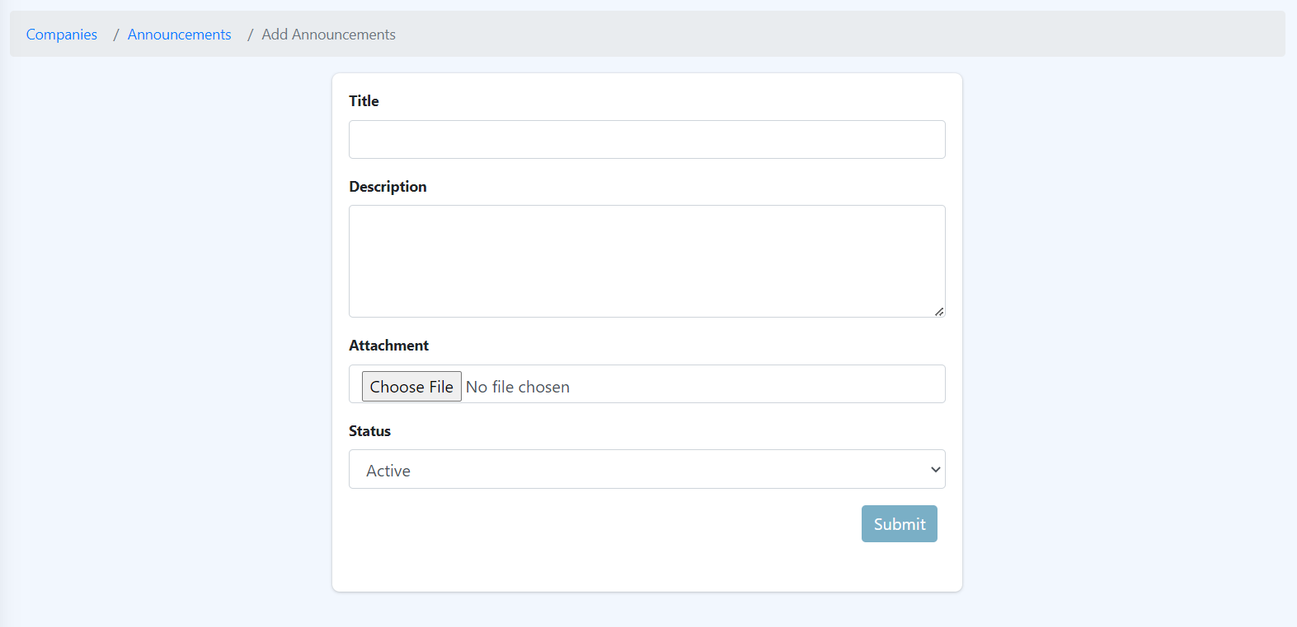

1. If the process is successful, the data is added to the table on the Announcements Page.

How to Export or download the Announcements Table?

1. Just click the Export XLSX button and download the Announcements table.



How to do Bulk Import Announcements?

1. Click the Bulk Import button.



1. Follow the given steps.

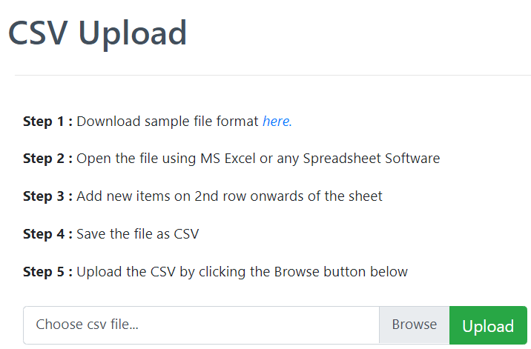

How to Mark as Active or Mark as Inactive an Announcements?

1. Select a single or multiple rows by clicking the checkbox located at the beginning of each row, and if you want to select all rows then click the first checkbox besides the table headers.

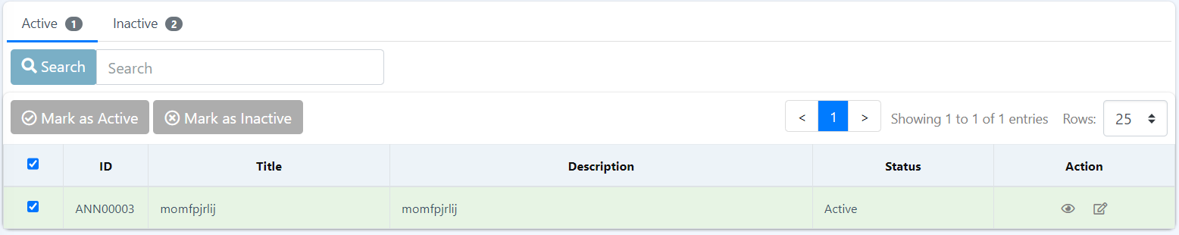

1. Click Mark as Inactive button and a message box will pop out.



1. Hit submit and check the data if the status changed to inactive

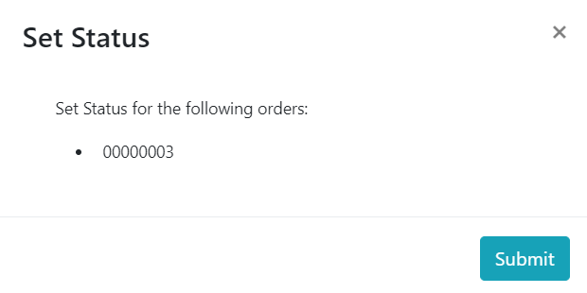

1. To Mark the data to active just repeat the 1-3 steps but before you do the first step navigate first to the Inactive tab by clicking the inactive tab.



How to see more details about the Announcements?

1. Click the eye icon under the Actions column and will show more details about the selected data.



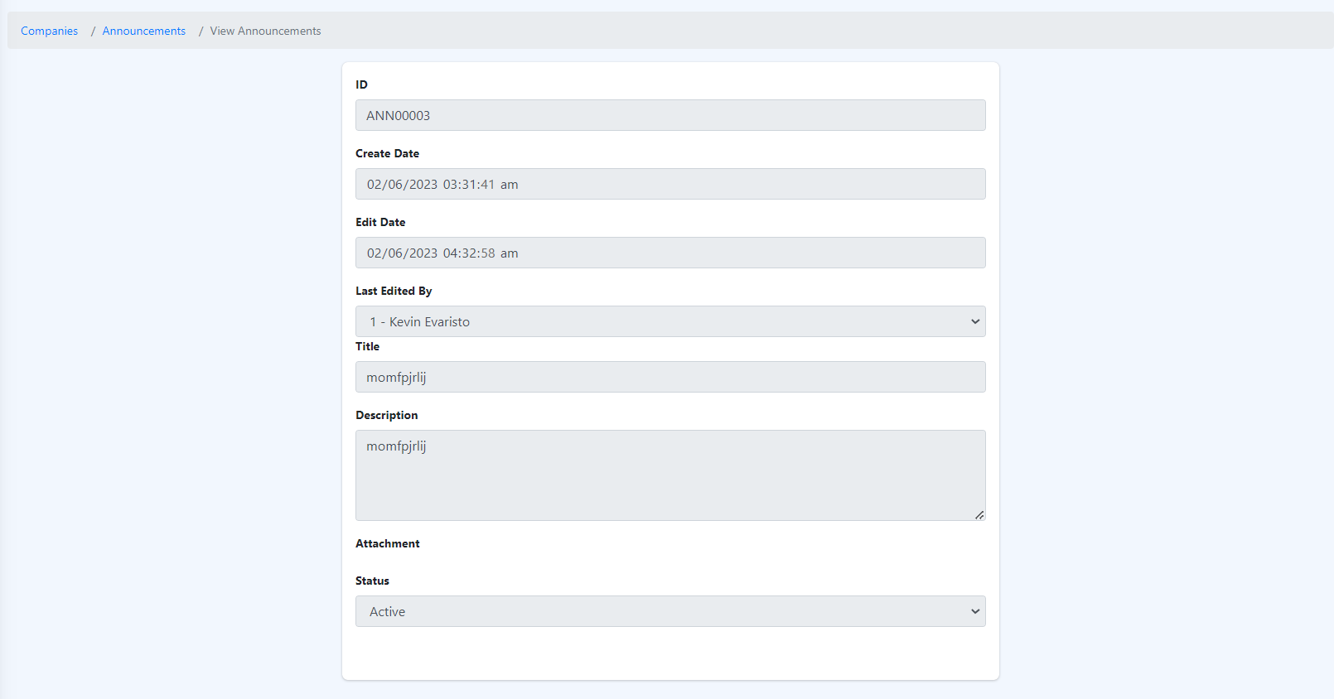

**How to Edit Announcements?**

1. Click the edit icon under Action column, the icon beside eye icon.



1. Edit the required field and click Submit.

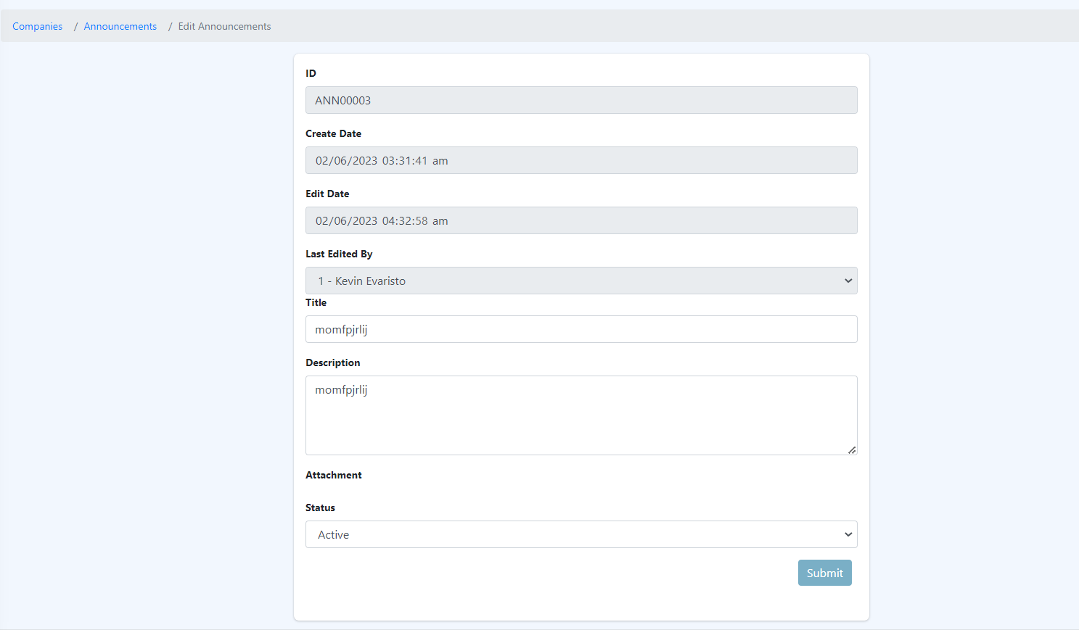

3.3 Policies

This page shows all the company policies. They cover various areas such as human resources, data security, code of conduct, privacy, and more, providing a framework for decision-making and setting expectations for employees and stakeholders.

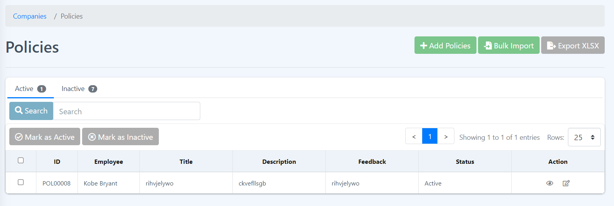

**How to Add new Policies?**

1. Click the Add Policies button.



1. Fill in all the required fields and hit Submit.

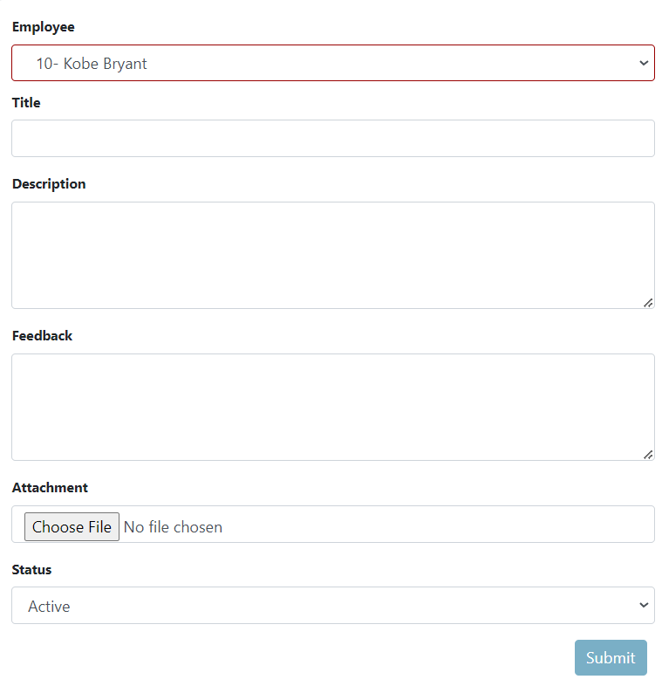

How to Export or download Policies Table?

1. Click the Export XLSX button and it will download the Policies Table.



How to Bulk Import of Policies?

1. Click the Bulk Import button.



1. Follow the given set of rules.

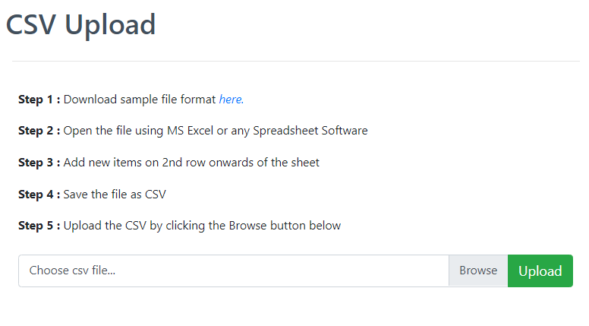

**How to Mark as Active or Mark as Inactive a Policies?**

1. Select a single or multiple rows by clicking the checkbox located at the beginning of each row, and if you want to select all rows then click the first checkbox beside the table headers.

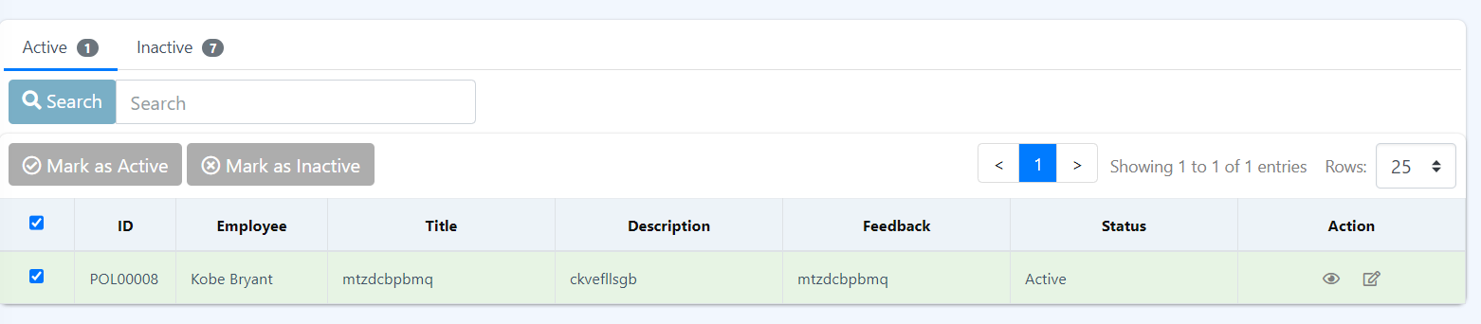

1. Click Mark as Inactive button and a message box will pop out.



1. Hit submit and check the data if the status changed to inactive.

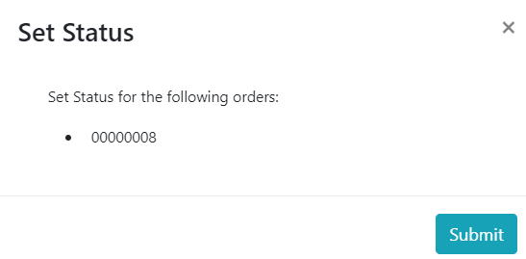

1. To Mark the data to active just repeat the 1-3 steps but before you do the first step navigate first to the Inactive tab by clicking the inactive tab.



**How to see more details about the policies?**

1. Click the eye icon under Actions column. This will display more details about the selected policies. It is not needed to check the checkbox to select what to see more. Just click the eye icon on the data you wanted to see.

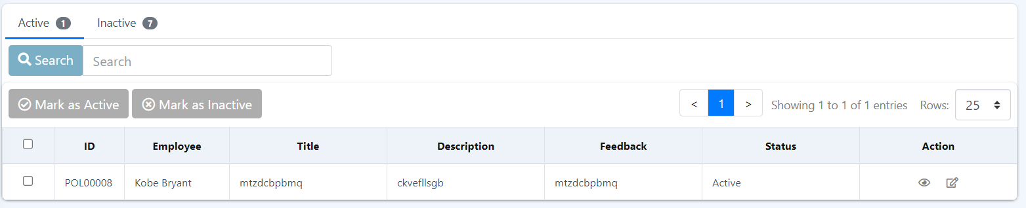

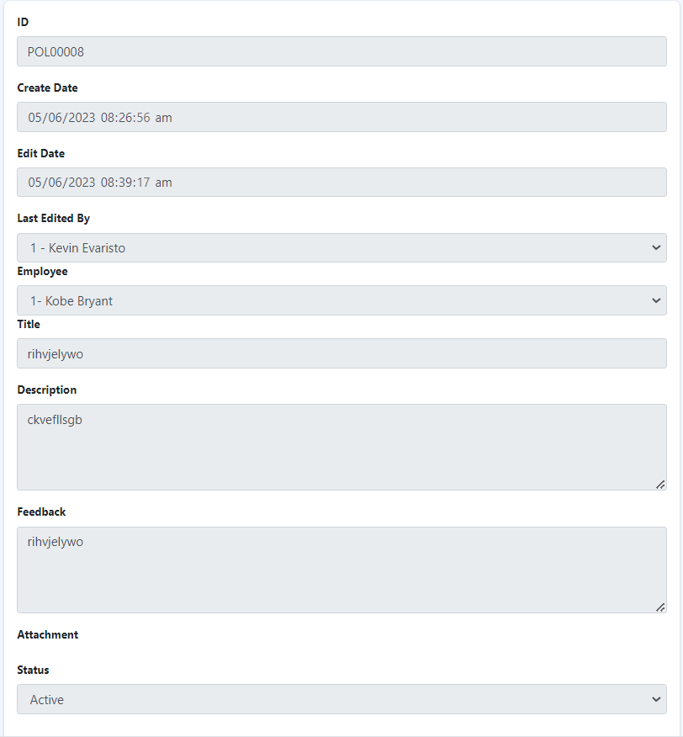

**How to Edit a Policy?**

1. Click the edit icon under Actions column, the icon beside eye icon. Here, it is also not needed to select or check the checkbox of the data you want to edit, just click the edit icon on the data you want to edit.



1. Edit or update the required fields and hit Submit button.

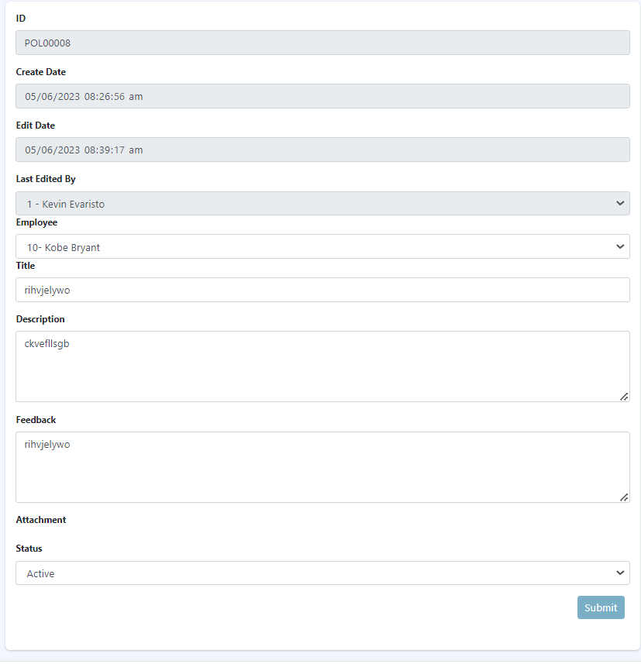

3.4 Organizational Chart

This shows the organizational hierarchy of the employees. It provides a graphical representation of the company's departments, positions, reporting lines, and relationships, enabling better understanding of the organizational hierarchy and facilitating effective communication and decision-making.

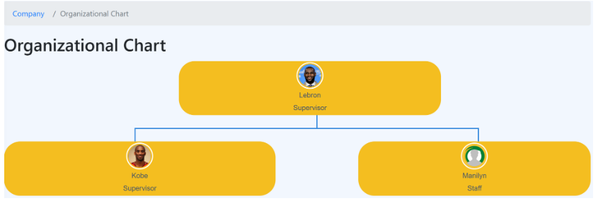

3.5 Holidays

This page shows all Holidays and its type during the current year and 2 years back. The Holidays Module is a component within a system or software that helps organizations manage and track holidays. It maintains a centralized calendar of holidays and vacation schedules, ensuring smooth coordination and efficient management of employee time off.

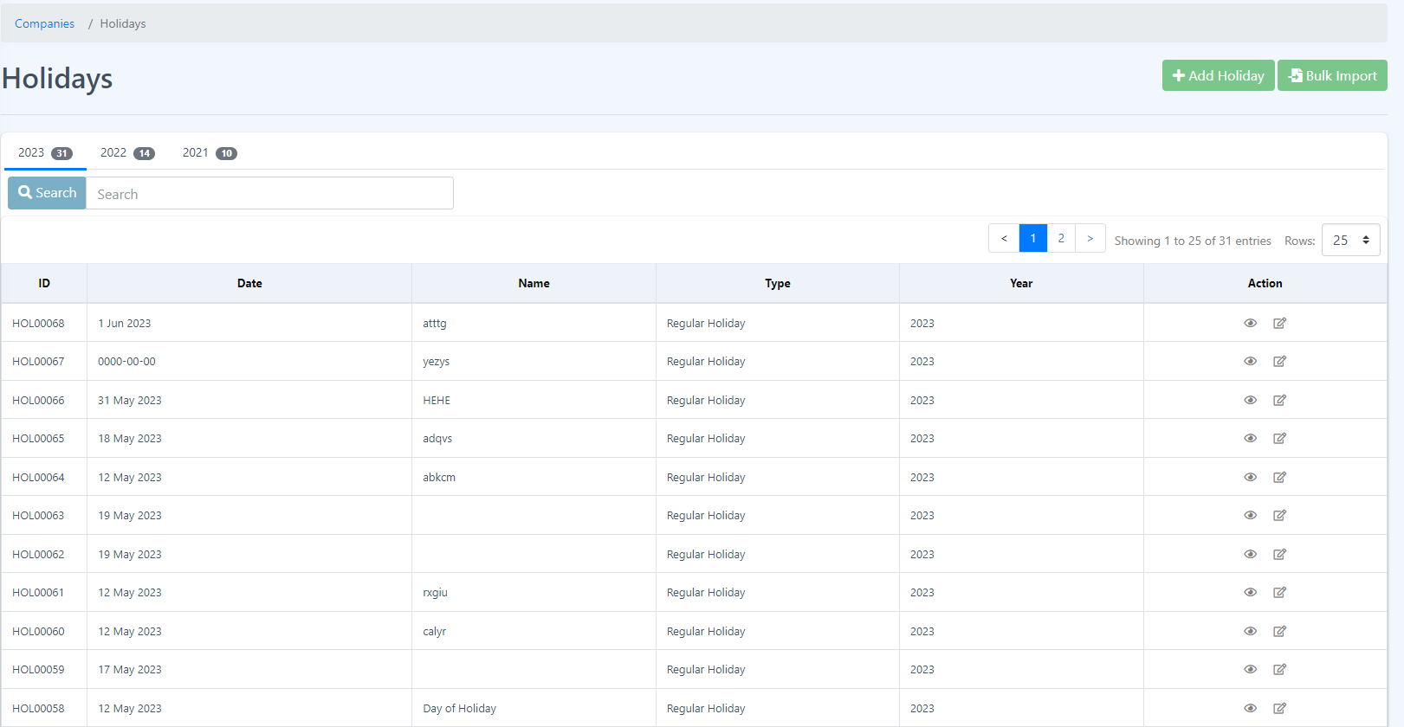

**How to Add a new Holiday?**

1. Click the Add Holiday.

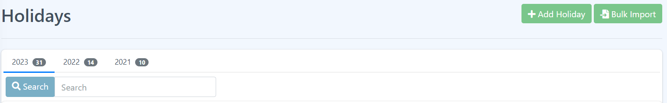

1. Fill in all the required fields such as the date and Year and click Submit button.

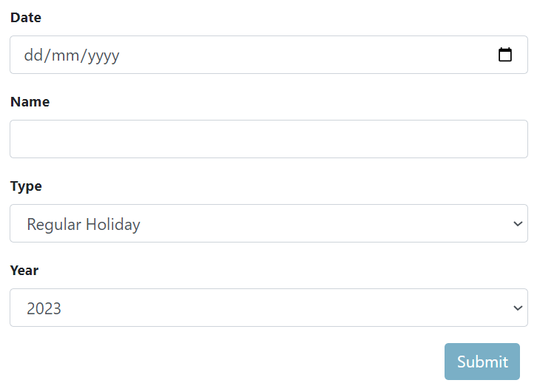

1. New added data are shown in the Holidays page table.

**How to Bulk Import of Holidays?**

1. Click the Bulk Import button.



1. Follow the given steps.

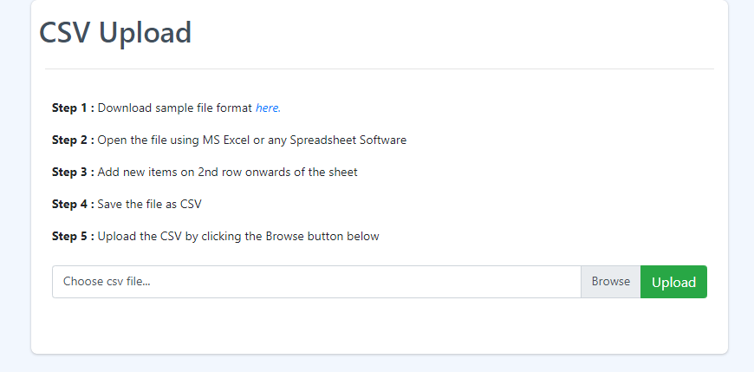

**How to filter the holiday table by year?**

1. Click the tab of the year you want to filter, by default the table shows the current year holidays. By default, the holidays during the current year will be displayed.

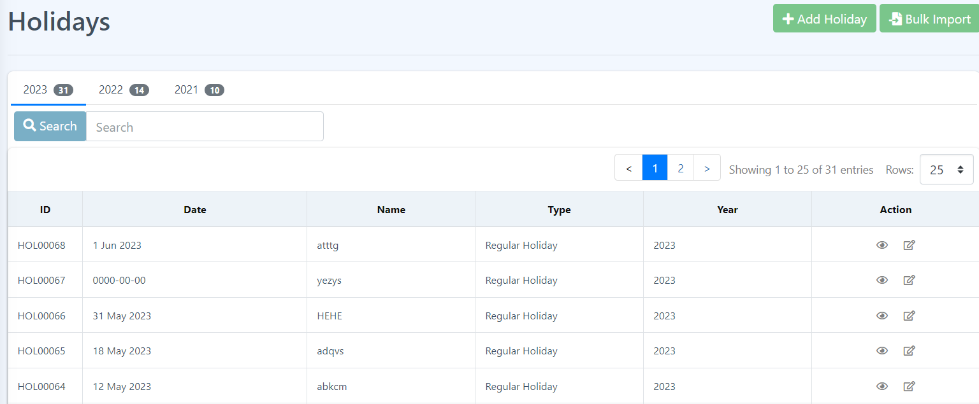

**How to see more details about the holiday?**

1. Click the eye icon under the Actions column. It will display more details about the selected data.



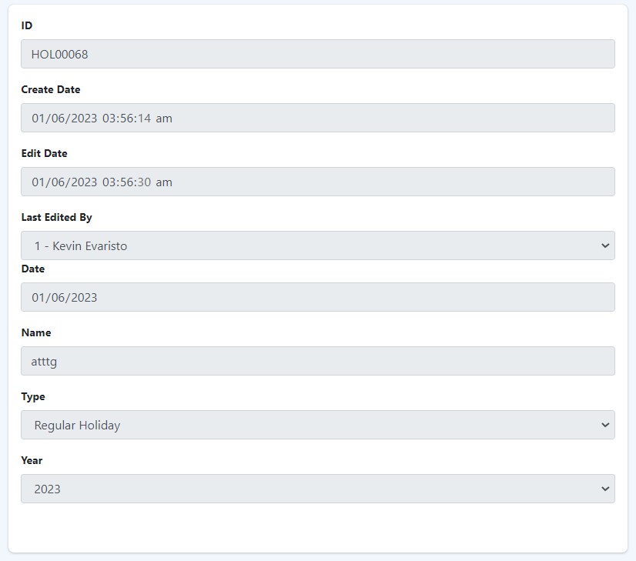

**How to edit a Holiday?**

1. Click the edit icon under the Actions column.



1. Edit or update all required fields and click Submit button.

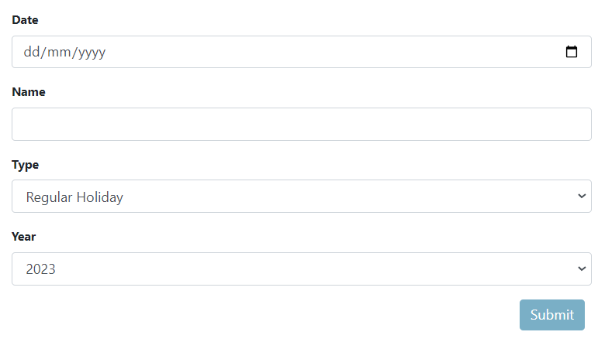

4 Employee

The employee module in Eyebox HRMS (Human Resource Management System) is a core component that focuses on managing employee-related information and processes. It serves as a centralized hub for storing, tracking, and accessing various employee data and activities. Here's an overview of the key features and functionalities found in the employee module of Eyebox HRMS:

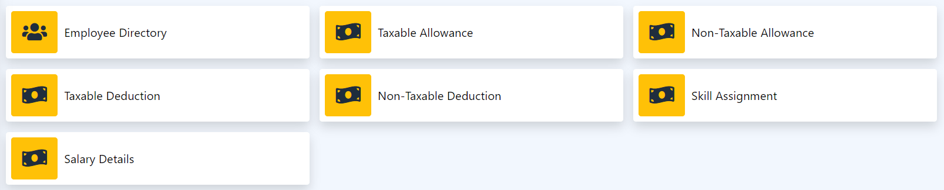

Employee Directory

1. Taxable Allowance
2. Non-taxable Allowance
3. Taxable Deduction
4. Non-taxable Deduction
5. Skill Assignment
6. Salary Details

The employee module in an HRMS plays a crucial role in streamlining HR processes, enhancing employee engagement, improving data accuracy, and ensuring compliance with employment regulations. It serves as a comprehensive solution for managing the employee lifecycle from recruitment to retirement within the organization.

4.1 Employee Directory

Eyebox HRMS (Human Resource Management System) often includes an employee directory or employee search functionality that allows users to quickly access and search for employee information. The employee directory provides a comprehensive listing of employees within the organization, typically accessible to authorized personnel. Here's an overview of the employee directory Eyebox HRMS:

1. Search Functionality: The employee directory in HRMS usually includes a search bar or advanced search options to facilitate finding specific employees based on various criteria. Users can search by name, department, job title, or other relevant parameters.

2. Employee Profiles: Each employee listed in the directory typically has a dedicated profile page that provides detailed information about the individual. This may include contact details, job title, department, reporting structure, and other pertinent information.

3. Profile Pictures: Some HRMS platforms allow employees to upload their profile pictures. The employee directory may display these pictures alongside the employee's name, enhancing recognition and personalization.

4. Filtering and Sorting: Depending on the HRMS capabilities, users may be able to filter and sort the employee directory based on specific criteria, such as department, location, or employment status. This helps narrow down the search and find relevant employee information efficiently.

The employee directory Eyebox HRMS serves as a centralized hub for employee information, making it easier for users to locate and connect with colleagues. It promotes collaboration, facilitates communication, and fosters a sense of community within the organization.

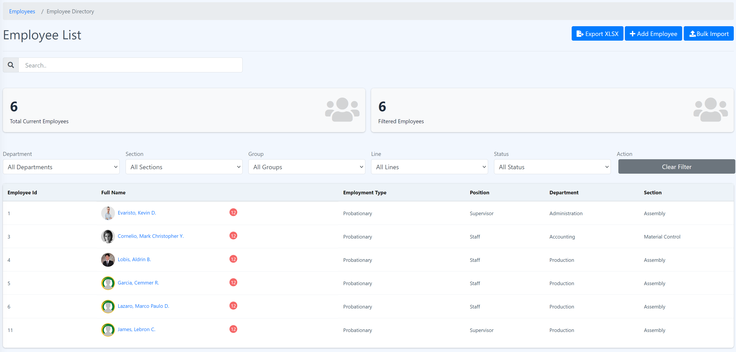

**Personal Info**

Eyebox HRMS (Human Resource Management System) typically includes an employee list or employee directory that serves as a centralized database containing essential information about employees within an organization. The employee list in an HRMS provides an overview of the workforce and facilitates easy access to employee details. Here are the common elements you can find in an HRMS employee list:

1. Employee ID: A unique identifier assigned to each employee within the HRMS.

2. Employee Name: The full name of the employee, including first name, middle name (if applicable), and last name.

3. Contact Information: Contact details such as email address, phone number, and address for communication purposes.

4. Job Title/Position: The job title or position held by the employee within the organization.

5. Department/Division: The department or division to which the employee belongs.

6. Employment Status: Indicates whether the employee is full-time, part-time, temporary, or contract based.

7. Employment Start Date: The date on which the employee began working for the organization.

8. Employment End Date: If the employee has left the organization, the date on which their employment ended.

9. Personal Information: Basic personal details like date of birth, gender, and marital status, based on the organization's requirements and privacy policies.

10. Additional Custom Fields: Eyebox HRMS systems allow organizations to add custom fields to the employee list based on their specific requirements. These fields can include information such as emergency contacts, skills, training records, or any other relevant data.

The employee list in Eyebox’s HRMS provides HR professionals and management with a centralized and up-to-date view of their workforce, facilitating efficient HR operations, reporting, and decision-making processes.

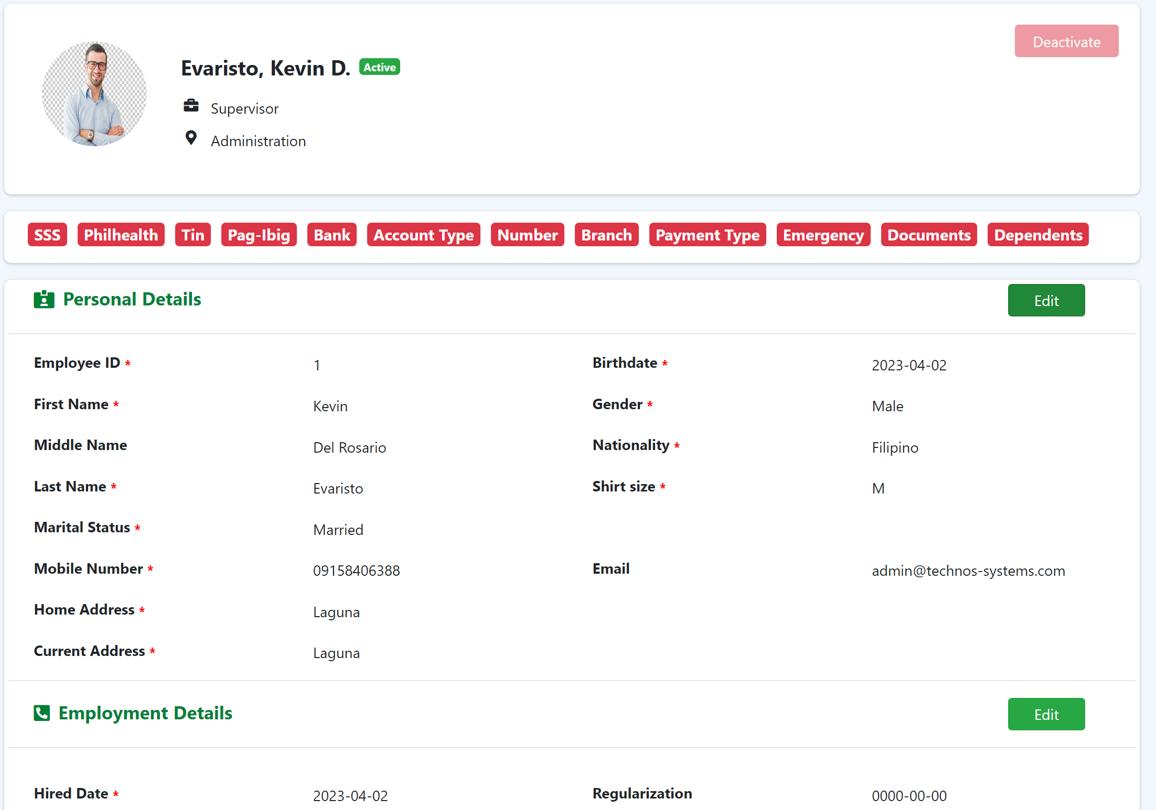

**Edit Employee Personal Details**

**Procedure:**

Step 1: Go to Employee List and search for the employee you want to change personal details.

Step 2: Click “Edit” to redirect you to edit page.



Step 3: Change the details you want to make changes then click “Submit” button.

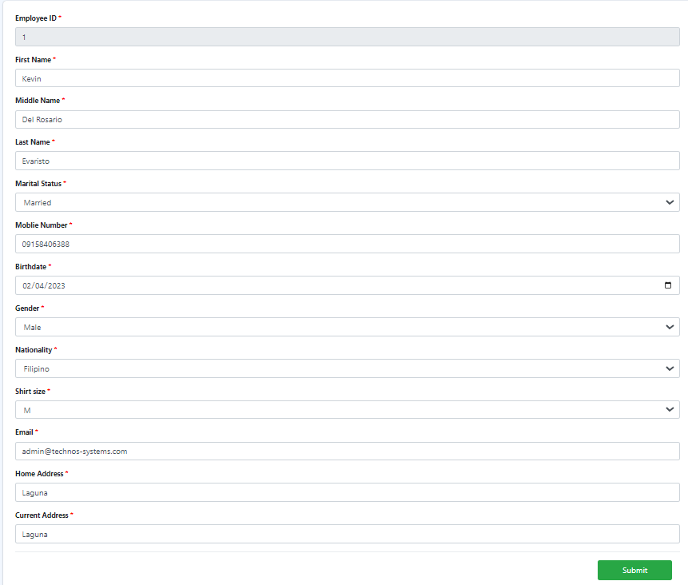

**Edit Employment Details**

**Procedure:**

Step 1: At the employee personal info, look for Employment details and click “Edit”.



Step 2: Change the details you want to make changes then click “Submit” button.

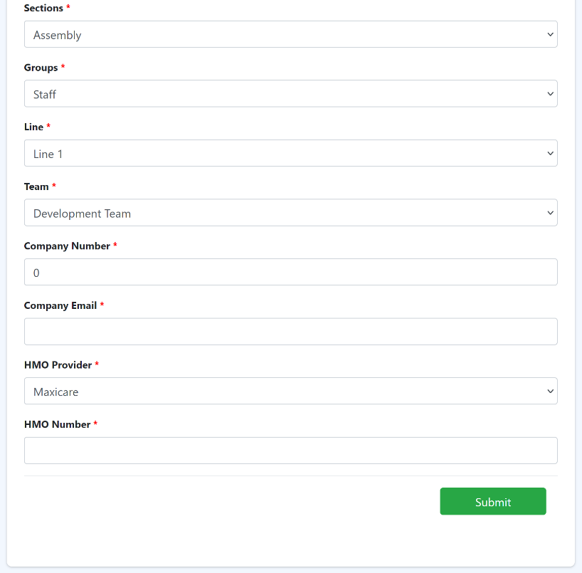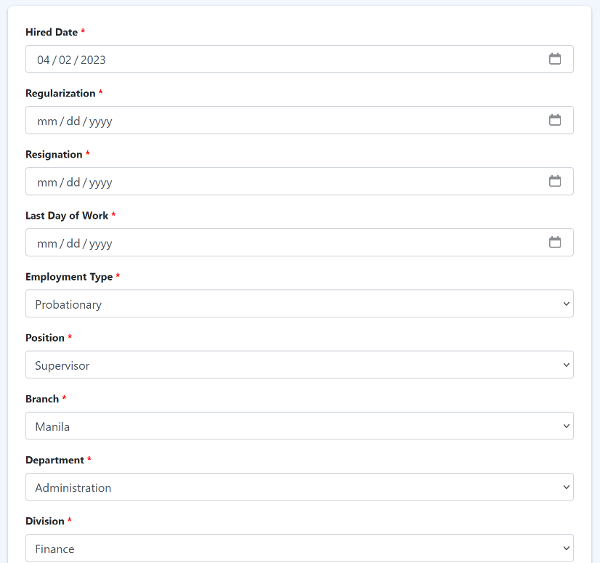

**Edit ID Details**

**Procedure:**

Step 1: At the employee personal info, look for “ID Details” and click “Edit”.



Step 2: Fill in the blanks with your ID details then click “Submit” button.

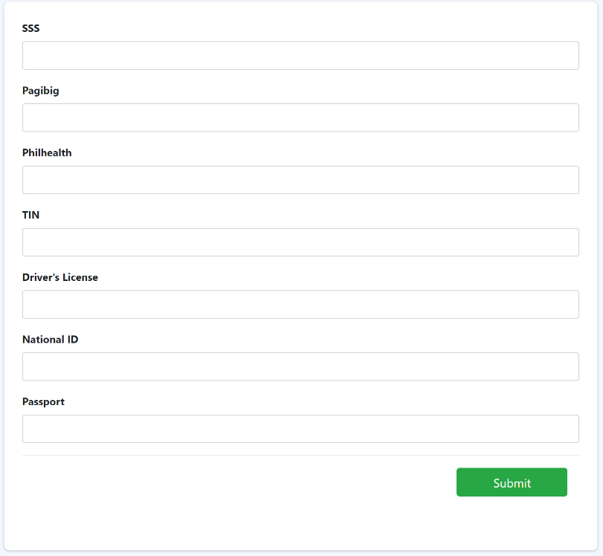

How to Add Education?

Step 1: At the employee personal info, look for “Add Education” and click “Add”.



Step 2: Fill the blanks with your educational details then click “Submit” button.

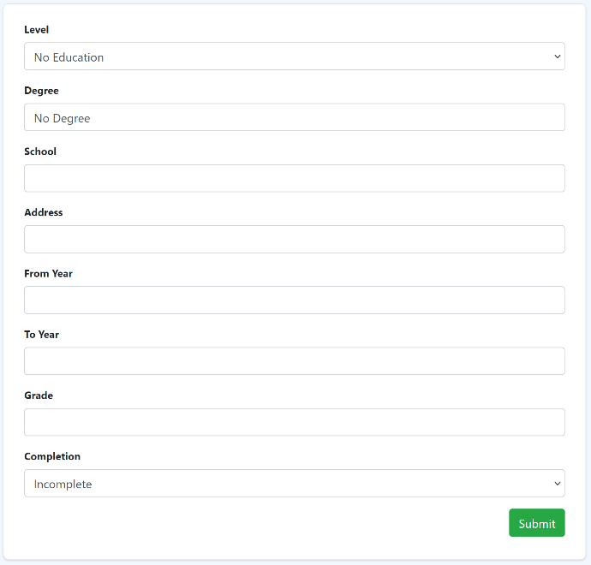

**Adding skills**

**Procedure:**

Step 1: At the employee personal info, look for “Add Skill” and click “Add”.



Step 2: Fill the inputs by choosing the skill you want then click “Submit” button.

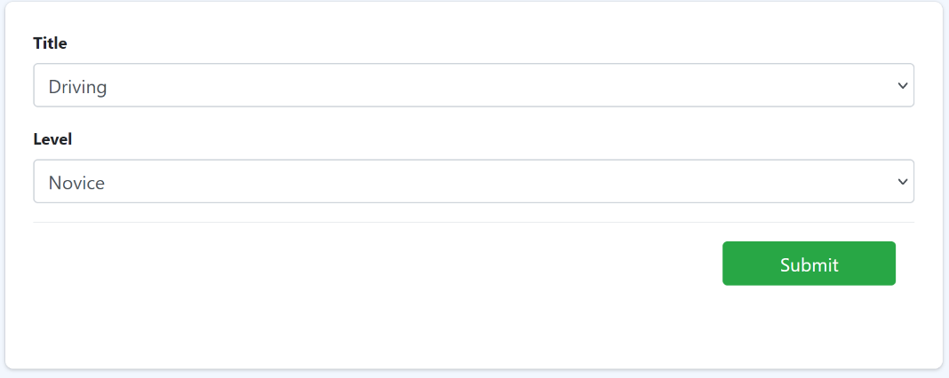

How to attach Documents in the employee personal info?

Step 1: At the employee personal info, look for “Add Document” and click “Add”.



Step 2: Fill in the inputs by choosing the document you want to attach then click “Submit” button.

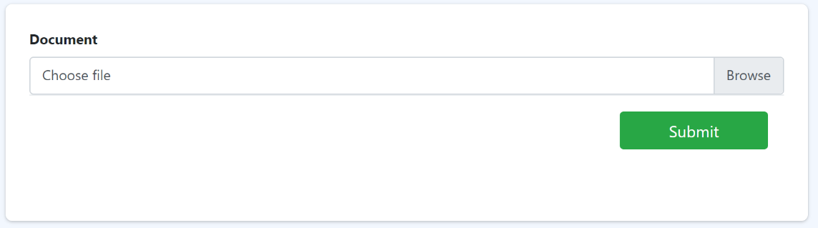

**Adding Dependent in the employee personal info**

**Procedure:**

Step 1: At the employee personal info, look for “Add Dependent” and click “Add”.



Step 2: Fill the blanks with the employee beneficiary details then click “Submit” button.

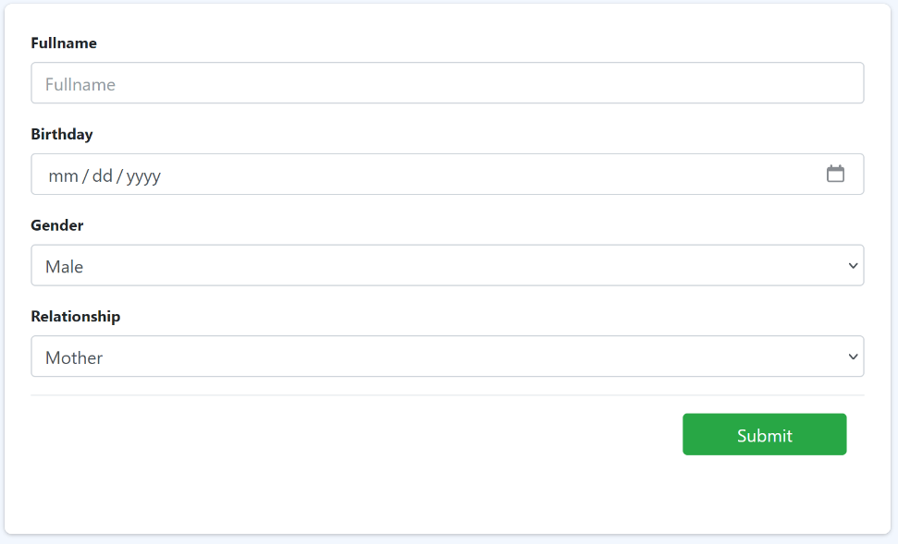

**Add employee Emergency Contacts**

**Procedure:**

Step 1: At the employee personal info, look for “Emergency Contact” and click “Add”.



Step 2: Fill the blanks with the employee emergency contact details then click “Submit” button.

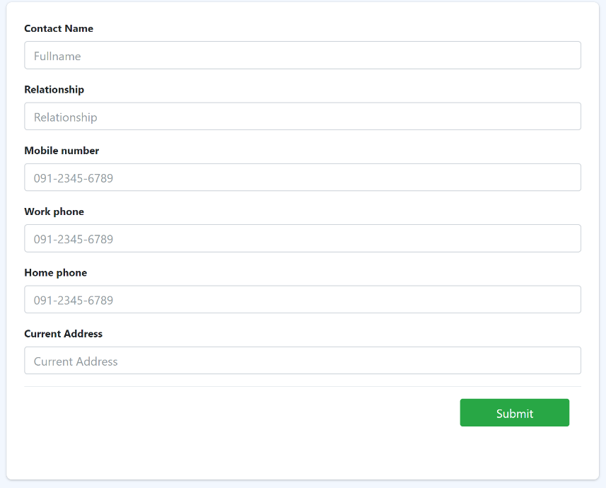

4.2 Taxable Allowance

In Eyebox HRMS (Human Resource Management System), the taxable allowance feature allows organizations to manage and track the taxable allowances provided to employees. Taxable allowances are specific types of compensation that are subject to taxation. Here's an explanation of how the HRMS handles taxable allowances:

1. Setup and Configuration: Within the HRMS, administrators or HR professionals can configure the taxable allowances based on the organization's policies and relevant tax regulations. This involves defining the types of taxable allowances and specifying the associated tax rules and rates.

2. Allowance Assignment: HR personnel can assign taxable allowances to individual employees within their profiles or through a centralized configuration interface. This includes specifying the name and type of allowance, the amount or percentage, and any conditions or restrictions.

3. Payroll Calculation: When processing payroll, the HRMS automatically includes the taxable allowances in the calculations. The system considers the taxable allowances as part of the employee's gross income and applies the appropriate tax rates and deductions.

4. Tax Reporting: The HRMS generates reports or data exports that provide accurate information about taxable allowances for tax reporting purposes. These reports can be used for internal record-keeping or provided to tax authorities as required.

5. Compliance and Updates: The HRMS should be designed to handle changing tax regulations and rates. Administrators or HR professionals can update the tax rules within the system when there are revisions to tax laws or changes in taxable allowance policies.

By utilizing the taxable allowance feature in an HRMS, organizations can effectively manage and calculate the tax obligations associated with specific compensation components. This ensures compliance with tax laws, streamlines payroll processing, and provides accurate information for tax reporting and record-keeping purposes.

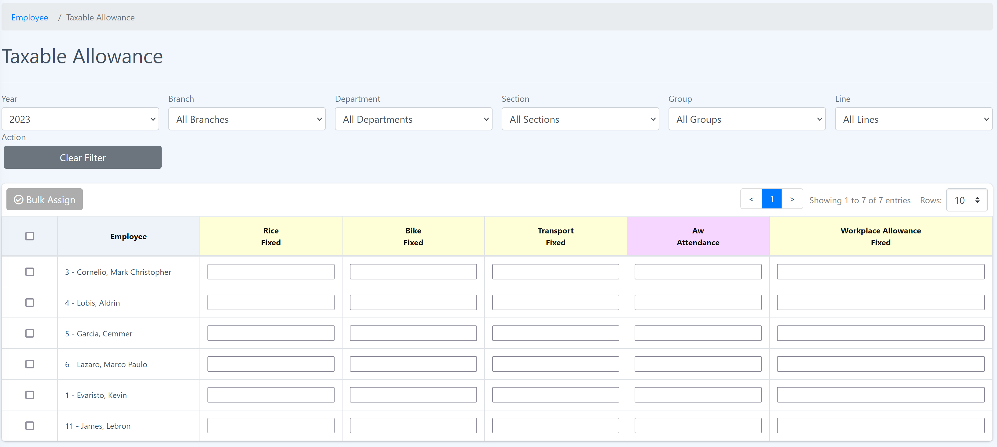

**Add value to the Taxable Allowance**

**Procedure:**

Step 1: Enter the value of tax in the input box.



Step 2: Then press “Enter”. The value should be saved and able to see value you have entered.

**Assigning Taxable Allowance to employees in bulk**

**Procedure:**

Step 1: Mark the checkbox of the employee on the left side of the table.

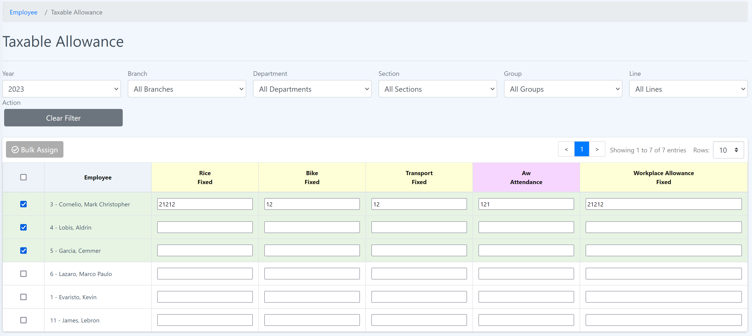

Step 2: Click “Bulk Assign”. The popup will show.



Step 3: Choose the taxable allowance and enter the value and click “Save”.

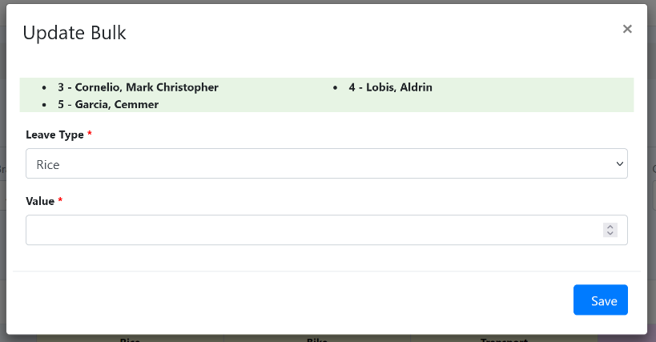

4.3 Non-taxable Allowance

In Eyebox HRMS (Human Resource Management System), the non-taxable allowance feature allows organizations to manage and track allowances provided to employees that are exempt from taxation. Non-taxable allowances are specific types of compensation that are not subject to income tax. Here's an explanation of how the HRMS handles non-taxable allowances:

1. Setup and Configuration: HR personnel or administrators can configure the non-taxable allowances within the HRMS based on the organization's policies and relevant tax regulations. This involves defining the types of non-taxable allowances and specifying the conditions or criteria that make them exempt from taxation.

2. Allowance Assignment: Within the HRMS, administrators or HR professionals can assign non-taxable allowances to individual employees. This can be done through the employees' profiles or a centralized configuration interface. The process includes specifying the name and type of allowance, the amount or percentage, and any conditions or restrictions that apply.

3. Payroll Calculation: When processing payroll, the HRMS recognizes the non-taxable allowances and excludes them from the employee's taxable income. The system ensures that these allowances are not subject to income tax withholding or other applicable deductions.

4. Reporting and Documentation: The HRMS generates reports or provides data exports that reflect the non-taxable allowances provided to employees. These reports can be used for internal record-keeping, auditing purposes, or to provide accurate information to employees about their compensation breakdown.

5. Compliance and Updates: The Eyebox HRMS is designed to handle changes in tax regulations or policies related to non-taxable allowances. Administrators or HR professionals can update the system accordingly to ensure compliance with the latest tax laws and regulations.

By leveraging the non-taxable allowance feature in Eyebox HRMS, organizations can effectively manage and differentiate between taxable and non-taxable components of employee compensation. This helps ensure accurate payroll processing, compliance with tax regulations, and transparency in employee compensation.

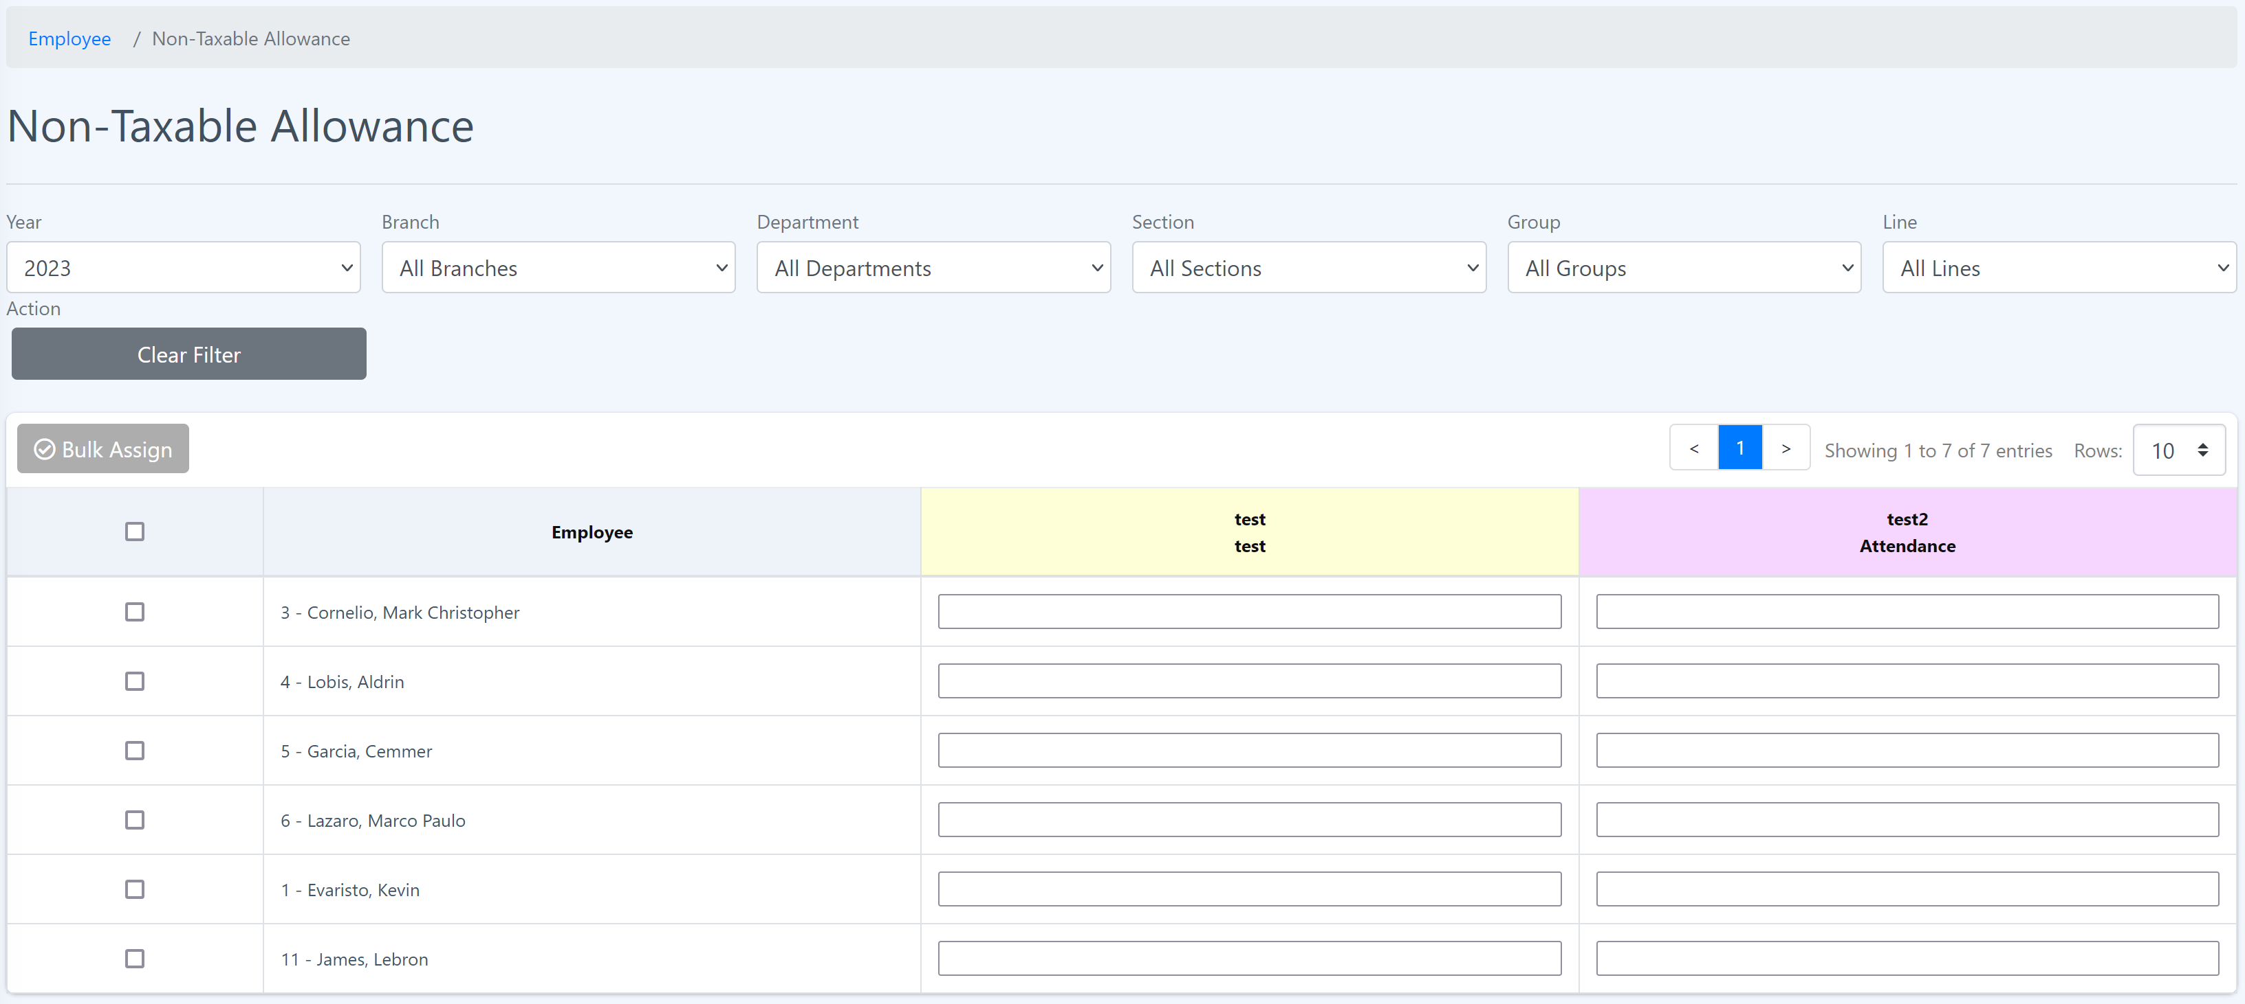

**Add value to the Non-Taxable Allowance**

**Procedure:**

Step 1: Enter the value of allowance in the input box.



Step 2: Then press “Enter”. The value should be saved and able see value you have entered.

How to assign Non-Taxable Allowance to employees in bulk?

Step 1: Mark the checkbox of the employee on the left side of the table.

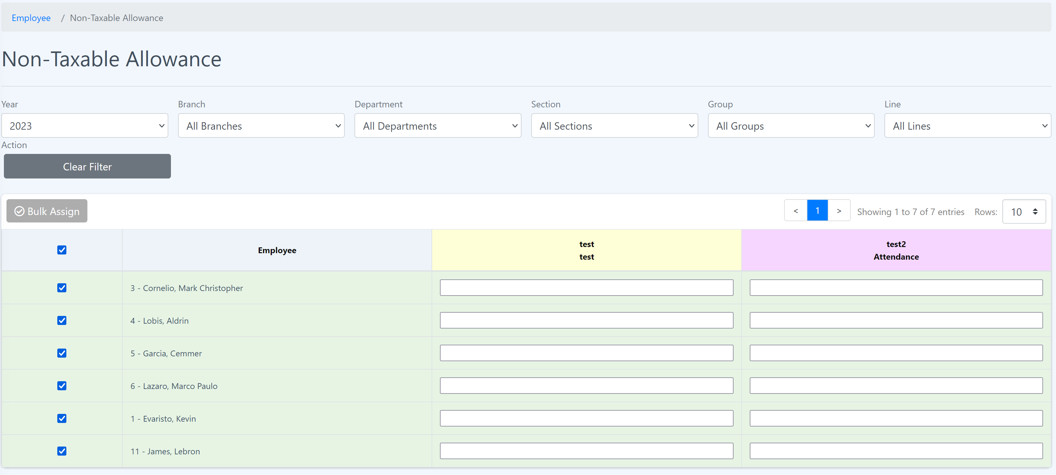

Step 2: Click “Bulk Assign”. The popup will show.



Step 3: Choose the taxable allowance and enter the value and click “Save”.

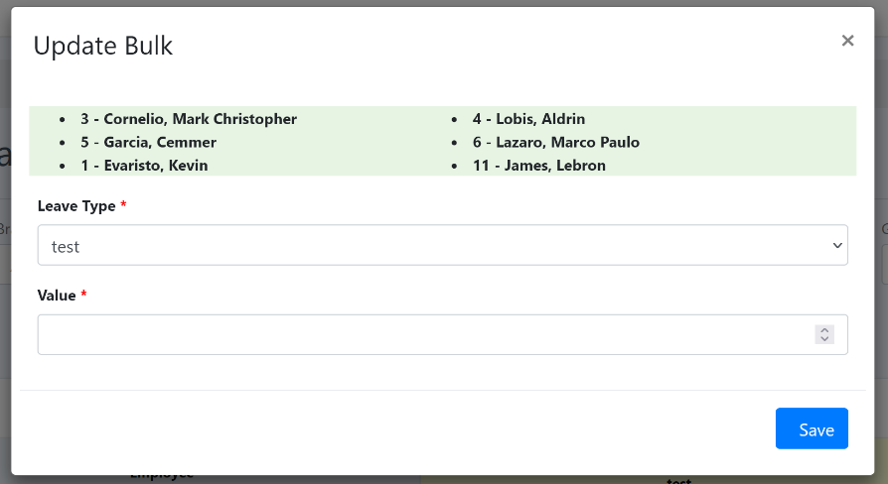

4.4 Taxable Deduction

In Eyebox HRMS (Human Resource Management System), the taxable deduction feature allows organizations to manage and track deductions from an employee's taxable income. Taxable deductions are specific amounts or items that reduce an employee's taxable income and, consequently, their tax liability. Here's an explanation of how the HRMS handles taxable deductions:

1. Setup and Configuration: HR personnel or administrators can configure the taxable deductions within the HRMS based on the organization's policies and relevant tax regulations. This involves defining the types of taxable deductions and specifying the conditions or criteria for applying them.

2. Deduction Assignment: Within the HRMS, administrators or HR professionals can assign taxable deductions to individual employees. This can be done through the employees' profiles or a centralized configuration interface. The process includes specifying the name and type of the deduction, the amount or percentage, and any conditions or restrictions that apply.

3. Payroll Calculation: When processing payroll, the HRMS automatically considers the taxable deductions in the calculations. The system subtracts the specified deduction amount from the employee's taxable income, reducing their tax liability accordingly. This ensures accurate withholding of income tax from the employee's salary.

4. Deduction Reporting: The HRMS generates reports or data exports that provide information about the taxable deductions for payroll and tax reporting purposes. These reports can be used for internal record-keeping, auditing, or providing accurate information to employees about their deduction breakdown.

5. Compliance and Updates: The HRMS should be designed to handle changes in tax regulations or policies related to taxable deductions. Administrators or HR professionals can update the system accordingly to ensure compliance with the latest tax laws and regulations.

By utilizing the taxable deduction feature in Eyebox HRMS, organizations can effectively manage and calculate the tax obligations associated with specific deduction components. This ensures compliance with tax laws, streamlines payroll processing, and provides accurate information for tax reporting and record-keeping purposes.

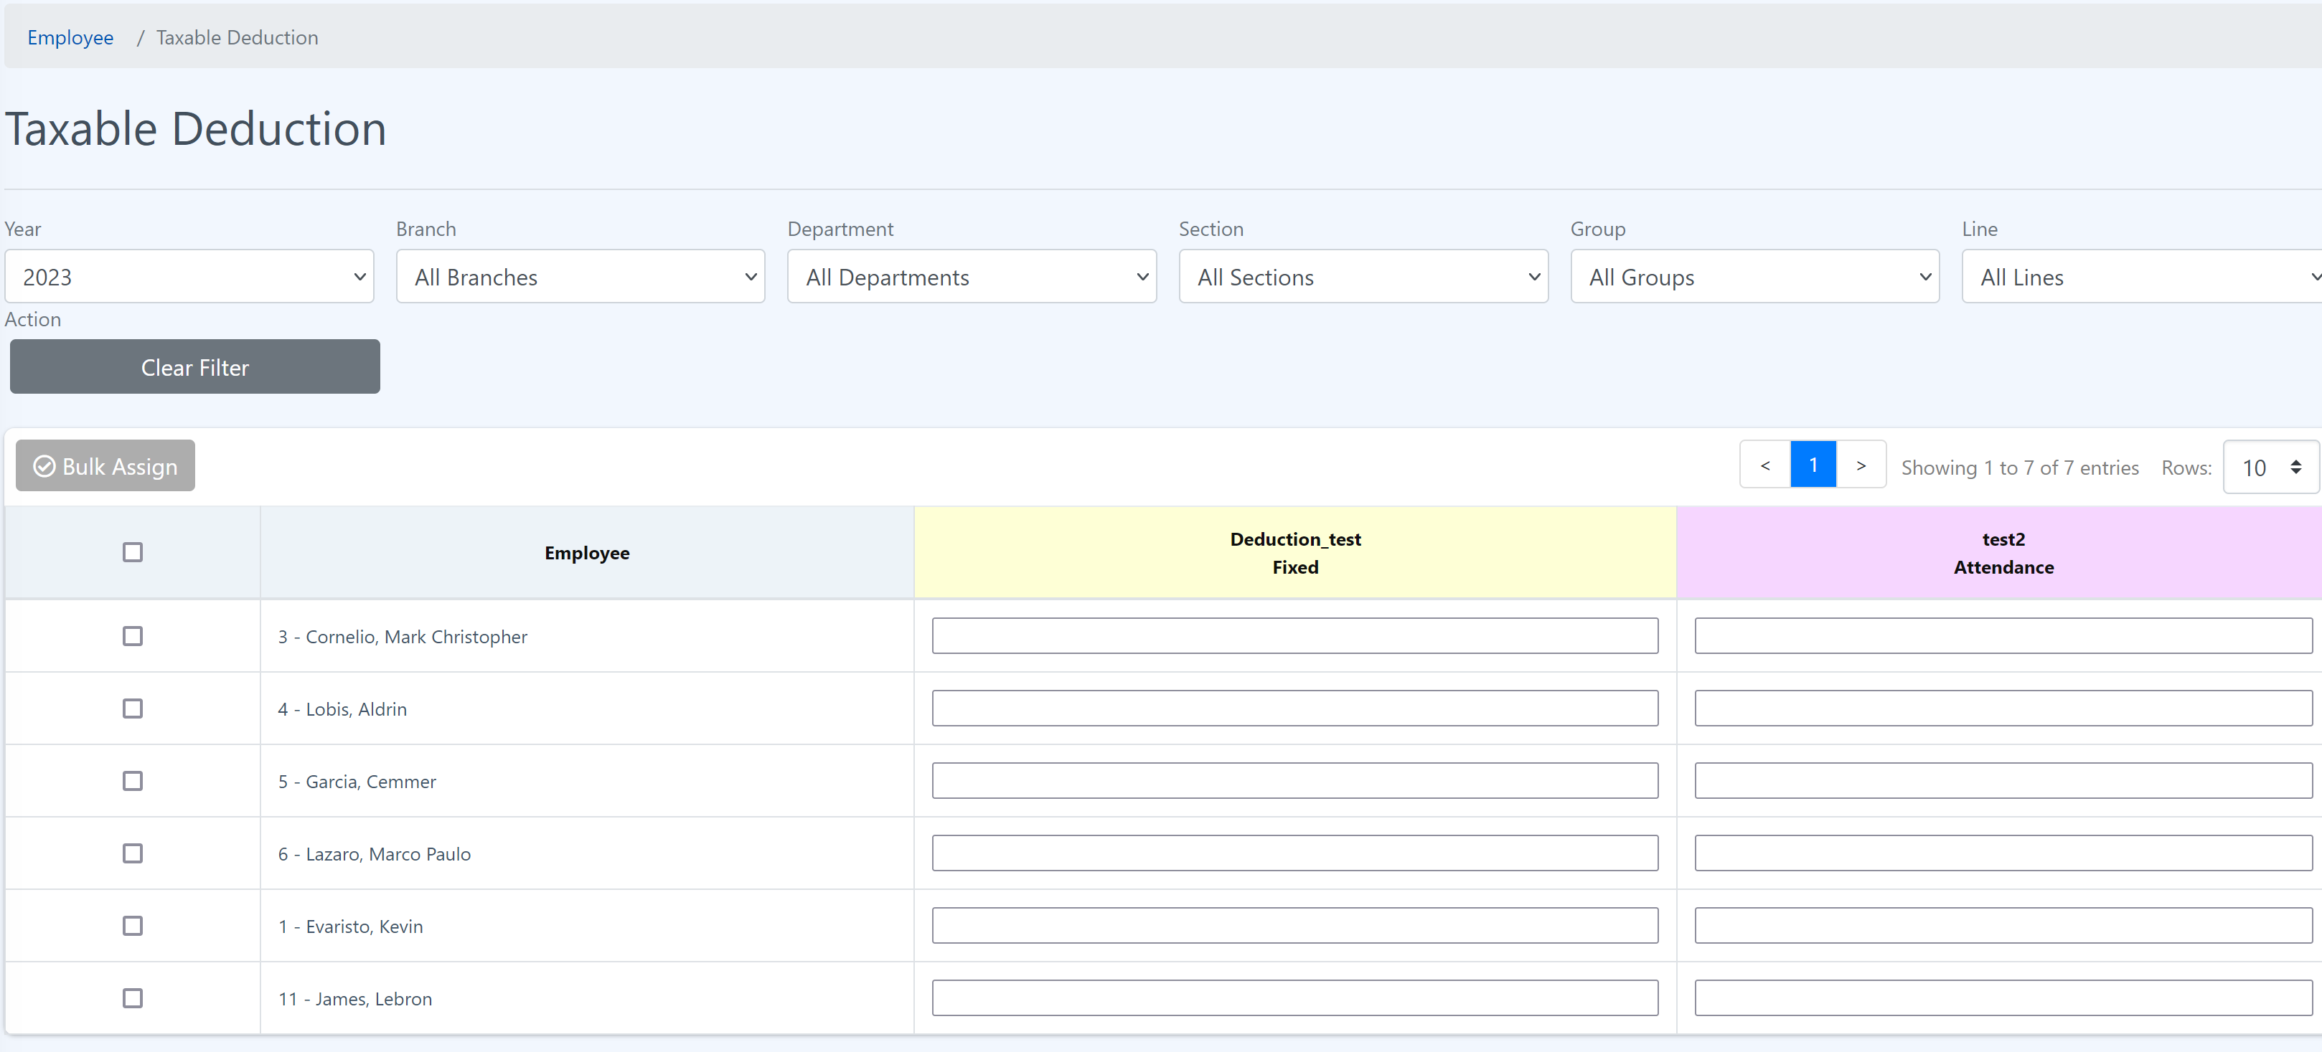

**Add details to the Salary**

**Procedure:**

Step 1: Enter the value of deduction in the input box.



Step 2: Then press “Enter”. The value should be saved and able see value you have entered.

**Assign Salary to employees in bulk**

**Procedure:**

Step 1: Mark the checkbox of the employee on the left side of the table.

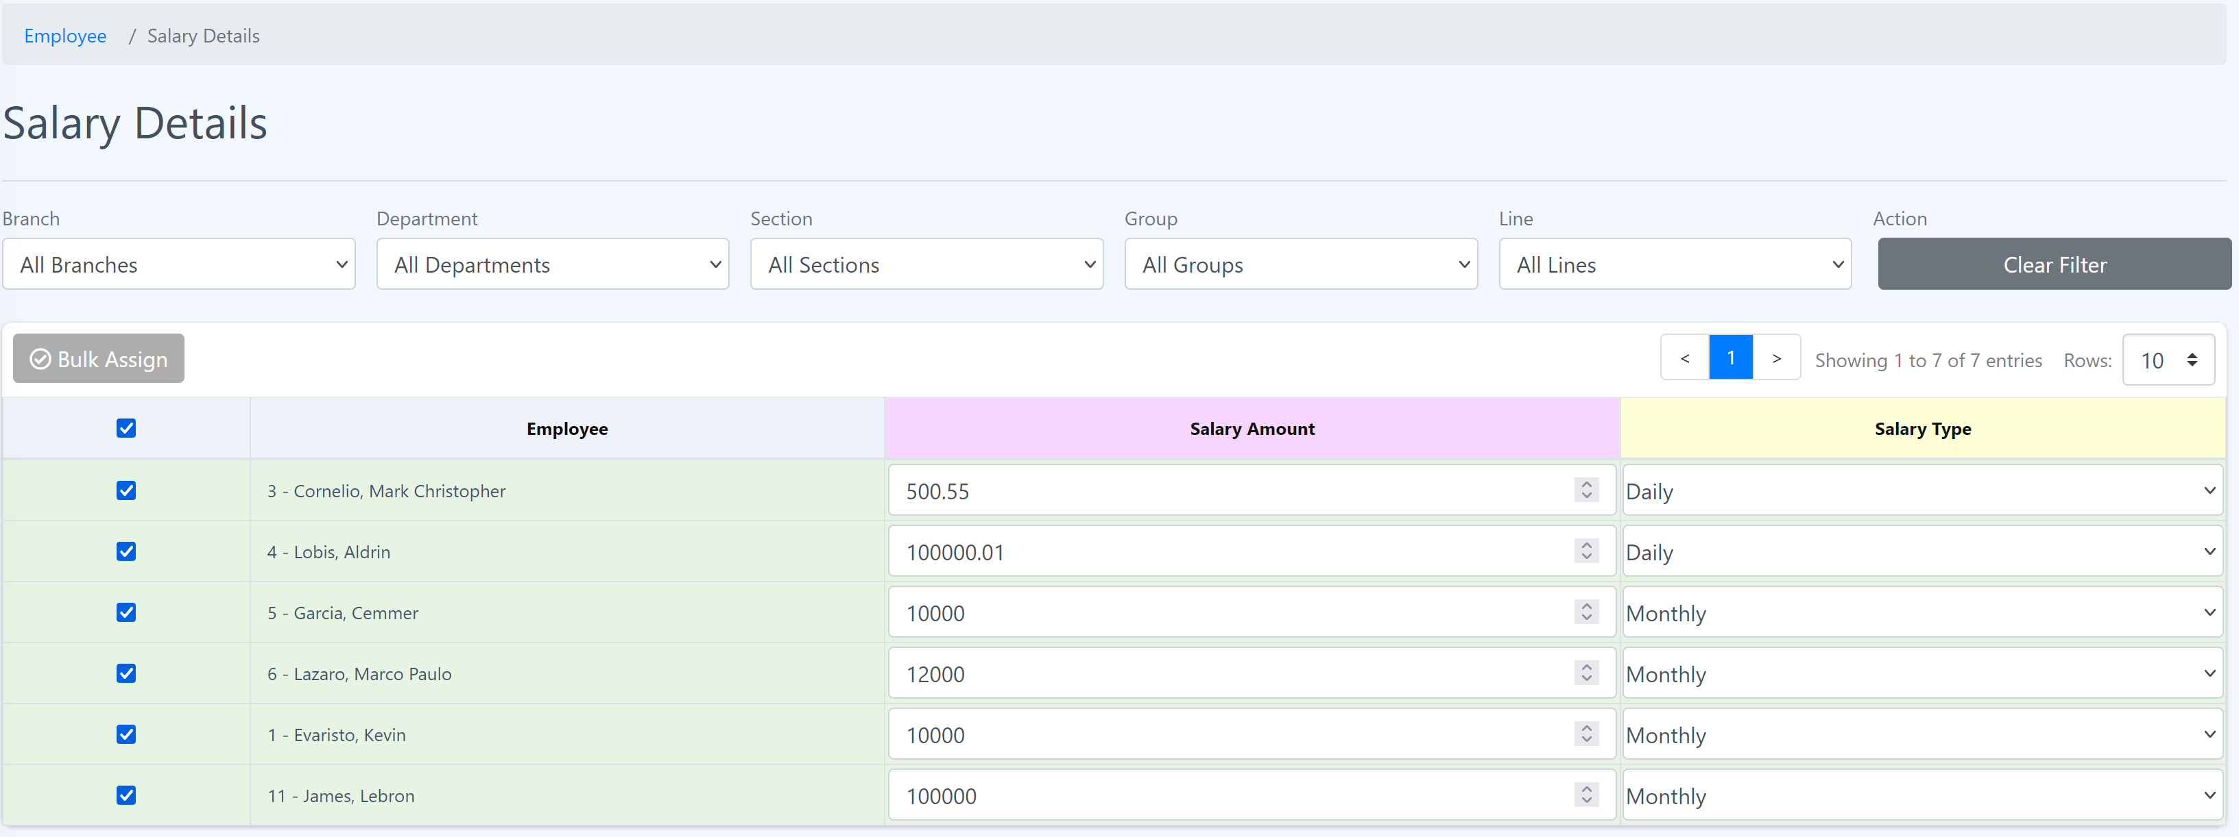

Step 2: Click “Bulk Assign”. The popup will show.

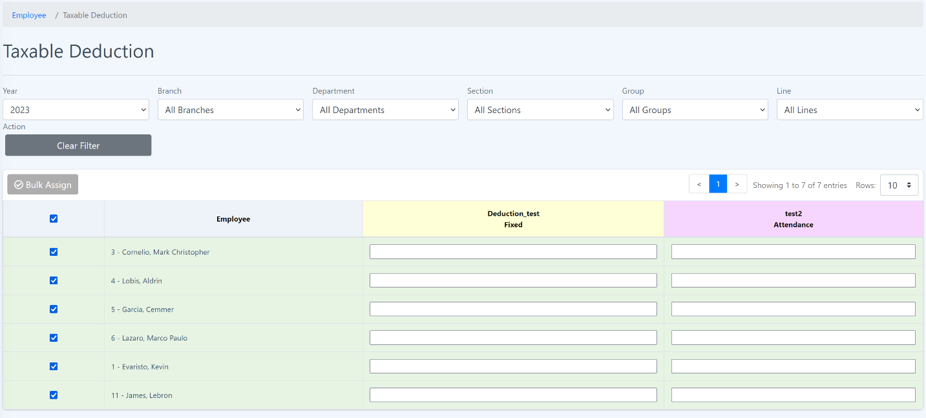

Step 3: Choose the taxable allowance and enter the value and click “Save”.

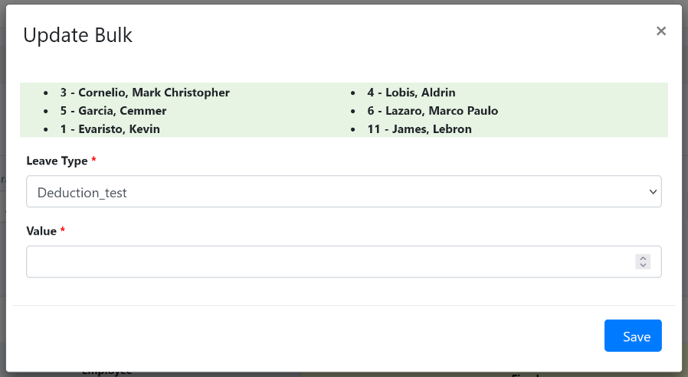

4.5 Non-taxable Allowance

In Eyebox HRMS (Human Resource Management System), the non-taxable deduction feature allows organizations to manage and track deductions from an employee's income that are exempt from taxation. Non-taxable deductions are specific amounts or items that are deducted from an employee's income and are not subject to income tax. Here's an explanation of how the HRMS handles non-taxable deductions:

1. Setup and Configuration: HR personnel or administrators can configure the non-taxable deductions within the HRMS based on the organization's policies and relevant tax regulations. This involves defining the types of non-taxable deductions and specifying the conditions or criteria that make them exempt from taxation.

2. Deduction Assignment: Within the HRMS, administrators or HR professionals can assign non-taxable deductions to individual employees. This can be done through the employees' profiles or a centralized configuration interface. The process includes specifying the name and type of the deduction, the amount or percentage, and any conditions or restrictions that apply.

3. Payroll Calculation: When processing payroll, the HRMS recognizes the non-taxable deductions and excludes them from the employee's taxable income. The system ensures that these deductions are not subject to income tax withholding or other applicable deductions.

4. Reporting and Documentation: The HRMS generates reports or provides data exports that reflect the non-taxable deductions applied to employees. These reports can be used for internal record-keeping and auditing purposes, or to provide accurate information to employees about their deduction breakdown.

5. Compliance and Updates: The HRMS should be designed to handle changes in tax regulations or policies related to non-taxable deductions. Administrators or HR professionals can update the system accordingly to ensure compliance with the latest tax laws and regulations.

By leveraging the non-taxable deduction feature in Eyebox HRMS, organizations can effectively manage and differentiate between taxable and non-taxable components of employee deductions. This helps ensure accurate payroll processing, compliance with tax regulations, and transparency in employee compensation.

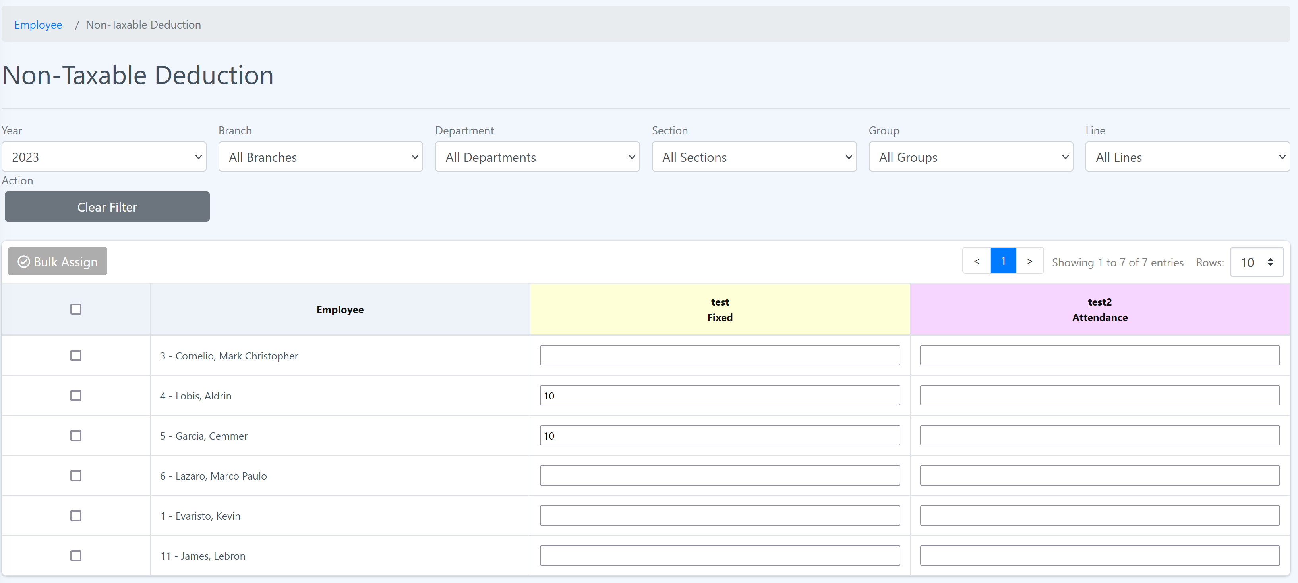

A**dd value to the Non-taxable Deduction**

**Procedure:**

Step 1: Enter the value of deduction in the input box.

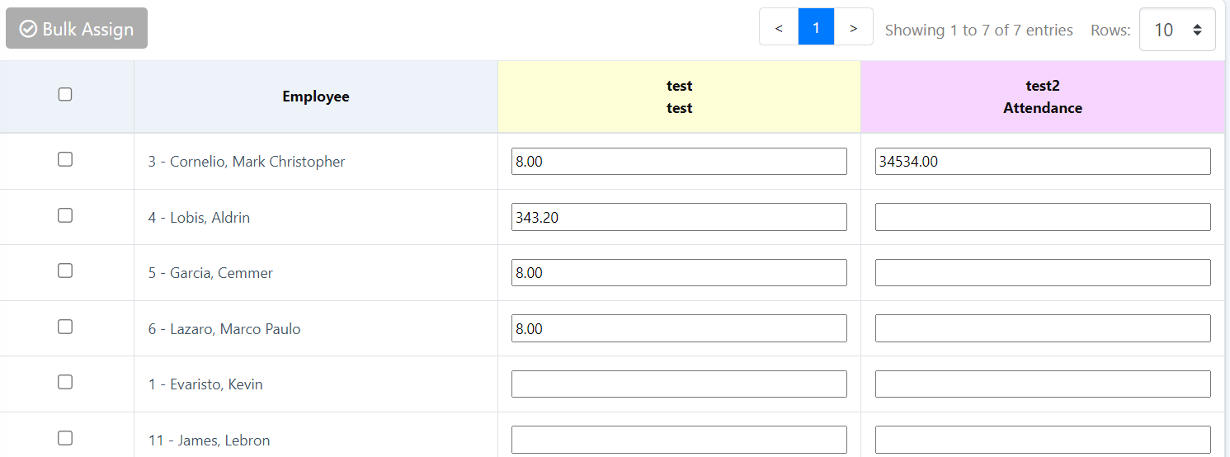

Step 2: Then press “Enter”. The value should be saved and able see value you have entered.

How to assign Non-taxable Deduction to employees in bulk?

Step 1: Mark the checkbox of the employee on the left side of the table.

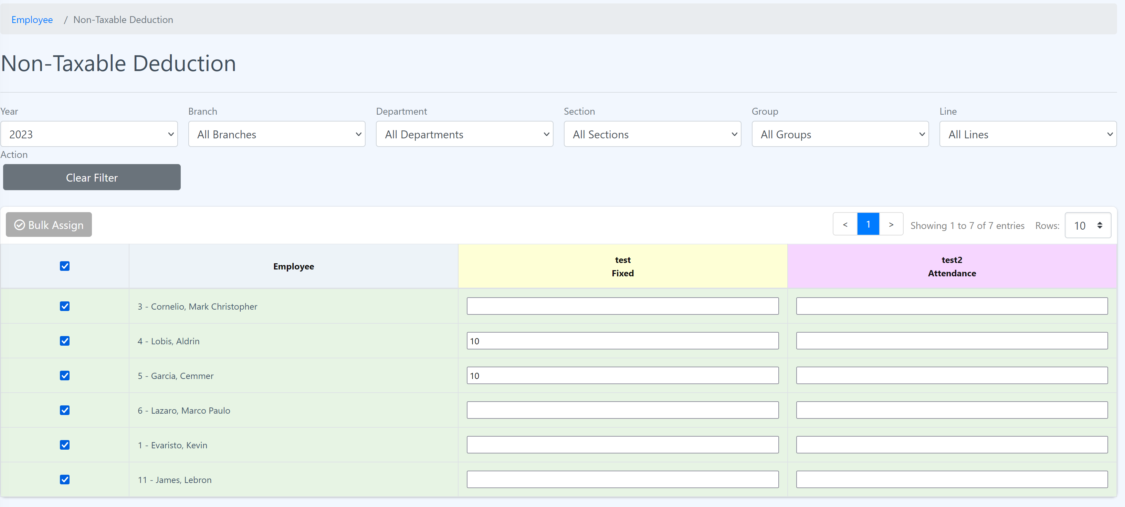

Step 2: Click “Bulk Assign”. The popup will show.



Step 3: Choose the taxable allowance and enter the value and click “Save”.

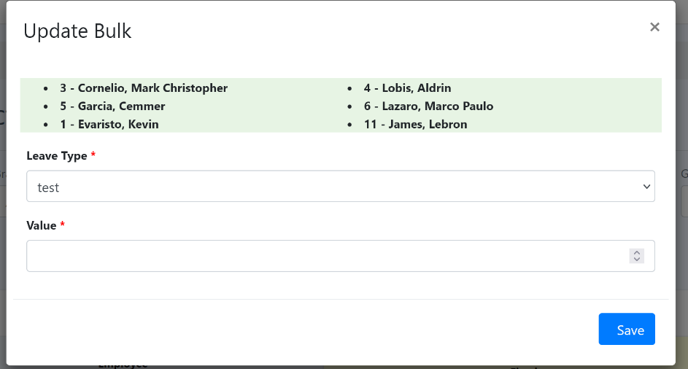

4.6 Skill Assignment

In Eyebox HRMS (Human Resource Management System), the skill assignment feature allows organizations to manage and track the skills possessed by employees. Skill assignment enables the HR department to maintain a comprehensive database of employee skills, which can be used for various purposes such as talent management, training and development, project staffing, and performance evaluations. Here's an explanation of how the HRMS handles skill assignment:

1. Skill Database: The HRMS includes a skill database or skill library where a wide range of skills can be defined and categorized. These skills can cover technical expertise, professional qualifications, soft skills, languages, certifications, and any other relevant competencies.

2. Employee Skill Profiles: Each employee within the HRMS has a dedicated skill profile where their skills and proficiency levels can be recorded. HR personnel or employees themselves can update and manage their skill profiles based on their qualifications, experiences, and acquired expertise.

3. Skill Assignment: HR administrators or managers can assign skills to employees within their profiles or through a centralized skill management interface in the HRMS. They can specify the skill, proficiency level, and any additional details or certifications related to that skill.

4. Skill Search and Matching: The HRMS typically includes a search functionality that allows users to search for employees based on specific skills. This feature helps identify employees with expertise for project assignments, skill gap analysis, succession planning, or other talent management initiatives.

5. Training and Development: The HRMS can integrate with the learning management system (LMS) or training modules to identify skill gaps and recommend relevant training programs for employees. Skill assignments can serve as a basis for designing personalized development plans and tracking progress in acquiring new skills.

6. Reporting and Analysis: The HRMS generates reports or provides data exports that summarize the skills possessed by employees across the organization. This information can be used for strategic workforce planning, identifying skill shortages, and assessing the overall skill composition of the workforce.

By utilizing the skill assignment feature in Eyebox HRMS, organizations can effectively manage and leverage the skills of their employees. It enables efficient talent management, targeted training and development, and improved workforce planning by harnessing the skills and capabilities of the workforce more strategically.

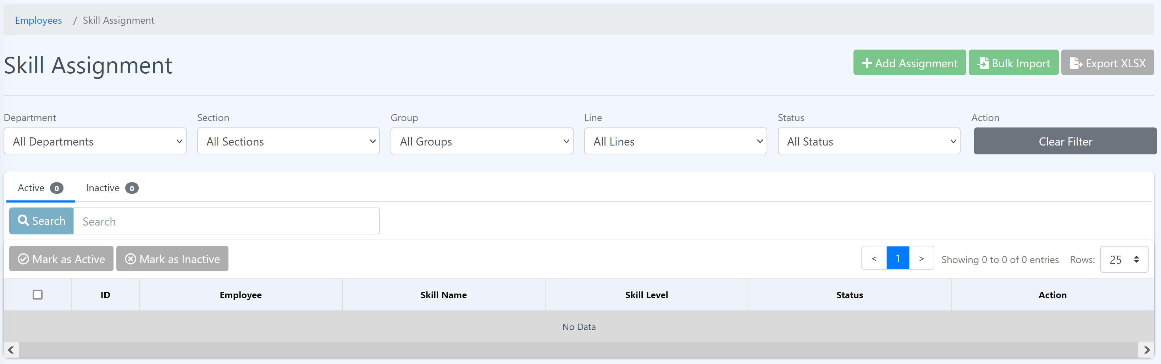

**Add Skill Assignment**

**Procedure:**

Step 1: In “Skill Assignment” click “Add Assignment” button at the upper right corner of the page.



Step 2: Fill the form and click “Submit”

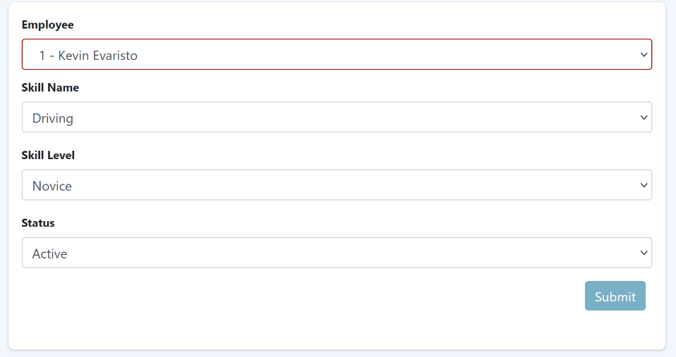

**Bulk import**

**Procedure:**

Step 1: In “Skill Assignment” click “Bulk Import” button at the upper right corner of the page.

Step 2: Follow the step given before uploading the CSV.

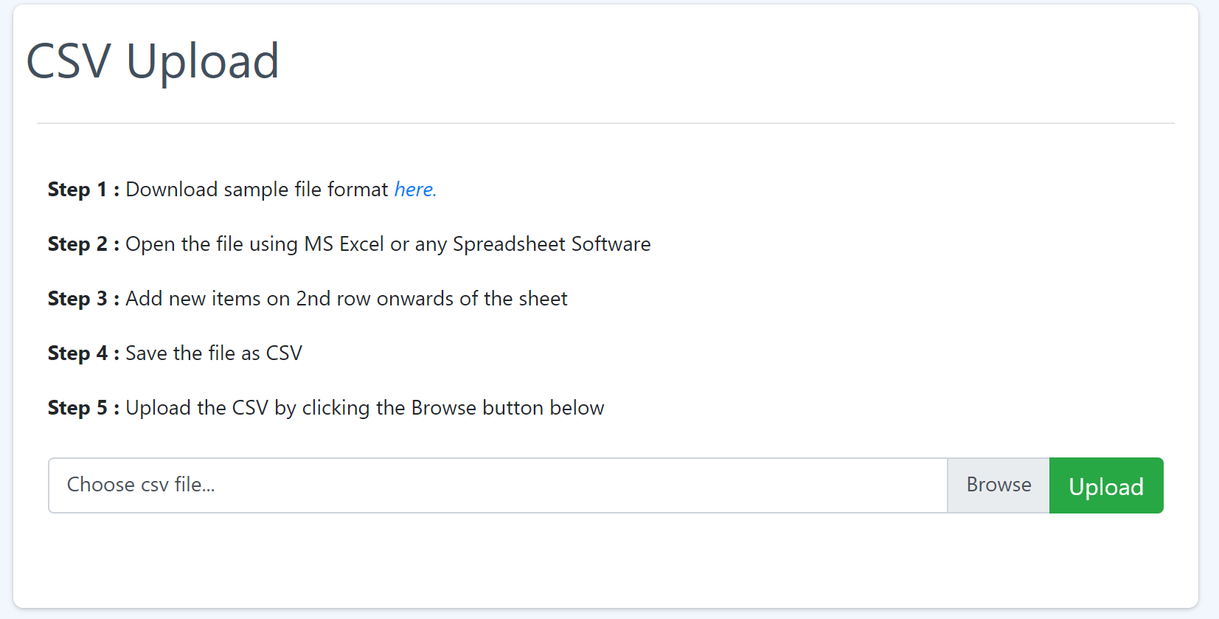

4.6 Salary Details

In Eyebox HRMS (Human Resource Management System), the salary details feature allows organizations to manage and maintain comprehensive information about employee compensation. The salary details section in an HRMS provides a centralized location to record and track various components of an employee's salary. Here's an explanation of how the HRMS handles salary details:

1. Basic Salary: The HRMS captures the employee's basic salary, which is the fixed component of their compensation that is agreed upon and documented in their employment contract.

2. Pay Frequency: The HRMS captures the frequency at which employees are paid, such as monthly, bi-weekly, or weekly, and ensures accurate calculation of salary amounts based on the designated pay period.

3. Reports and Analytics: The HRMS generates reports and provides analytics on salary details, including summaries of salary components, total compensation, salary distribution by department or job level, and other relevant metrics.

By utilizing the salary details feature in Eyebox HRMS, organizations can effectively manage and track employee compensation, ensure compliance with regulatory requirements, facilitate payroll processing, and gain insights into salary-related metrics for analysis and decision-making purposes.

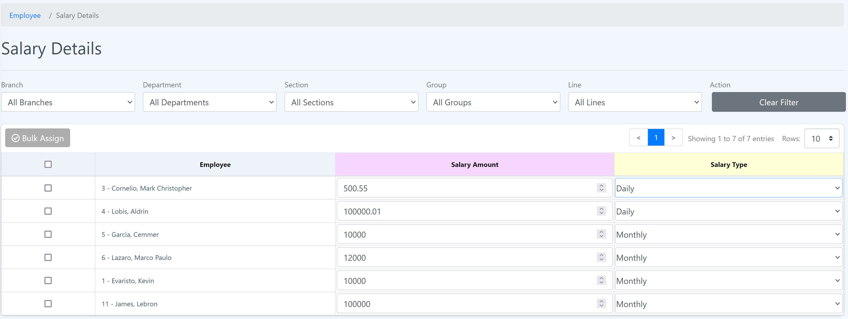

**Assign Salary to employee**

Step 1: Enter the value of salary in the input box and choose the salary type.



**Assign salary to employees in bulk**

**Procedure:**

Step 1: Mark the checkbox of the employee on the left side of the table.



Step 2: Click “Bulk Assign”. The popup will show.

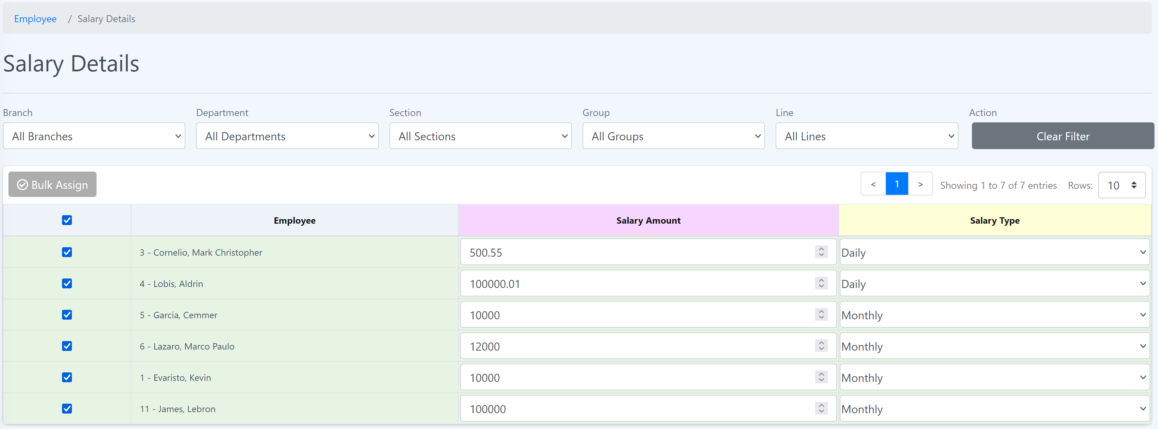

Step 3: Choose the salary type and enter the salary amount and click “Update”.

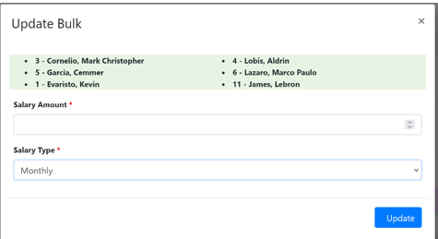

5 HR Essentials

The HRMS (Human Resource Management System) provides a range of essential HR functionalities to help streamline and automate HR processes. Here are some key HR essentials you can access through the HRMS:

* + 1. HR Dashboard
    2. Announcement
    3. Warnings
    4. Support
    5. Complaint
    6. Survey
    7. Knowledge Base
    8. Policies
    9. About the Company

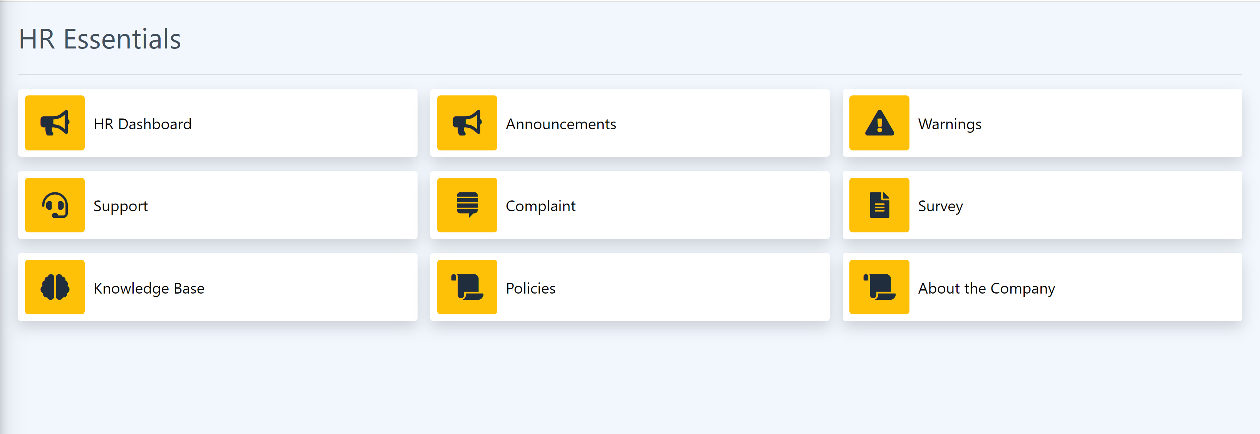

5.1 HR Dashboard

The Eyebox HRMS (Human Resource Management System) often includes an HR dashboard that provides HR professionals with an overview of key HR metrics, insights, and tools to effectively manage HR processes. Here are the features of the Eyebox Dashboard:

1. Total number of employees within the company.

2. Total of newly hired and resigned employees.

3. Total number of employees with no skills, education and dependents.

4. Employee age report, salary, allowance, employee per department chart and years of service chart.

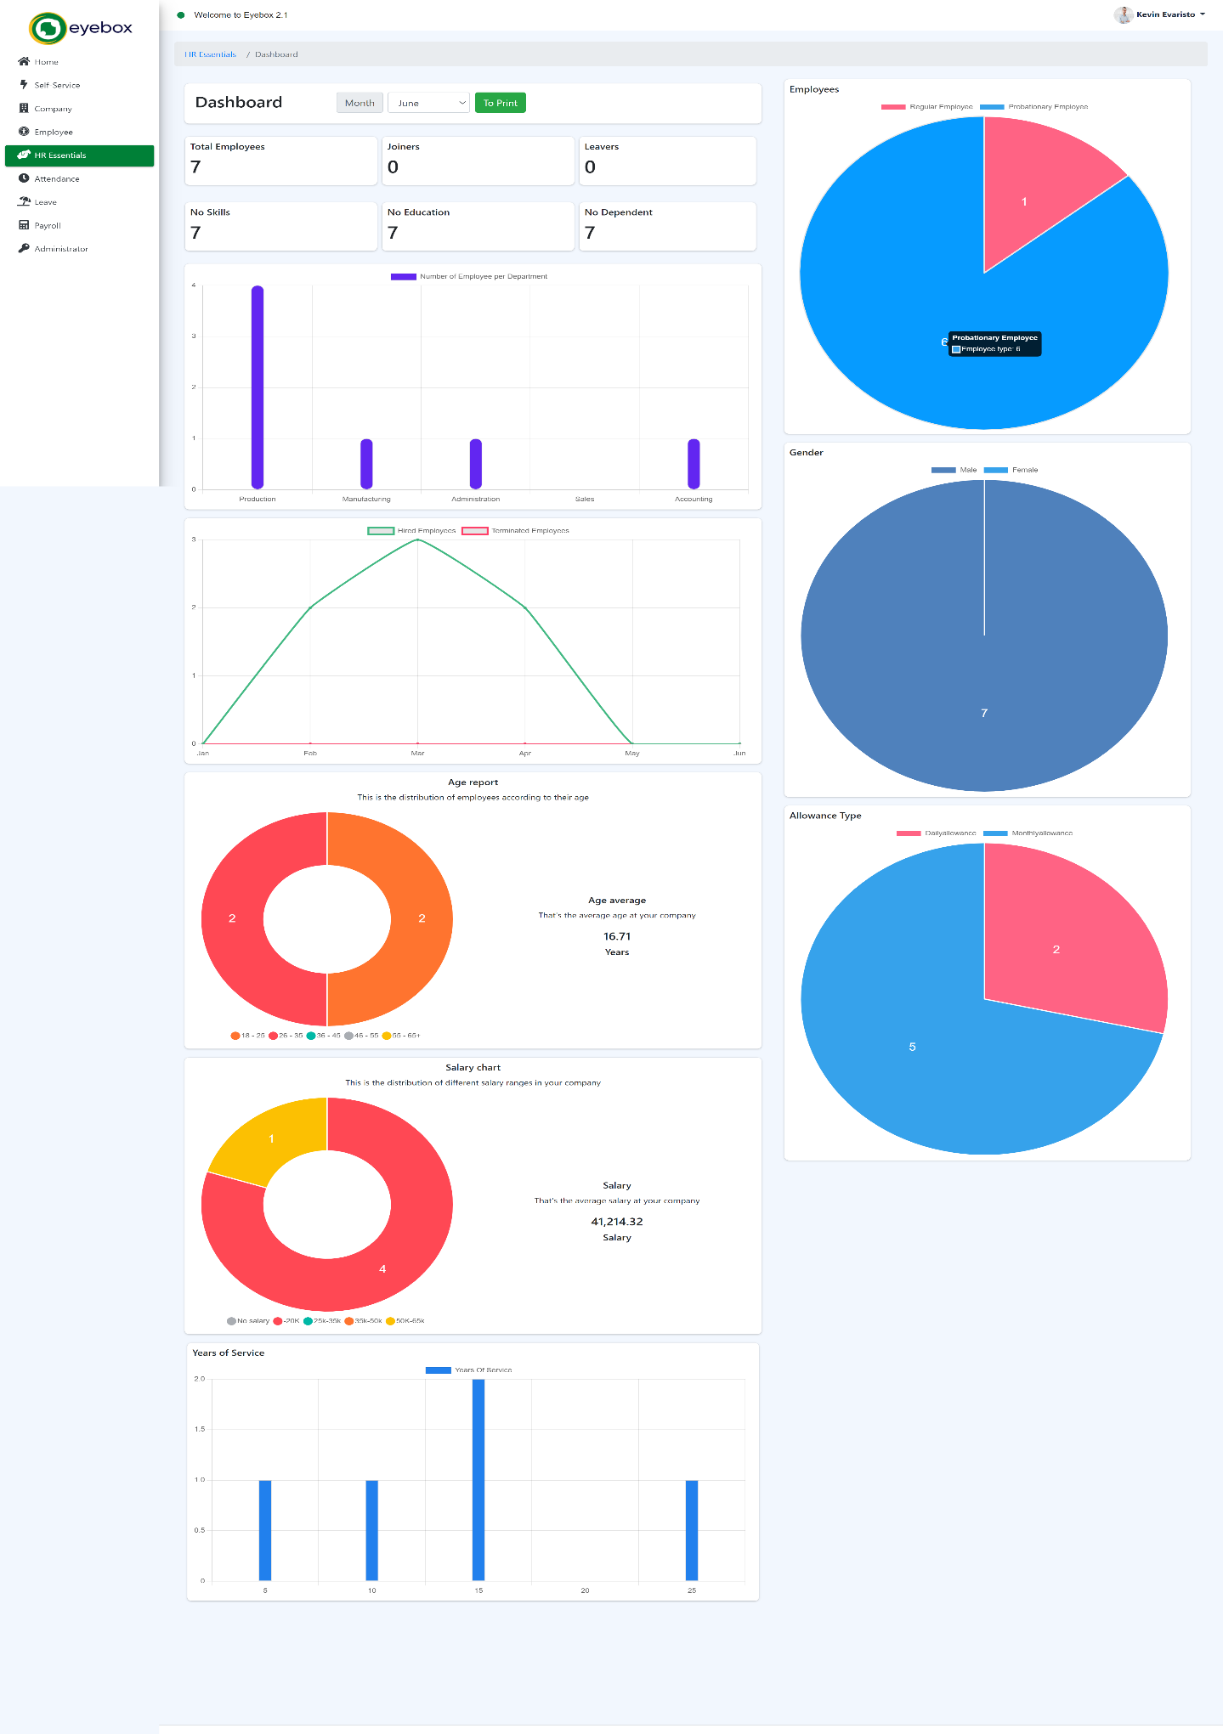

5.2 Announcements

The Eyebox HRMS (Human Resource Management System) includes an announcement feature that allows HR departments or administrators to communicate important information and updates to employees.

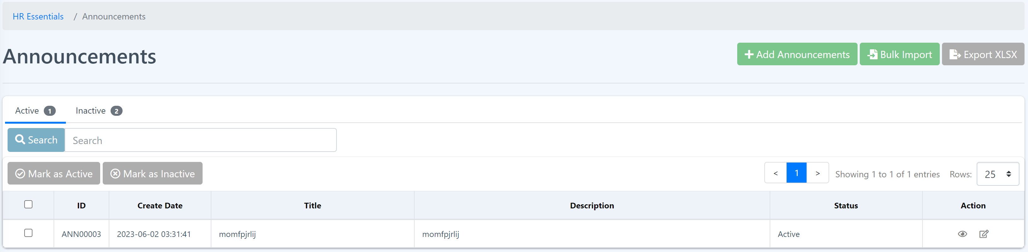

The announcement feature within the Eyebox HRMS enables HR departments to effectively communicate important information to employees. Stay updated on the latest announcements and ensure that you read and understand the information shared. Utilize the announcement feature to share relevant information, keep employees informed, and maintain effective communication within the organization.

**Adding Announcement**

**Procedure:**

**Step 1:** In the “Announcements” page, look for “Add Announcement” button and click the button.



**Step 2: Fill in** the form and attach a file if need. Then click the “Submit” button. The page will redirect you to the Announcement page.

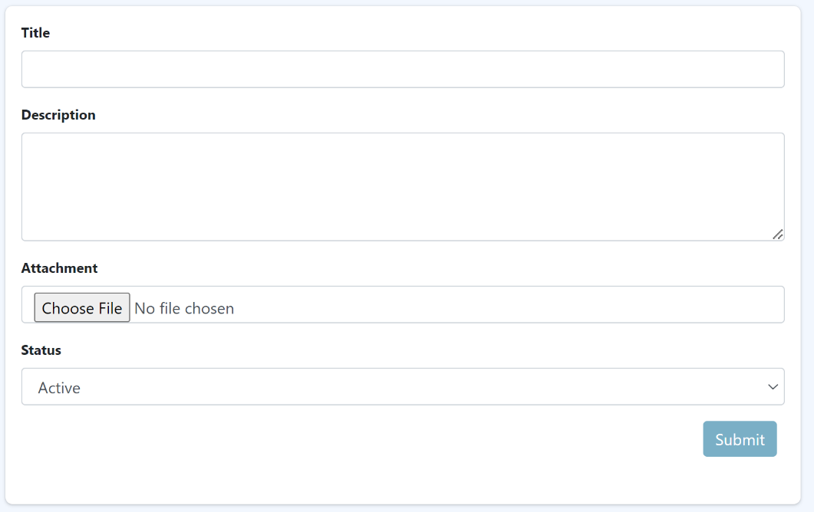

**Bulk Importing**

**Procedure:**

**Step 1**: In the “Announcements” page, look for “Bulk Import” button and click the button.



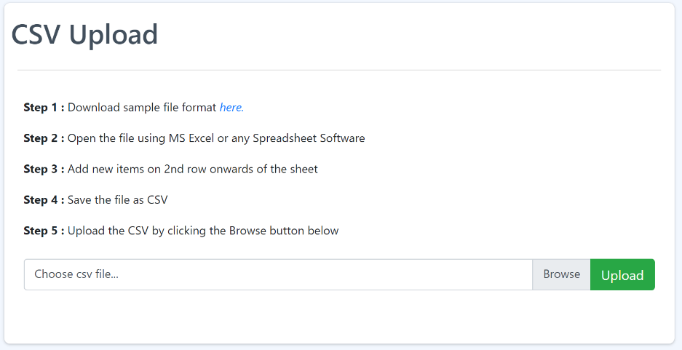**Step 2**: Follow the instructions. Before uploading.

**Step 3**: Click the “Upload” button.



**Viewing the announcement**

**Procedure:**

**Step 1:** At the action section, click the “eye” icon. You should be able to see the announcement details.



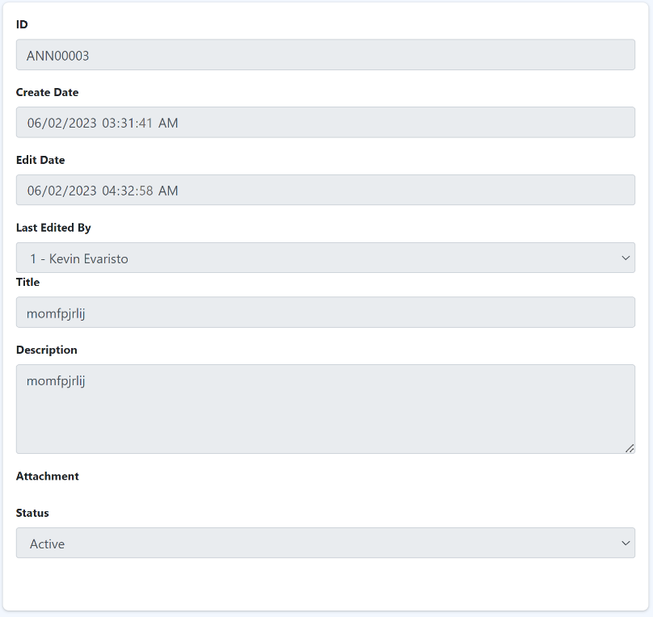

**Editing Announcement**

**Procedure:**

**Step 1:** At the action section, click the “edit” icon. You should be able to see and edit the announcement details.



**Step 2:** Edit the announcement according to your needs and click the “Submit” button to save the changes.

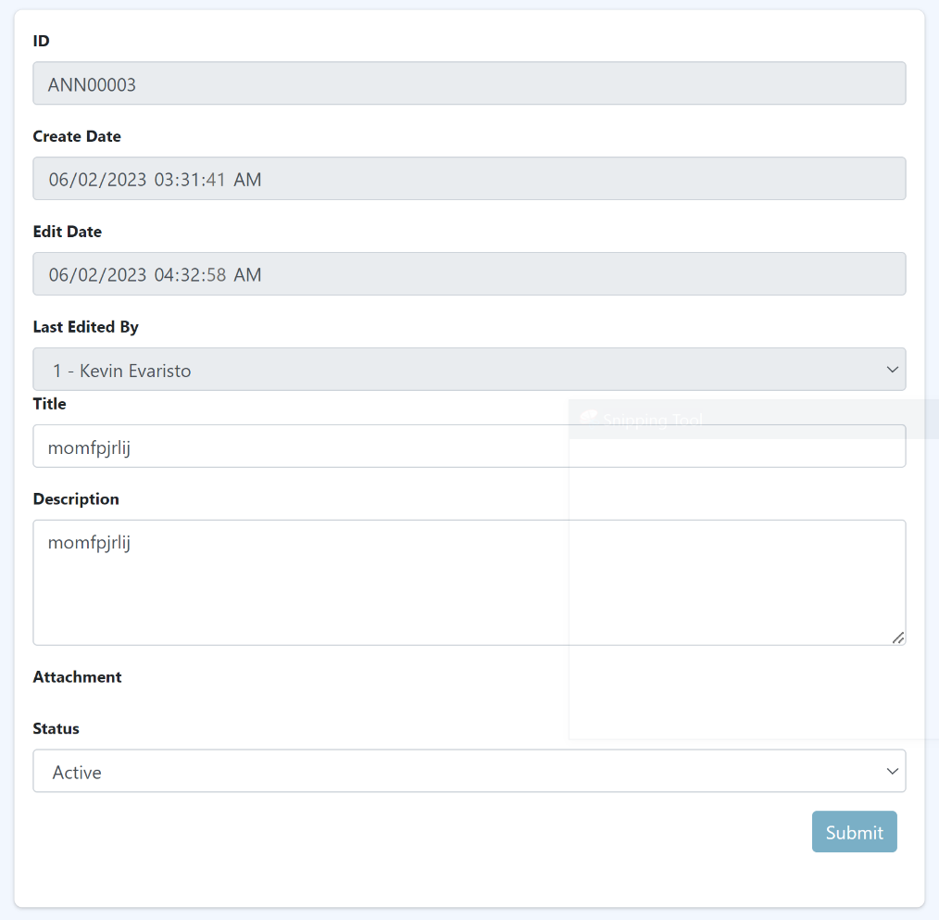

**Bulk marking “Active” or “Inactive” on announcements**

**Procedure:**

**Step 1**: Click the checkbox to select the announcement you want to mark as “active” or “inactive”. Or you can select all by clicking the checkbox of the very first row of the table beside the “ID”.

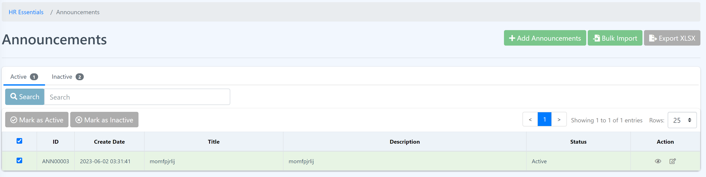

**Step 2**: Now, you can mark “active” or “inactive the announcement by clicking the buttons at the top of the table.



**Step 3:** Click the “Submit” button to save the changes.

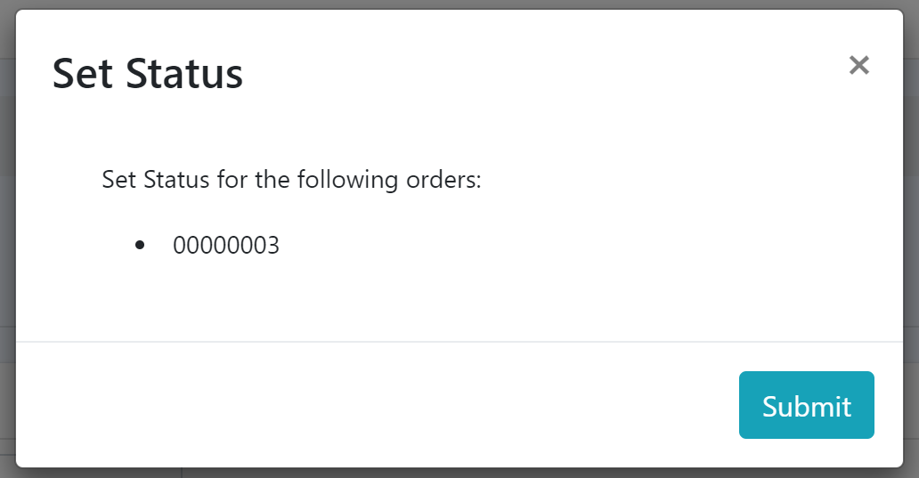

5.3 Warnings

Warnings serve to document and address concerns, providing employees with an opportunity to improve their performance or rectify their behavior.

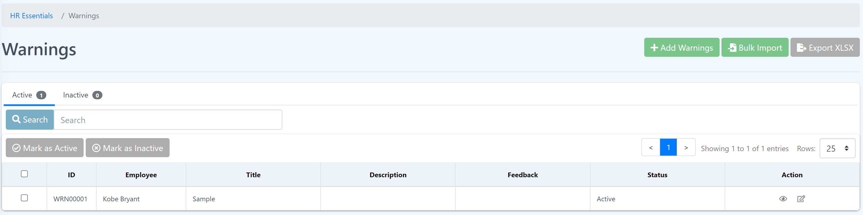

Eyebox HRMS includes features to manage employee records, performance evaluations, and disciplinary actions. These systems help streamline the process of issuing warnings and tracking them for future reference. Here's a general overview of how warnings are handled within an HRMS or HR essentials software:

* + - * 1. **Recording the warning**: HRMS platforms usually have a module or section dedicated to managing employee records. HR professionals can access this module to record the details of the warning, including the date, nature of the violation, and any specific incidents or evidence supporting the warning.
        2. **Notification**: Once a warning is recorded, the HRMS system can generate automated notifications to inform the employee about the warning. These notifications can be in the form of emails, system-generated messages, or alerts within the HRMS platform. The warning should clearly outline the concern, the expected improvements, and any potential consequences if the behavior or performance does not improve.

1. **Documentation**: HRMS software enables HR professionals to store and maintain a centralized database of employee records, including warnings. The system typically allows for attaching relevant documents, such as written warnings or performance improvement plans, to the employee's record. This documentation serves as evidence in case further disciplinary actions are required in the future.
2. **Follow-up and monitoring**: The HRMS system can facilitate the monitoring of the employee's progress after receiving a warning. It may include features for setting reminders to follow up on the issue, scheduling progress reviews, and tracking any additional incidents related to the initial warning.
3. **Escalation and further actions:** If the employee fail to improve or continues to violate policies despite the warning, the HRMS software can support the escalation process. It may include features for initiating further disciplinary actions, such as suspensions or terminations, and maintaining a comprehensive record of the entire disciplinary process.

It's important to note that the specific functionalities and workflows related to warnings can vary across different HRMS or HR essentials software solutions. Organizations may customize these systems to align with their specific policies and procedures for issuing warnings.

**Adding Warning**

**Procedure:**

**Step 1:** In the “Warnings” page, look for “Add Warnings” button and click the button.

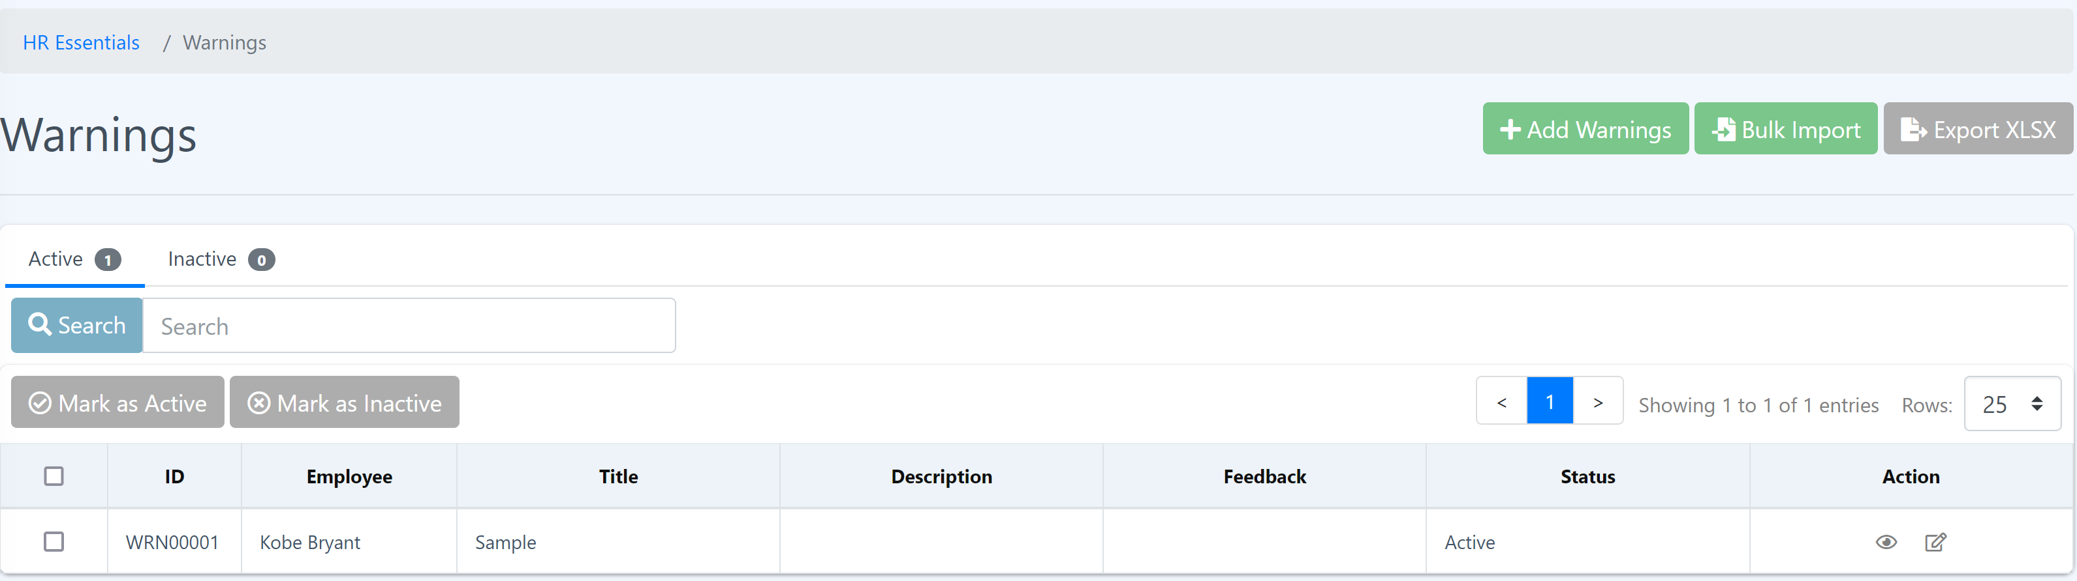

**Step 2: Fill in** the form and attach a file if needed. Then click the “Submit” button. The page will redirect you to the Announcement page.

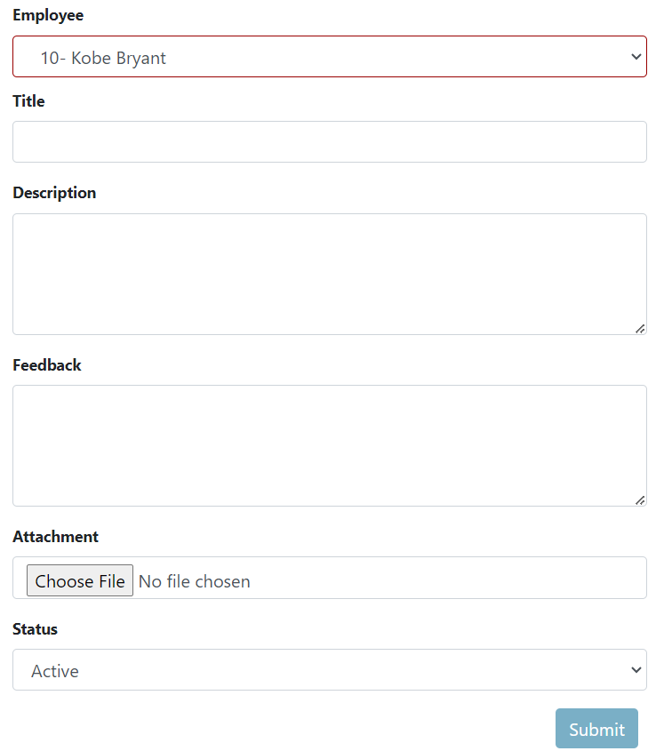

**Warning Bulk Import**

**Procedure:**

**Step 1**: In the “Warnings” page, look for “Bulk Import” button and click the button.

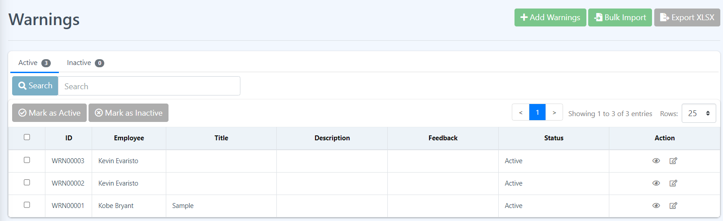

**Step 2**: Follow the instructions. Before uploading.

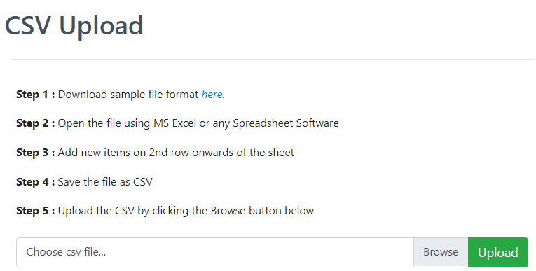

**Viewing the warning details**

**Procedure:**

**Step 1:** At the action section, click the “eye” icon. You should be able to see the warning details.

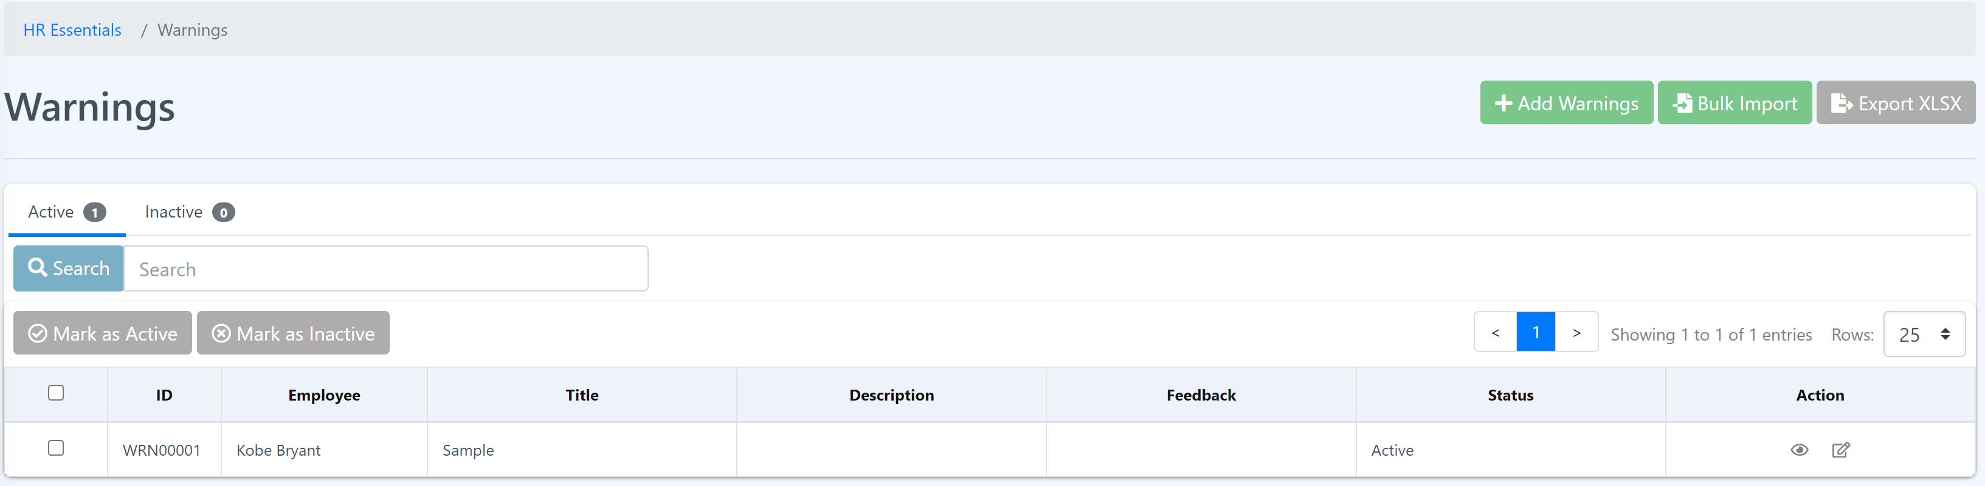

**Editing Announcement**

**Procedure:**

**Step 1:** At the action section, click the “edit” icon. You should be able to see and edit the warning details.



**Step 2:** Edit the warning details according to your needs and click the “Submit” button to save the changes.

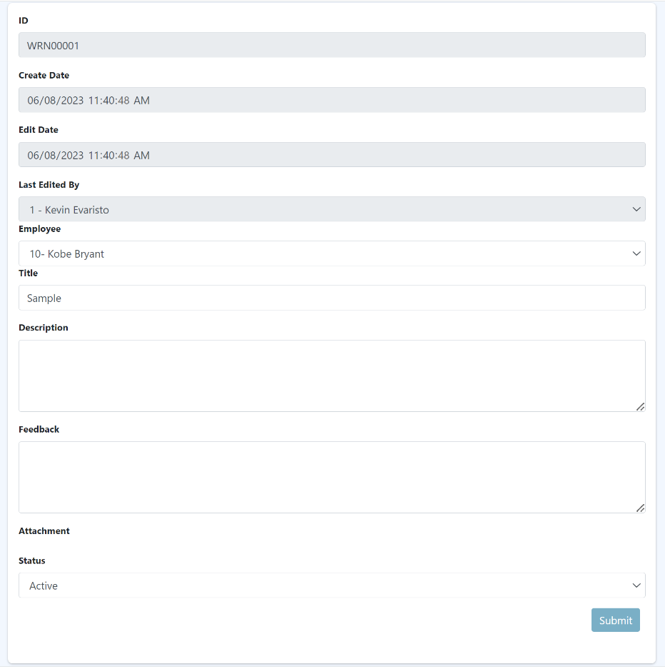

**Bulk marking “Active” or “Inactive” on warnings**

**Procedure:**

**Step 1**: Click the checkbox to select the warnings you want to mark as “active” or “inactive”. Or you can select all by clicking the checkbox of the very first row of the table beside the “ID”.

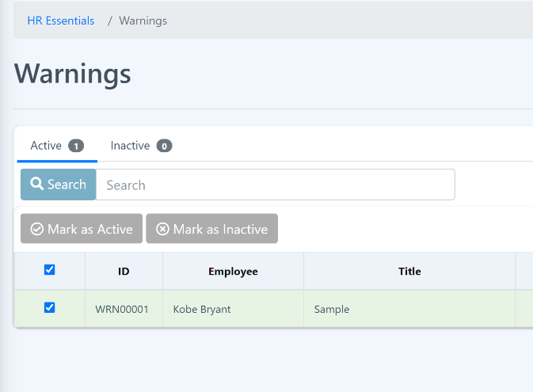

**Step 2**: Now, you can mark “active” or “inactive the warnings by clicking the buttons at the top of the table.

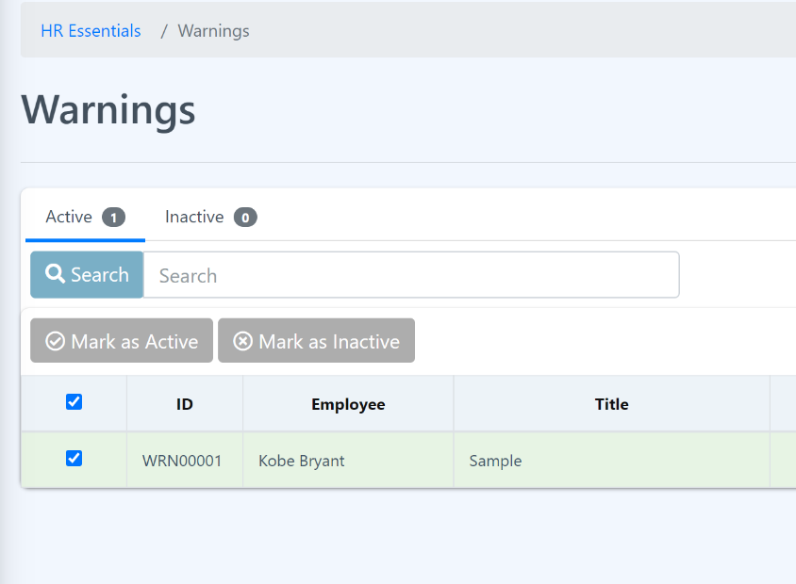

**Step 3:** Click the “Submit” button to save the changes.

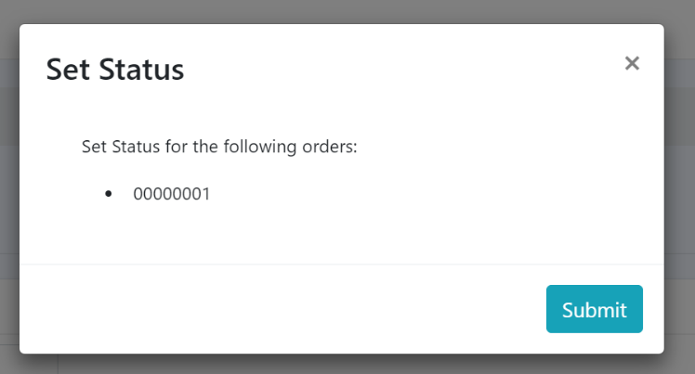

5.4 Supports

Eyebox HRMS (Human Resource Management System), the support is a component or feature within the system that is designed to aid and support HR professionals, managers, and employees. The support module aims to streamline communication, address inquiries, and resolve HR-related issues efficiently. Here are the functionalities and features found in a support module of Eyebox HRMS:

* 1. **Help desk or ticketing system:** The support module includes a help desk or ticketing system that allows users to submit HR-related inquiries, issues, or requests. Users can raise tickets or log their concerns, and the system assigns them unique identifiers for tracking purposes.
  2. **Employee self-service portal:** An employee self-service portal is often part of the support module. It provides employees with a user-friendly interface to access information, submit requests, and find answers to frequently asked questions without relying on HR personnel.
  3. **Communication and notifications:** The support module enables HR personnel to send announcements, notifications, and updates to employees and managers. It helps disseminate important information, such as policy changes, upcoming events, or HR-related news, ensuring effective communication across the organization.

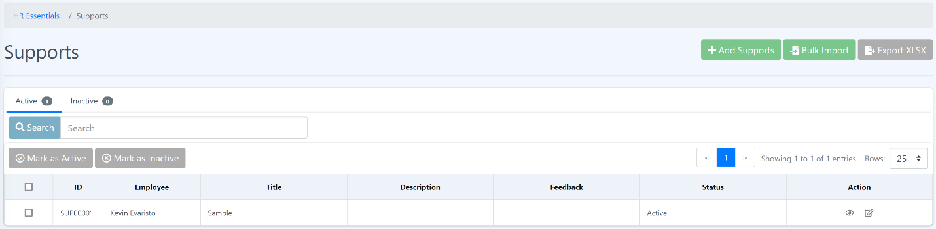

The support module in Eyebox HRMS plays a crucial role in streamlining HR operations, improving user experience, and enhancing communication between HR personnel, managers, and employees. It ensures that HR-related inquiries or issues are efficiently addressed, promoting a positive employee experience and effective HR service delivery.

**Adding Support**

**Procedure:**

**Step 1:** In the “Supports” page, look for “Add Supports” button and click the button.

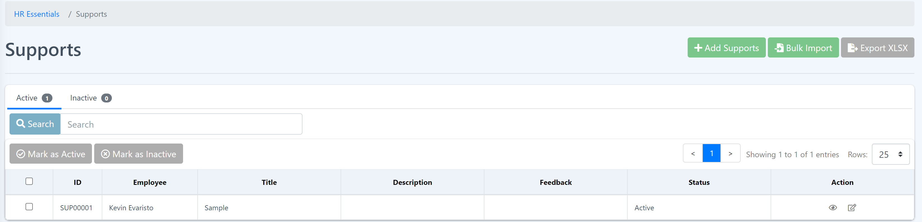

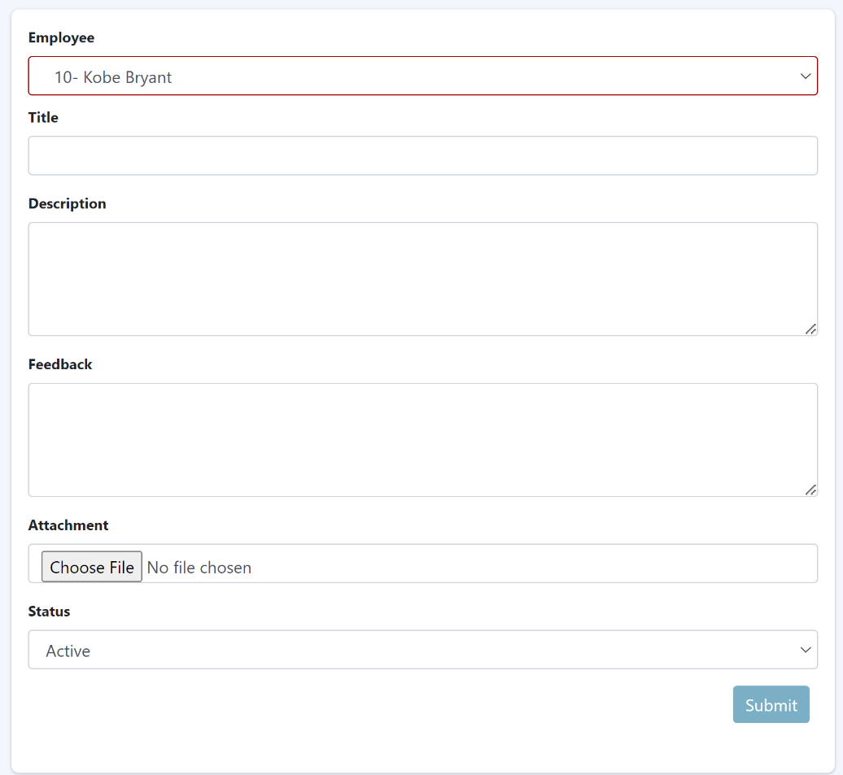**Step 2: Fill in** the form and attach a file if needed. Then click the “Submit” button. The page will redirect you to the Announcement page.

**Support Bulk Import**

**Procedure:**

**Step 1**: In the “Supports” page, look for “Bulk Import” button and click the button.



**Step 2**: Follow the instructions. Before uploading.

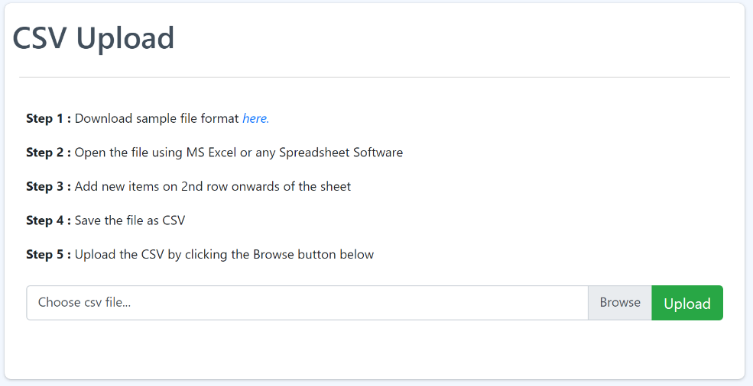

**Step 3**: Click the “Upload” button.

**Viewing the support details**

**Procedure:**

**Step 1:** At the action section, click the “eye” icon. You should be able to see the support details.



**Editing Announcement**

**Procedure:**

**Step 1:** At the action section, click the “edit” icon. You should be able to see and edit the warning details.



**Step 2:** Edit the warning details according to your needs and click the “Submit” button to save the changes.

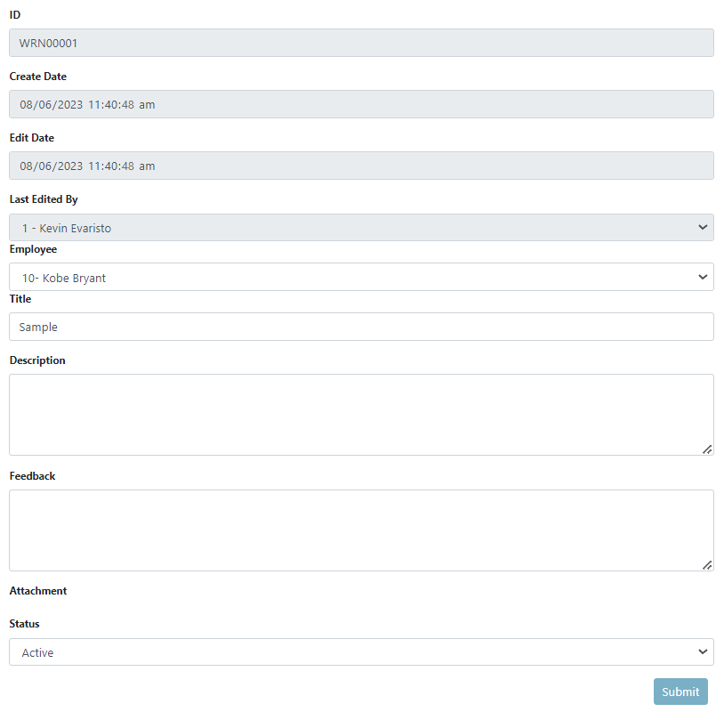

**Bulk marking “Active” or “Inactive” on warnings**

**Procedure:**

**Step 1**: Click the checkbox to select the warnings you want to mark as “active” or “inactive”. Or you can select all by clicking the checkbox of the very first row of the table beside the “ID”.

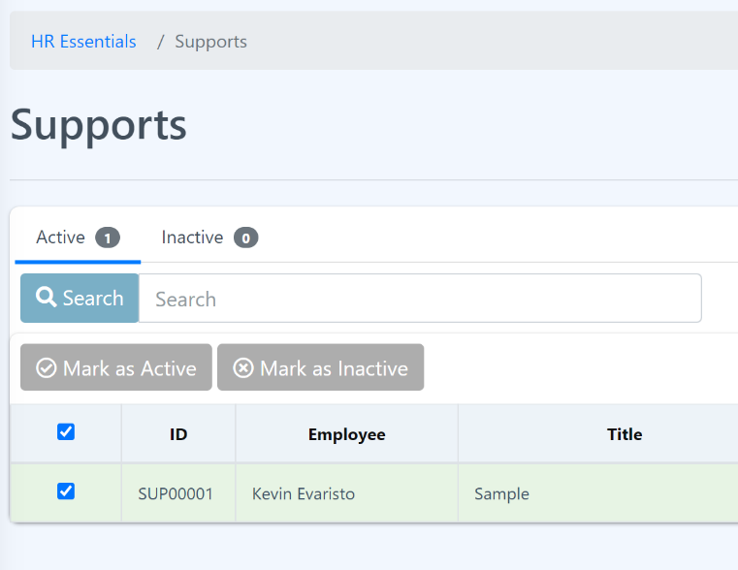

**Step 2**: Now, you can mark “active” or “inactive the support by clicking the buttons at the top of the table.

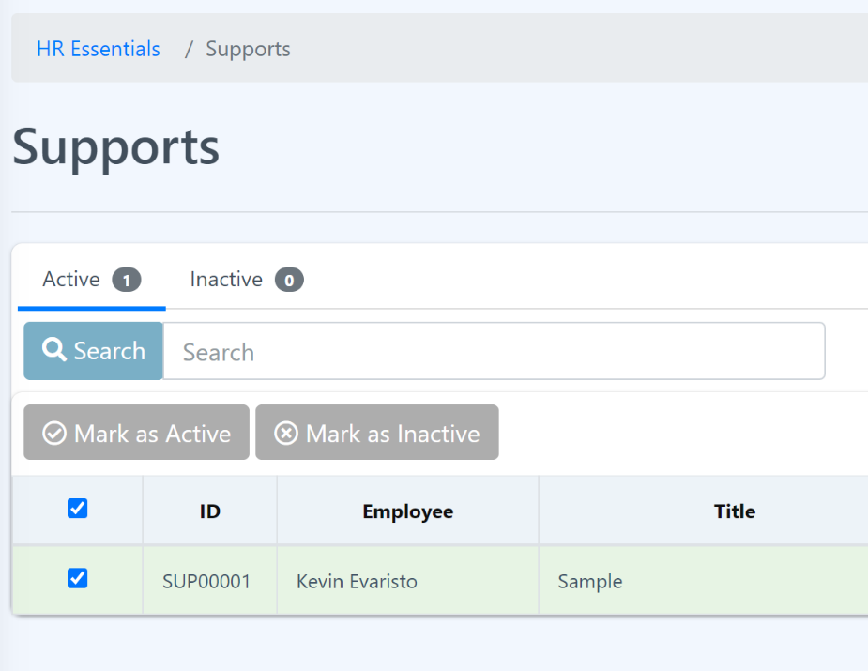

**Step 3:** Click the “Submit” button to save the changes.



5.5 Complaints

The complaint module within Eyebox HRMS (Human Resource Management System) refers to a component or feature that helps manage and address employee complaints or grievances. It provides a structured process for employees to report concerns, allows HR personnel to investigate and resolve complaints, and maintains a record of complaint-related information. Here are the key functionalities and features commonly found in a complaint module of Eyebox HRMS:

* + 1. **Complaint submission:** The module enables employees to submit complaints or grievances electronically through a user-friendly interface. Employees can describe the nature of the complaint, provide relevant details, and attach supporting documents or evidence.
    2. **Case tracking and management:** The complaint module facilitates the tracking and management of complaints throughout the resolution process. HR personnel can assign case numbers, categorize complaints, assign investigators or responsible parties, and monitor the progress of each case.

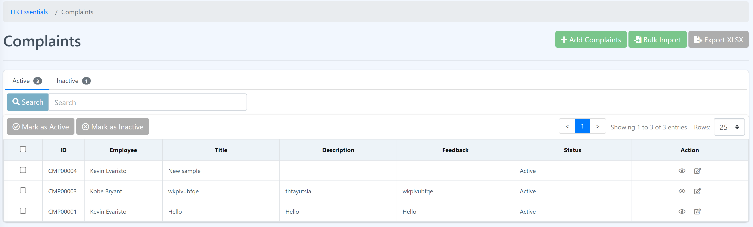

The complaint module in Eyebox HRMS helps organizations establish a structured and consistent process for managing employee complaints or grievances. It promotes transparency, fairness, and accountability in addressing employee concerns, fostering a positive and inclusive work environment.

**Adding Complaint**

**Procedure:**

**Step 1:** In the “Complaints” page, look for “Add Complaints” button and click the button.



**Step 2: Fill in** the form and attach a file if needed. Then click the “Submit” button. The page will redirect you to the Complaints page.

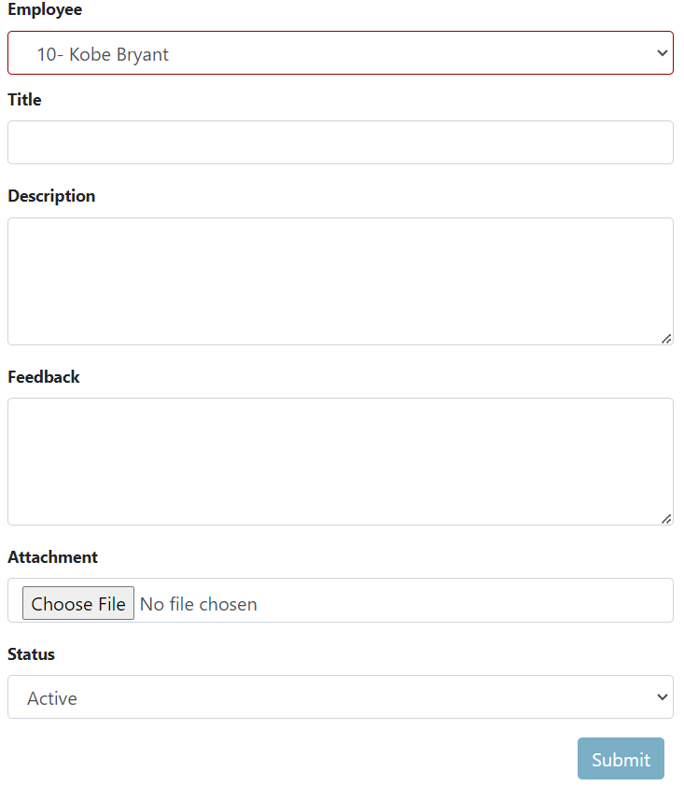

**Support Bulk Import**

**Procedure:**

**Step 1**: In the “Supports” page, look for “Bulk Import” button and click the button.



**Step 2**: Follow the instructions. Before uploading.

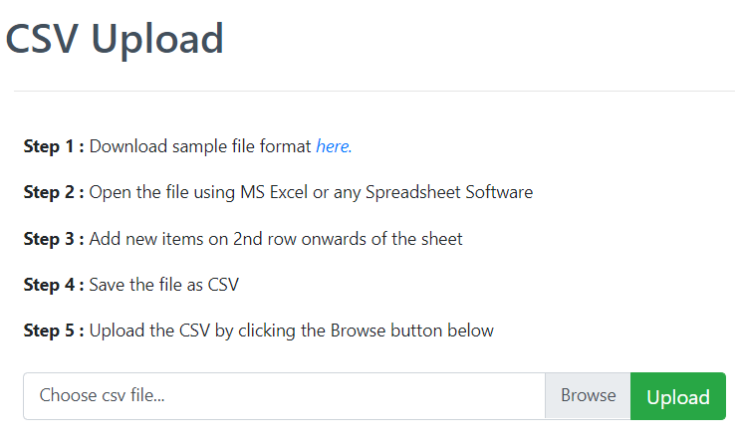

**Viewing the complaint details**

**Procedure:**

**Step 1:** At the action section, click the “eye” icon. You should be able to see the support details.



**Editing complaints**

**Procedure:**

**Step 1:** At the action section, click the “edit” icon. You should be able to see and edit the warning details. 

**Step 2:** Edit the warning details according to your needs and click the “Submit” button to save the changes.

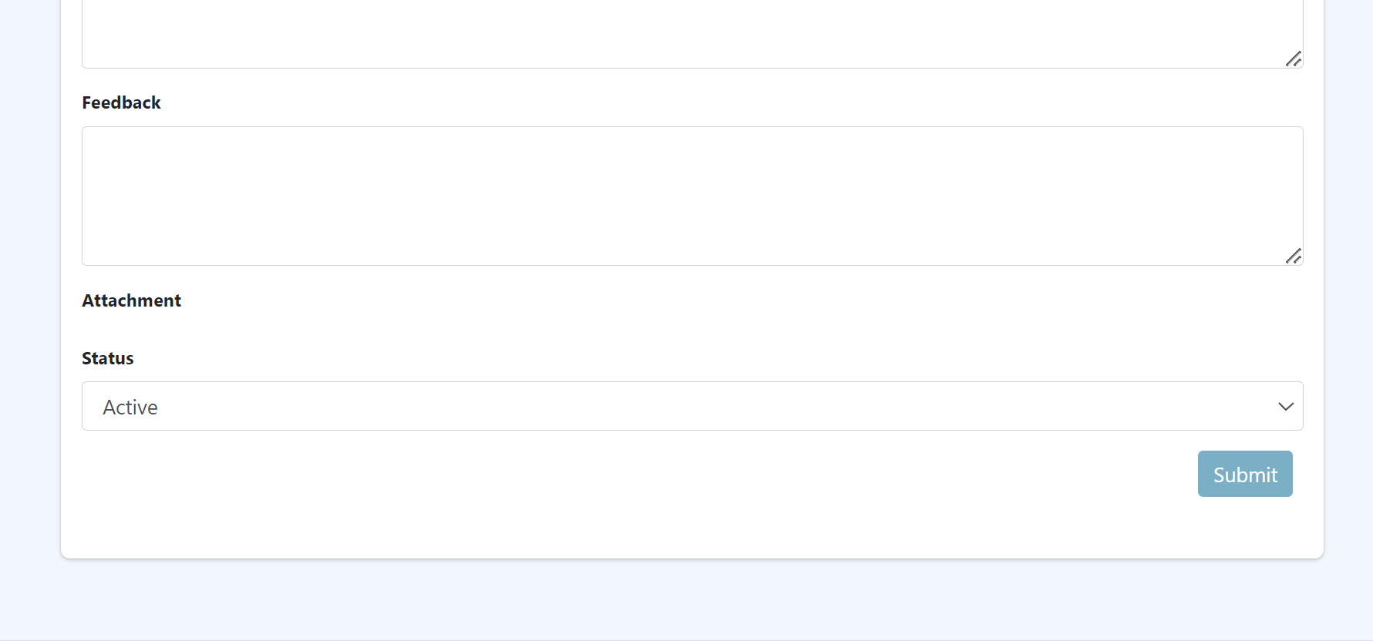

**Bulk marking “Active” or “Inactive” on complaints**

**Procedure:**

**Step 1**: Click the checkbox to select the warnings you want to mark as “active” or “inactive”. Or you can select all by clicking the checkbox of the very first row of the table beside the “ID”.

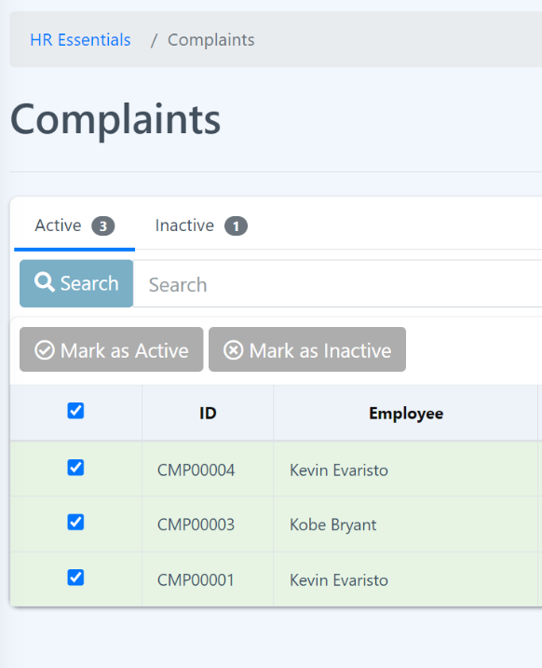

**Step 2**: Now, you can mark “active” or “inactive the complaints by clicking the buttons at the top of the table.

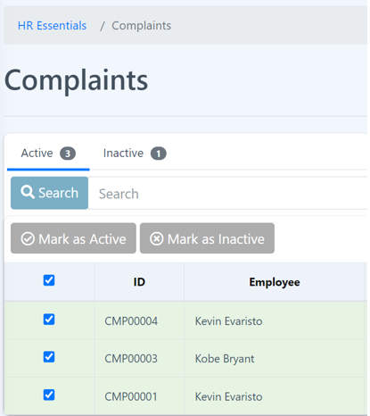

**Step 3:** Click the “Submit” button to save the changes.



5.6 Survey

Welcome to Survey page! In this page the HR can manage the overall of the implemented surveys. The HR can add a new survey and insert the overall feedback of the survey. All active and inactive can be seen on this page.

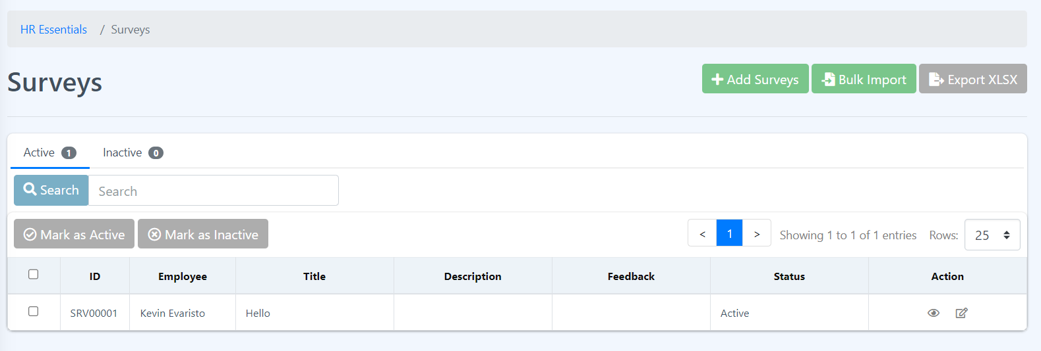

How to Add a new Survey?

Only authorized user can add a survey such as the human resource staffs, the Employee column shows the employee that added the survey while the Title column contains the subject of the survey, and the Description relays a more detailed information about the survey. The feedback column relays the overall result of the given survey. Steps on how to add are as follows:

1. Click the Add survey button.



1. Fill all the required fields. If the survey has yet to be concluded or the overall result are yet to be determined, you can just leave it blank and edit it when the results are out.

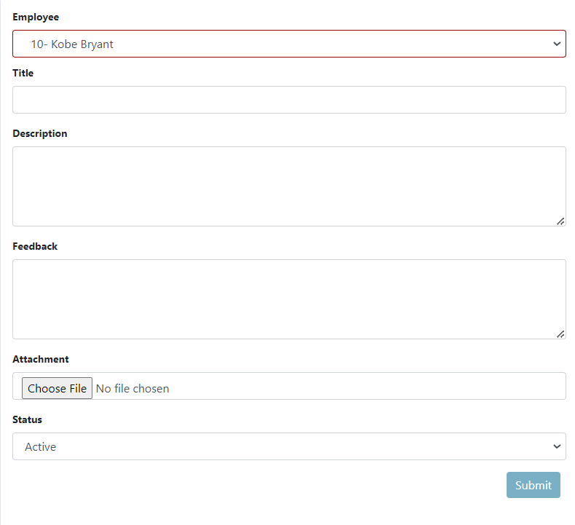

1. Click the submit button as marked in the image above and click Ok when the success message is displayed.

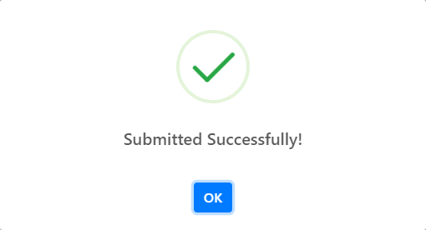

**How to import surveys in bulk?**

This feature allows the user to import surveys in bulk mode to save time and effort. This allows more efficient transfer of data. Remember that the data should follow the format to enable a seamless process to import the data.

1. Click the Bulk Import button.



1. Follow the given set of instructions.

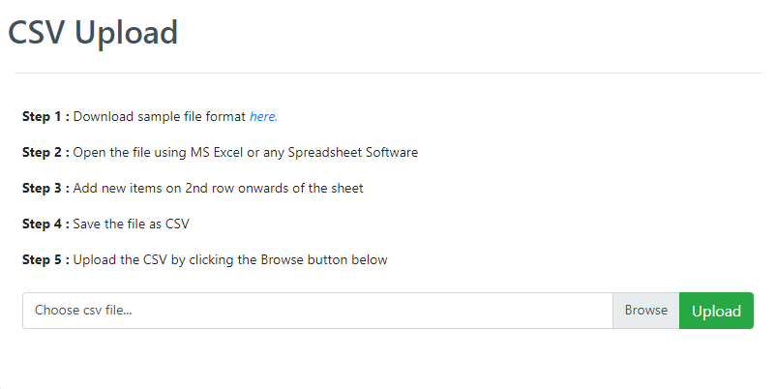

How to export the surveys?

This feature allows the user to download the surveys list. To export the survey just click the Export XLSX button. This will directly download the list of the surveys.



How to change the status of a single or multiple surveys?

Changing the status of a given surveys will determine if the survey is still active or inactive.

1. Select rows to change status by clicking the checkbox beside the row. If all the list are to be changes then click the checkbox in line with the table header.

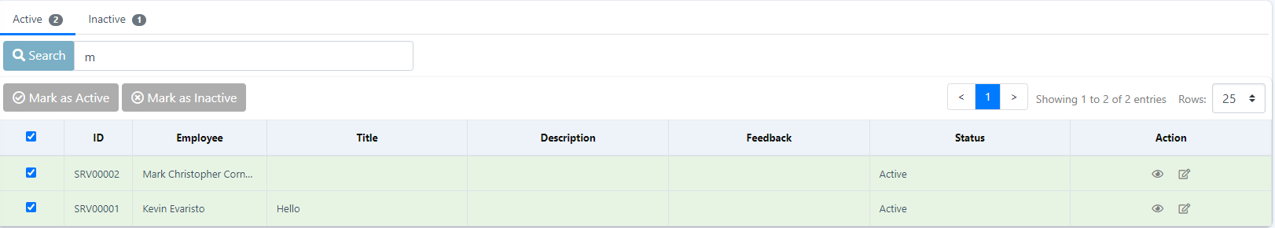

1. Since by default the table shows the active surveys so click the Mark as Inactive button to change its status.



1. A confirmation box will appear then click the Submit button.

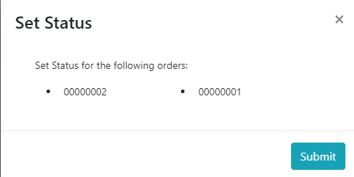

1. Click Ok to affirm that the process is successful.
2. To change the status of the inactive surveys, just click the Inactive tab and repeat the steps.



**How to get more details about a particular survey?**

This feature allows the user to view more about the survey, information such as attachments, create date and if the survey is edited by whom and when. To view more details about the survey just click the eye icon on the row of the survey you want to see more details about and it will show you more details about the survey.



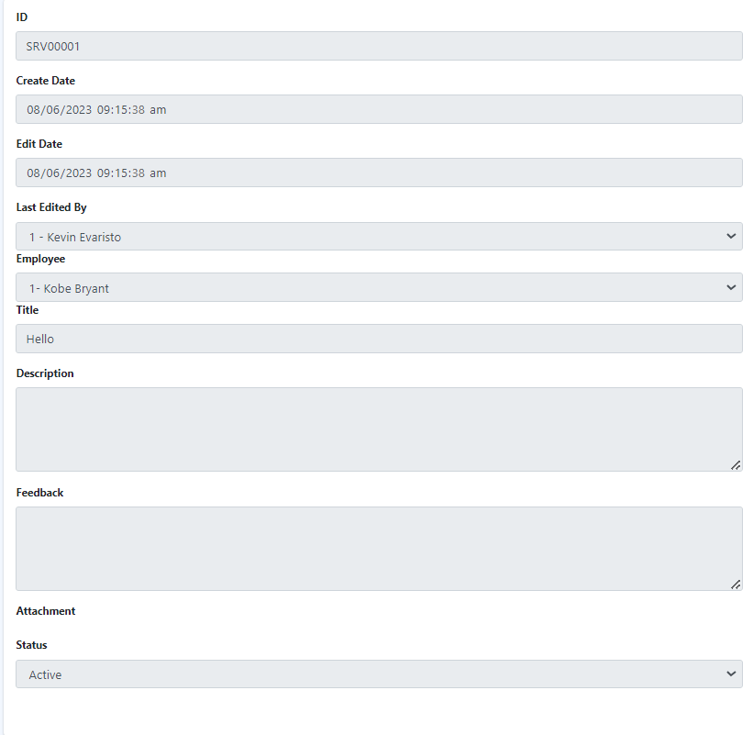

**How to edit a survey?**

If a survey needs to be updated, editing the survey is appropriate. This feature allows the user to make changes to a survey to make it up to date.

1. Click the edit icon beside the eye icon on the row to edit, no need to check the checkbox.

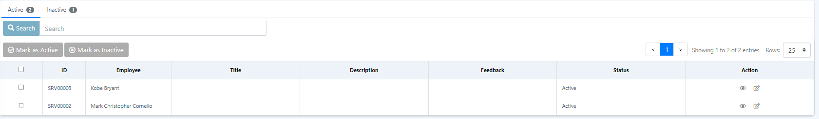

1. Fill all the required fields and click submit to update the survey.

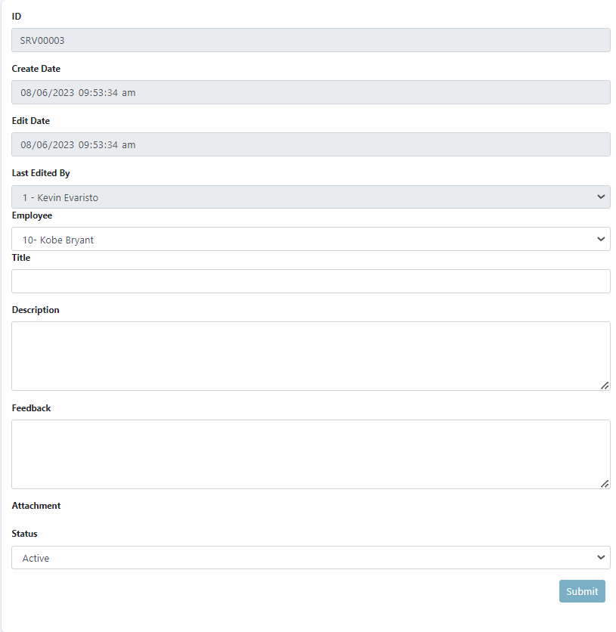

1. Click ok after a success message pops up.

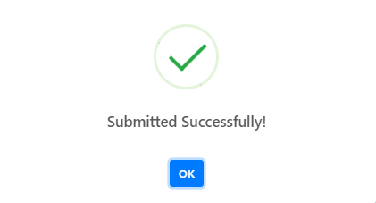

5.7 ­Knowledge Bases

The knowledge base page shows all the list of knowledge bases about the company. Only the HR can add or update the content of the page.

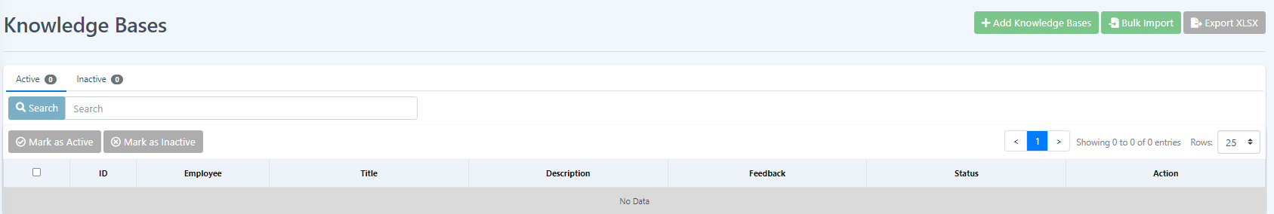

How to Add new Knowledge Base?

To add a new knowledge base please follow the given instructions.

1. Click the Add Knowledge Bases button.



1. Fill all the required fields and click submit.
2. 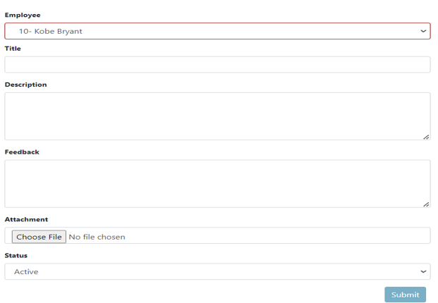
3. Click the submit button as marked in the image above and click Ok when the success message is displayed.

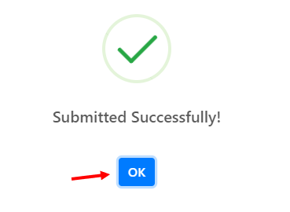

How to import knowledge bases in bulk?

This feature allows the user to import knowledge bases in bulk mode to save time and effort. This allows more efficient transfer of data. Remember that the data should follow the format to enable a seamless process to import the data.

1. Click the Bulk Import button.



1. Follow the given set of instructions.



How to export the Knowledge bases?

This feature allows the user to download the knowledge base list. To export the knowledge base just click the Export XLSX button. This will directly download the list of the knowledge base.



How to change the status of a single or multiple knowledge bases?

Changing the status of a given knowledge base will determine if the survey is still active or inactive.

1. Select rows to change status by clicking the checkbox beside the row. If all the list is to be changed then click the checkbox in line with the table header.

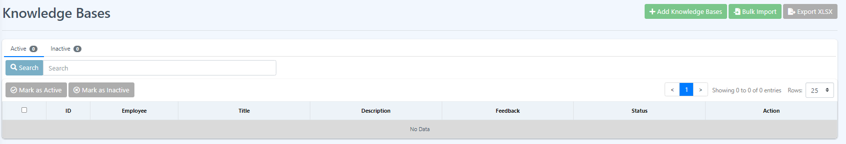

1. Since by default the table shows the active knowledge base so click the Mark as Inactive button to change its status.



1. A confirmation box will appear then click the Submit button.

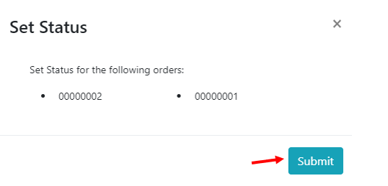

1. Click Ok to affirm that the process is successful.



1. To change the status of the inactive knowledge bases, just click the Inactive tab and repeat the steps.



How to view more details about a particular knowledge base?

This feature allows the user to view more about the knowledge bases, information such as attachments, create date and if the knowledge bases is edited by whom and when. To view more details about the knowledge bases just click the eye icon on the row of the knowledge bases you want to see more details about and it will show you more details about the knowledge bases.





**How to edit knowledge bases?**

If a survey needs to be updated, editing the survey is appropriate. This feature allows the user to make changes to a survey to make it up to date.

1. Click the edit icon beside the eye icon on the row to edit, no need to check the checkbox.



1. Fill in all the required fields and click submit to update the survey.



1. Click ok after a success message pops up.



5.8 Policies

This page shows all the company policies. They cover various areas such as human resources, data security, code of conduct, privacy, and more, providing a framework for decision-making and setting expectations for employees and stakeholders.

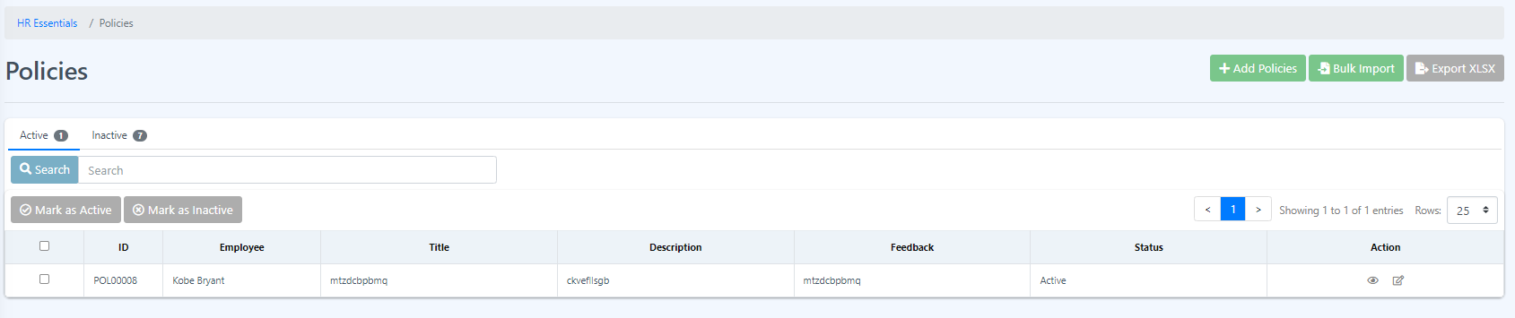

**How to Add new Policies?**

1. Click the Add Policies button.



1. Fill all the required fields and hit Submit.

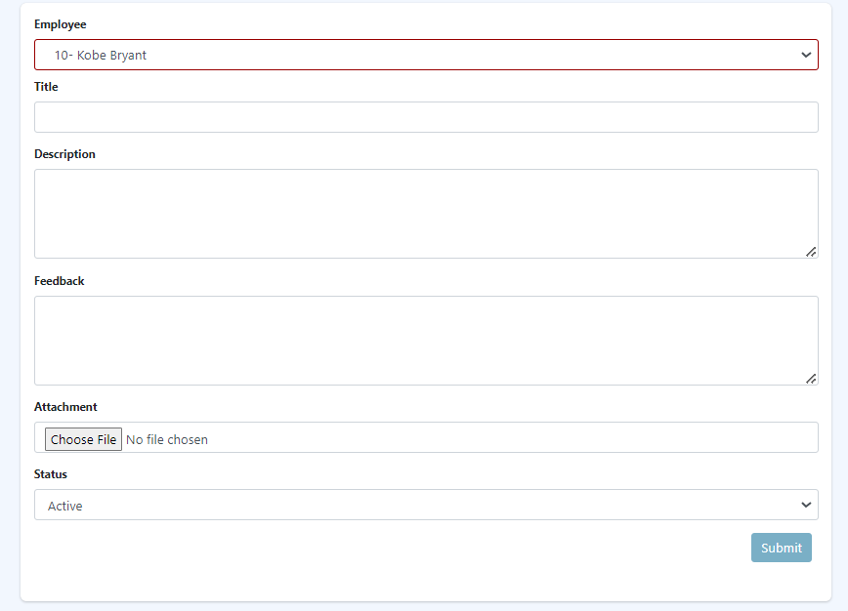

1. All new policies are added in the table at Policies Page.

**How to Export or download Policies Table?**

1. Click the Export XLSX button and it will download the Policies Table.



**How to do Bulk Import of Policies?**

1. Click the Bulk Import button.



1. Follow the given set of rules.

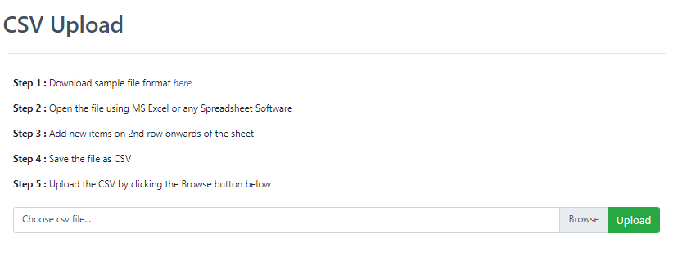

**How to Mark as Active or Mark as Inactive a Policies?**

1. Select a single or multiple rows by clicking the checkbox located at the beginning of each row, and if you want to select all rows then click the first checkbox beside the table headers.



1. Click Mark as Inactive button and a message box will pop out.



1. Hit submit and check the data if the status changed to inactive

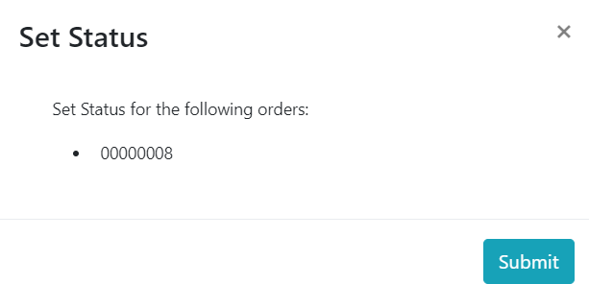

1. To Mark the data to active just repeat the 1-3 steps but before you do the first step navigate first to the Inactive tab by clicking the inactive tab.



**How to see more details about the policies?**

1. Click the eye icon under Actions column. This will display more details about the selected policies. It is not needed to check the checkbox to select what to see more. Just click the eye icon on the data you wanted to see.





**How to Edit a Policy?**

2. Click the edit icon under Actions column, the icon beside eye icon. Here, it is also not needed to select or check the checkbox of the data you want to edit, just click the edit icon on the data you want to edit.



3. Edit or update the required fields and hit Submit button, and click Ok



5.9 About the Company

This page shows the about the company in table form. The user can edit or export the contents of the about the company table.

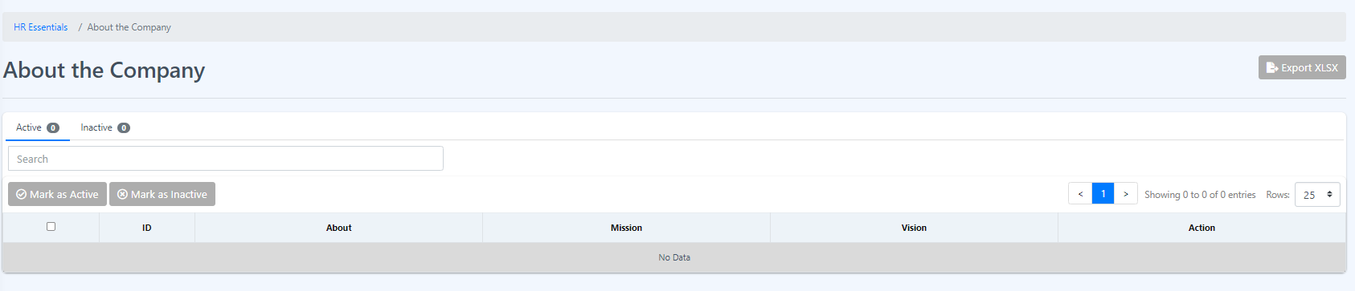

**How to export?**

1. Click the Export XLSX button and will directly download the data of the about the company page in excel file.



Changing the status of the list of about the company is the same as the previous pages. Please do the same here on the About the company page.

6 Attendance Module

The attendance module in Eyebox HRMS (Human Resource Management System) is a component or feature that enables organizations to effectively track and manage employee attendance and work hours. It provides a centralized system for recording, monitoring, and analyzing employee attendance data, allowing HR departments to streamline attendance management processes and ensure accurate payroll calculations.

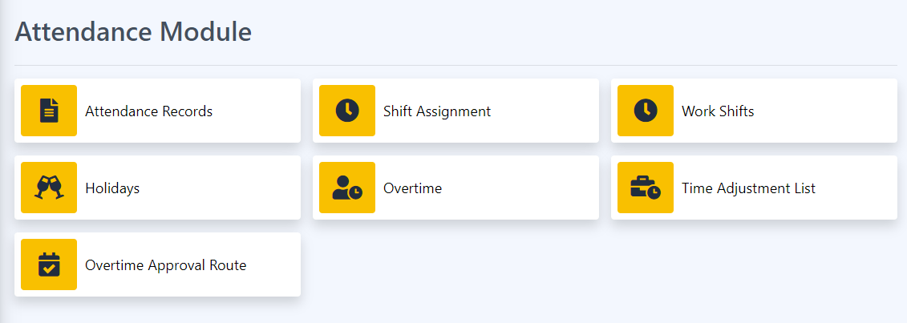

6.1 Attendance Records

Attendance records in Eyebox HRMS (Human Resource Management System) refer to the digital or electronic records that capture and store information about employee attendance, including clock-in and clock-out times, breaks, leaves, and other attendance-related data. The attendance records within an HRMS serve as a centralized and reliable source of information for tracking and managing employee attendance.

1. Time and Attendance Tracking: The HRMS captures employee attendance data through various methods such as manual entry, biometric devices, time clocks, or mobile applications. The system records precise timestamps for clock-in, clock-out, and breaks, ensuring accurate tracking of employee working hours.

2. Real-Time Updates: The HRMS provides real-time updates of attendance records, allowing supervisors, managers, and HR personnel to access the latest attendance data. This enables timely decision-making, such as identifying absences, addressing attendance issues, or managing staffing requirements.

3. Leave and Absence Management: The attendance records within the HRMS include information about employee leaves, such as vacation days, sick leaves, personal leaves, or any other approved time off. This helps in maintaining comprehensive attendance records and ensures accurate tracking of leave balances.

4. Compliance and Policy Enforcement: The attendance records within the HRMS facilitate compliance with labor laws and company attendance policies. They help in monitoring and enforcing attendance rules, such as tracking late arrivals, early departures, or managing overtime hours based on predefined policies and regulations.

5. Historical Data: The HRMS maintains historical attendance records, allowing organizations to track attendance patterns over time. This historical data can be used for analyzing trends, identifying absenteeism issues, and making data-driven decisions to improve attendance management and productivity.

6. Reporting and Analytics: The attendance records stored in the HRMS can be utilized to generate reports and analytics related to employee attendance. These reports provide insights into attendance patterns, absenteeism rates, punctuality, and other attendance-related metrics. They help HR personnel and management to identify areas for improvement and make informed decisions.

7. Integration with Payroll: The attendance records within the HRMS are often integrated with the payroll system. This integration ensures accurate calculation of employee wages based on attendance data, such as working hours, overtime, or leave deductions. It streamlines the payroll process and reduces manual errors.

8. Data Security and Privacy: Attendance records within the HRMS are securely stored, ensuring data privacy and compliance with data protection regulations. Access to attendance records is typically limited to authorized personnel, ensuring confidentiality and data integrity.

Attendance records in Eyebox HRMS provide a comprehensive and reliable system for tracking and managing employee attendance, enabling organizations to maintain accurate records, ensure compliance, and optimize workforce management processes. Import and export of data and endorsing it for payroll processing.

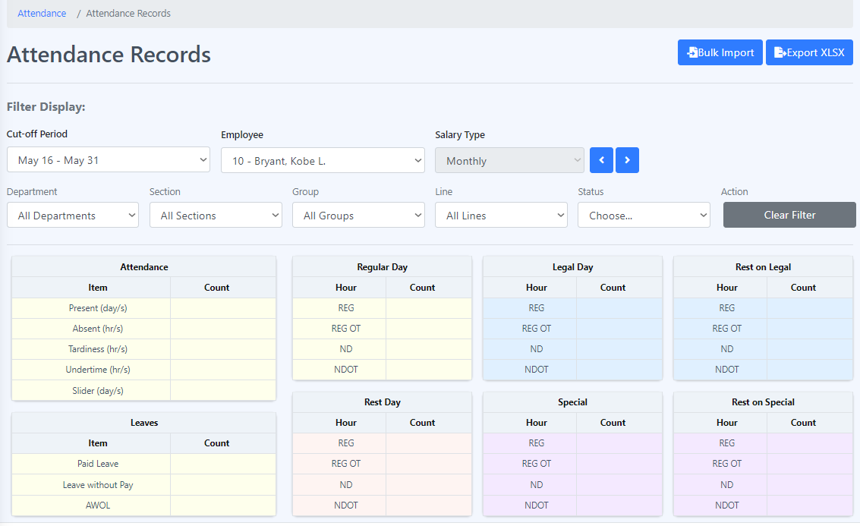

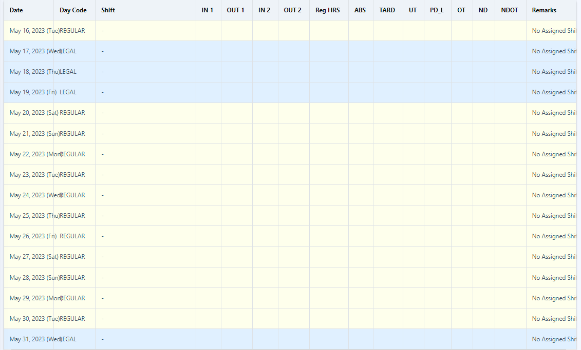



**Bulk import**

**Step 1**: In “Attendance records” click “Bulk Import” button at the upper right corner of the page.



**Step 2:** Follow the step given before uploading the CSV.

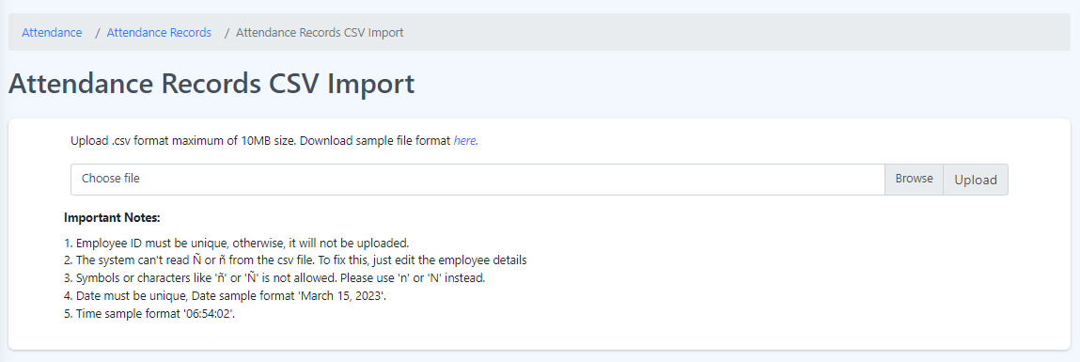

6.2 Shift Assignment

Shift assignment in Eyebox HRMS (Human Resource Management System) refers to the process of assigning employees to specific shifts or work schedules within an organization. It involves the allocation of employees to designated time slots or periods, ensuring adequate coverage and effective workforce management.

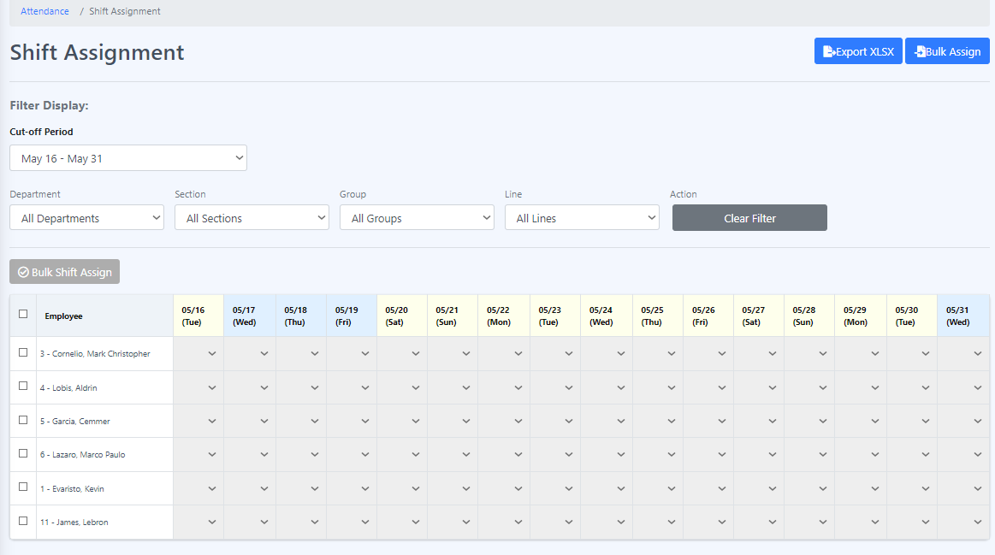

**Assigning shifts**

**Procedure:**

Step 1: Choose an employee to whom you want to assign a shift and select the day on which you will assign the chosen employee.

Step 2: Select the shift that you want to assign to the employee.

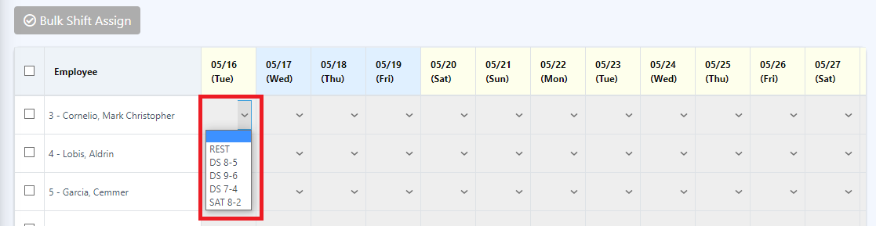

**Bulk shift assign**

**Procedure:**

**Step 1:** Click on an employee or select all employees that you want to bulk shift assign by clicking the checkbox before the employee column.

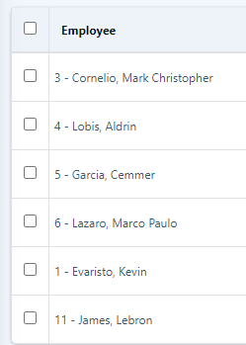

**Step 2:** Click on the bulk shift assign to initiate the process.

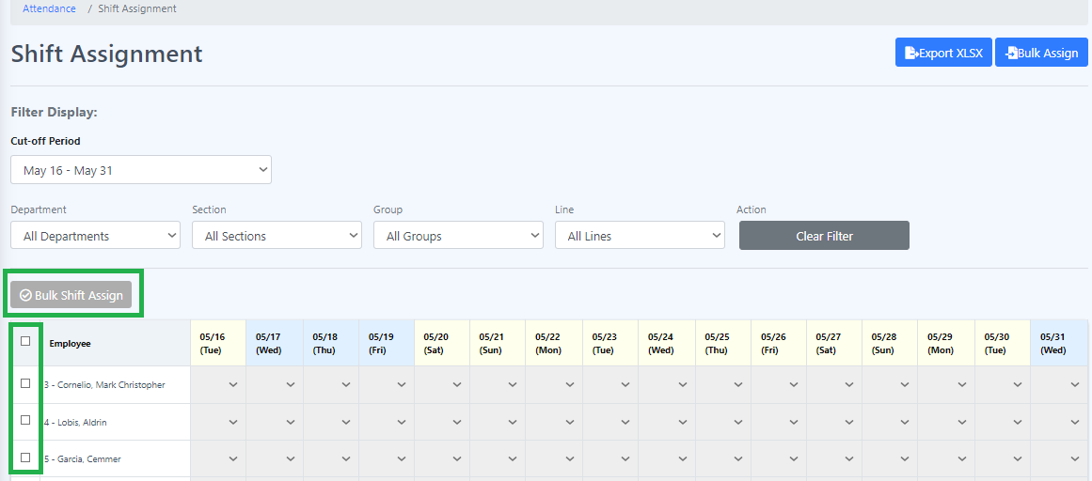

**Step 5:** Select the shift that you want to assign to the employee in the form or template.

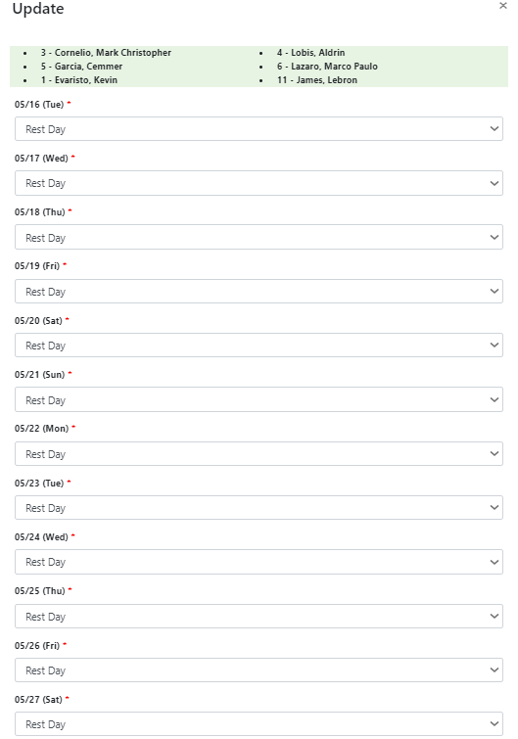

**Step 7:** Once you have finished assigning shifts, click the "Save" button to initiate the process.

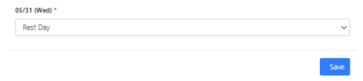

**Bulk Import of Shift Assignment**

**Procedure:**

1. Click the "Bulk Assign" button.

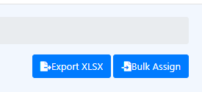

2. Follow the provided set of rules.

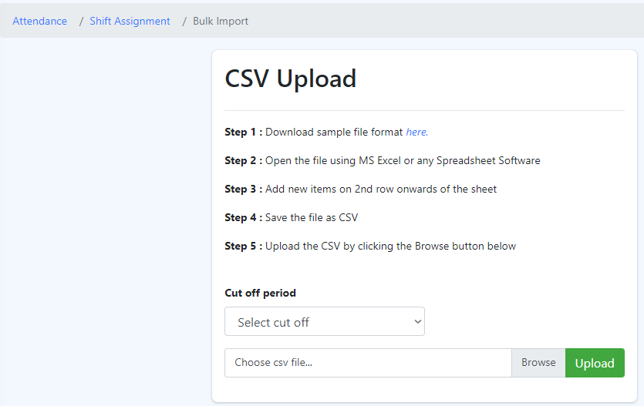

6.3 Work Shifts

Work shifts in Eyebox HRMS (Human Resource Management System) refer to predefined periods of time during which employees are scheduled to work. These shifts help organizations efficiently manage their workforce and ensure adequate coverage across various operational hours. Work shifts within an HRMS typically include specific start and end times, as well as any associated rules or requirements.

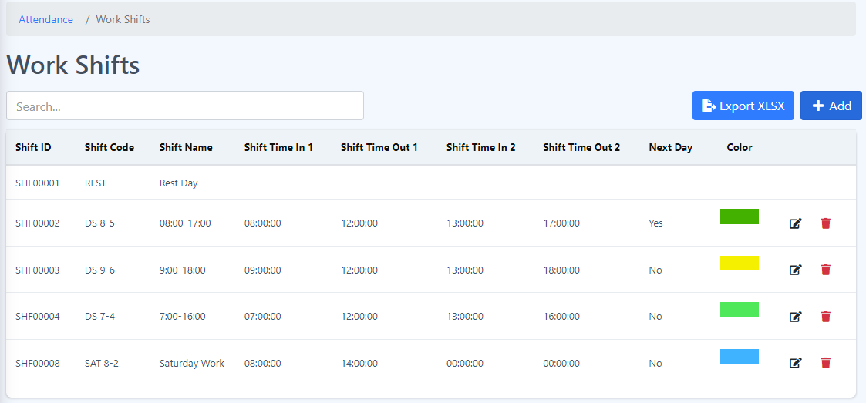

1. **Shift ID** - A shift ID, or Shift Identifier, is a unique alphanumeric code or numerical value assigned to a specific work shift within an organization. It serves as an identifier or reference for a particular shift and helps in tracking and managing schedules effectively.
2. **Shift Code** - A shift code, also known as a shift identifier or shift number, is a unique alphanumeric code or numerical value assigned to a specific work shift within an organization. It serves as a code or identifier to distinguish and reference a particular shift.
3. **Shift Name** - A shift name is a descriptive label or title assigned to a specific work shift within an organization. It serves as a recognizable name that represents a particular shift and helps in easily identifying and referring to it.
4. **Shift Time in and Time Out** - Shift time in and time out refer to the designated start and end times of a specific work shift within an organization. These time points indicate when employees are expected to begin and finish their work for a particular shift.
5. **Next Day** - When referring to shift time in and time out for the "next day," it typically means that the shift extends beyond midnight and carries over into the following calendar day. In such cases, the time out would occur after midnight, indicating the end of the shift on the subsequent day.
6. **Color** - Color is a visual perception resulting from the stimulation of photoreceptor cells in the human eye by different wavelengths of light. It is the characteristic that allows us to differentiate objects based on the wavelengths of light they reflect or emit.

**Add work shifts**

**Procedure:**

**Step 1:** Click the “Add” button.

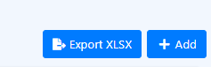

**Step 2:** Fill in all the required field(s) and click “Save”.

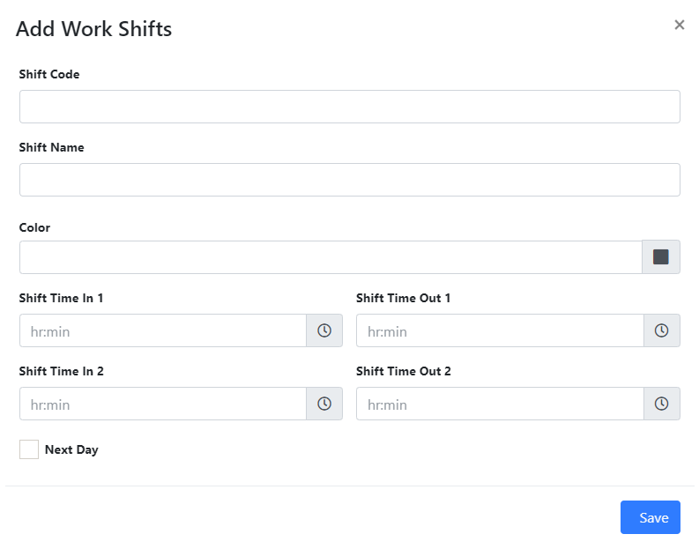All new work shifts are added to the table under the "Work Shifts" section.

**Edit Work Shifts**

**Step 1:** Click the edit icon located near the color column.

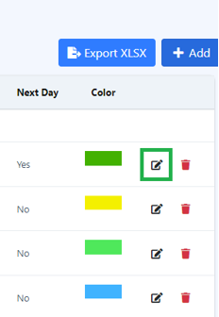

**Step 2**: Edit the required field(s) and click "Save".

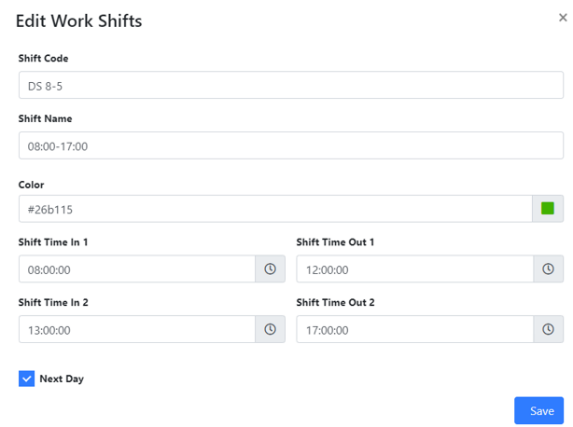

6.4 Holidays

Holidays in Eyebox HRMS (Human Resource Management System) refer to specific days that are recognized and designated as non-working days for employees. These are typically days of significance or importance, such as national holidays, religious observances, or other special occasions.

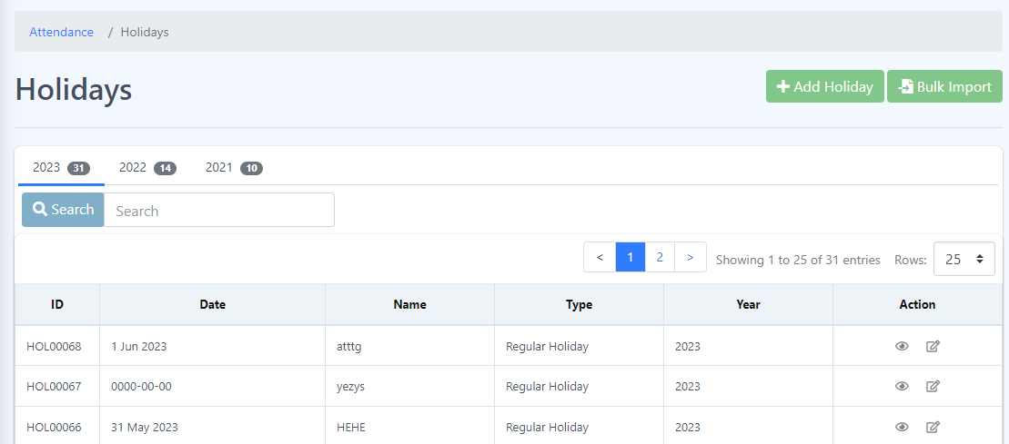

**1. Holiday ID:** Each holiday is assigned a unique identification number or code, known as the holiday ID. It serves as a reference point for the holiday and ensures its uniqueness within the system.

**2. Date:** The date attribute represents the specific day on which the holiday occurs. It includes the day, month, and year information to accurately identify the holiday.

**3. Name:** The name attribute refers to the official or commonly recognized name of the holiday. For example, "New Year's Day," "Christmas," or "Labor Day."

**4. Type:** The type attribute categorizes the holiday based on its nature or origin. This can include various types such as national holidays, public holidays, religious holidays, cultural holidays, or company-specific holidays. It helps in organizing and grouping holidays for reporting and management purposes.

**5. Year:** The year attribute specifies the calendar year to which the holiday belongs. This is particularly relevant when generating holiday calendars or scheduling employee time off, as holidays may vary from year to year.

**Add a new Holiday**

**Procedure:**

1. Click on the "Add Holiday" button.

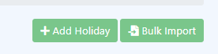

1. Fill in all the required fields, such as the date, name, type and year, and then click the "Submit" button.

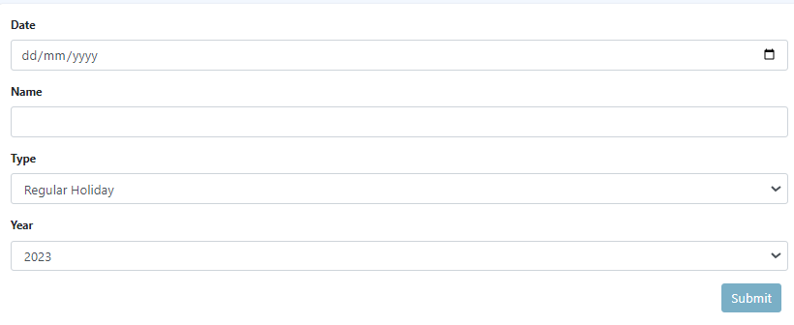

**View more details about the holiday**

* 1. Click on the “eye” icon located under the Actions column.

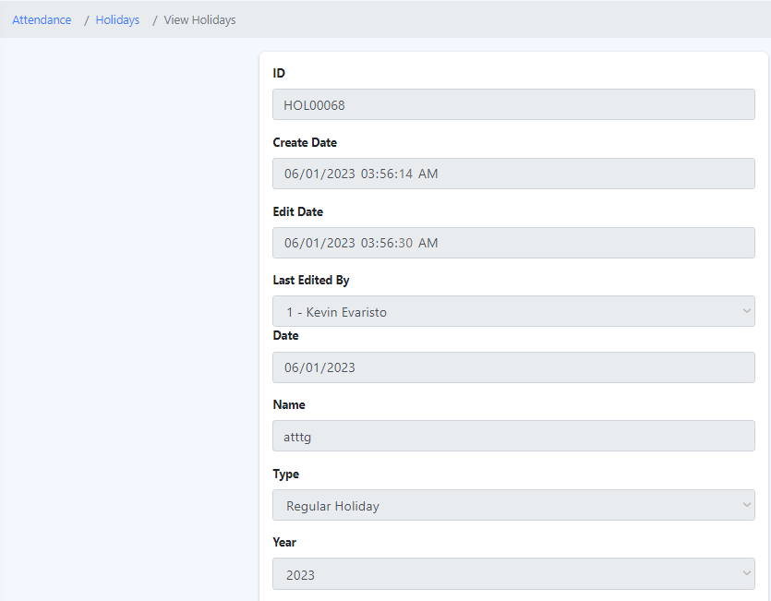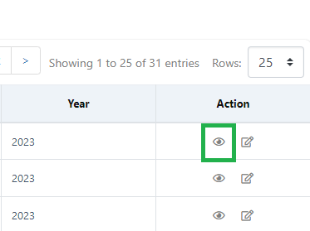

**Edit a Holiday**

1. Click the edit icon under the Actions column. which is the icon next to the eye icon.

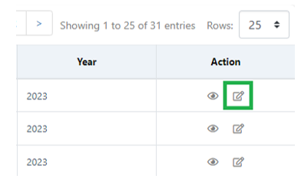

1. 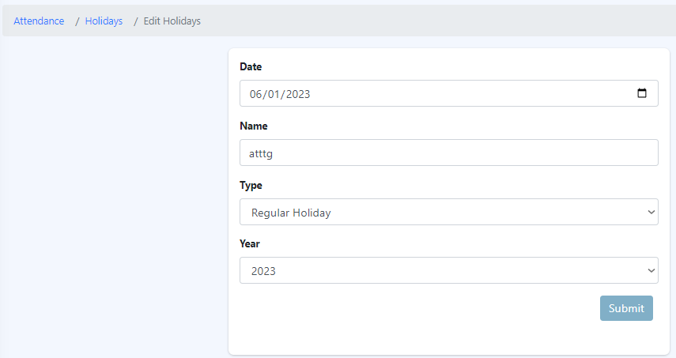Edit the required field(s) and click "Submit”.

6.5 Overtime Requests

The “Overtime Requests" feature within Eyebox HRMS allows employees to view and manage their recorded overtime hours. It provides a centralized platform for employees to track their overtime work and access relevant information related to their overtime hours. The functionalities of this section are the following:

1. Overtime Summary: The "Overtime Requests " section displays a summary of the employee's recorded overtime hours. It provides an overview of the total accumulated overtime hours, typically categorized by pay period or specific timeframes.
2. Overtime Details: Employees can access detailed information about their recorded overtime hours within the HRMS. This includes the date, time, and duration of each overtime session, as well as any associated remarks or comments.
3. Overtime Documentation: If required, employees can access any relevant documentation or supporting materials related to their recorded overtime hours. This may include timesheets, supervisor approvals, or any other evidence that justifies the overtime work performed.

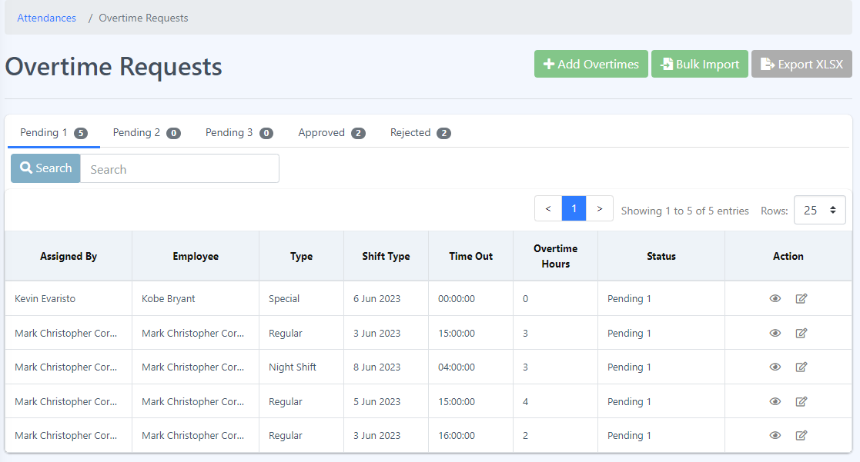

**Add Overtimes**

The "Add Overtimes" module in Eyebox HRMS streamlines the process of recording and managing overtime hours for employees. By providing a structured interface for entering overtime details, attaching supporting documentation, and facilitating the approval workflow, it ensures accurate tracking and proper management of additional work hours. This feature promotes transparency, compliance with labor regulations, and facilitates effective overtime management within the organization.

**Add Overtime Requests**

**Procedure:**

**Step 1**: Click the Add Overtimes button.

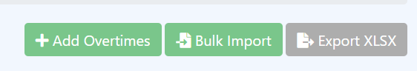

**Step 2**: Fill-up the form then click “Submit” button.

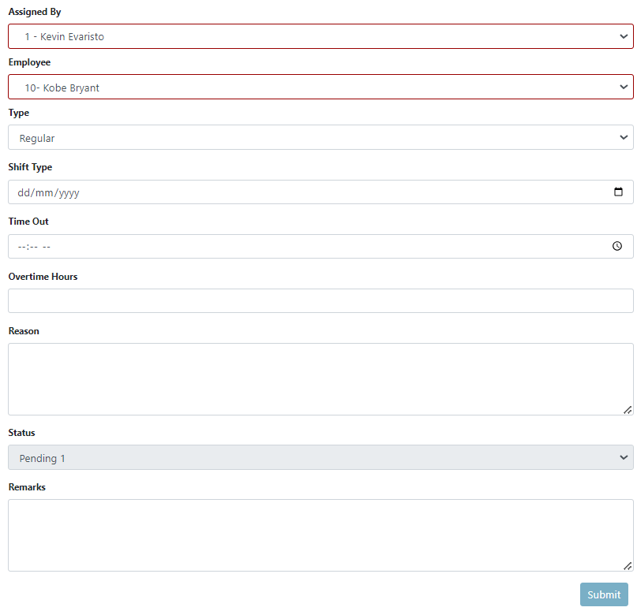

**Step 3:** A message will pop up that you have successfully submitted your form. Click the “Ok” button and this should redirect you to “Overtime Requests” page and able to see your created request.

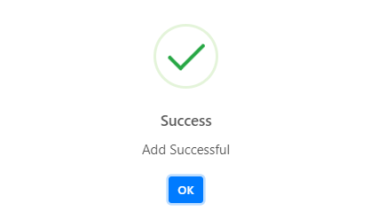

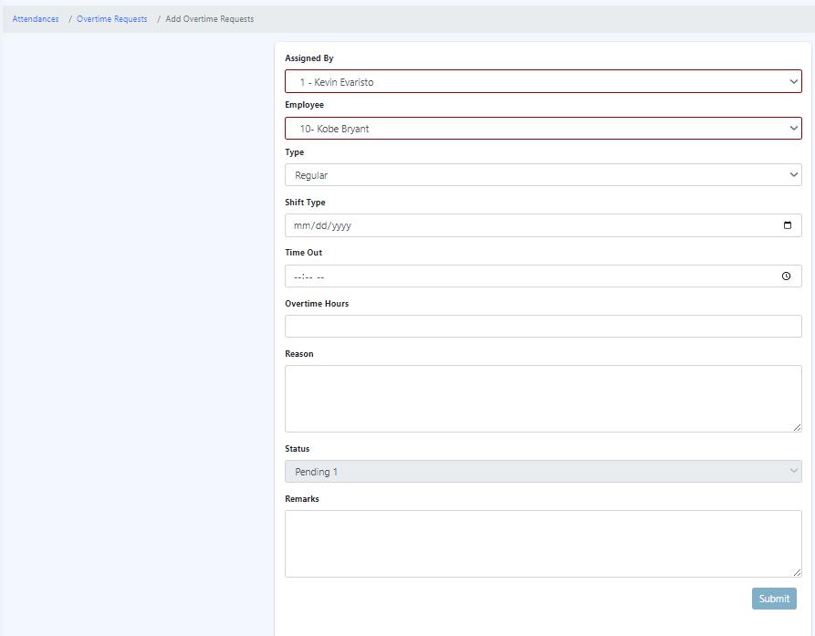

**View more details about the Overtime Requests**

1. Click the eye icon located under the “Actions” column.

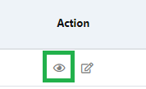

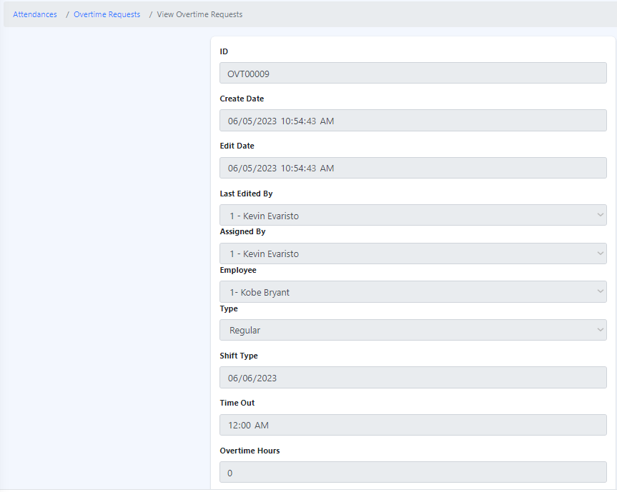

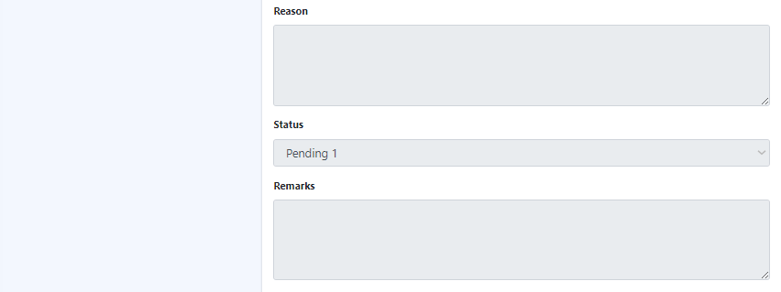

**Edit Overtime Requests**

1. Click the edit icon located under the Action column, which is the icon next to the eye icon.

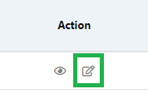

1. Edit the required field(s) and click "Submit".

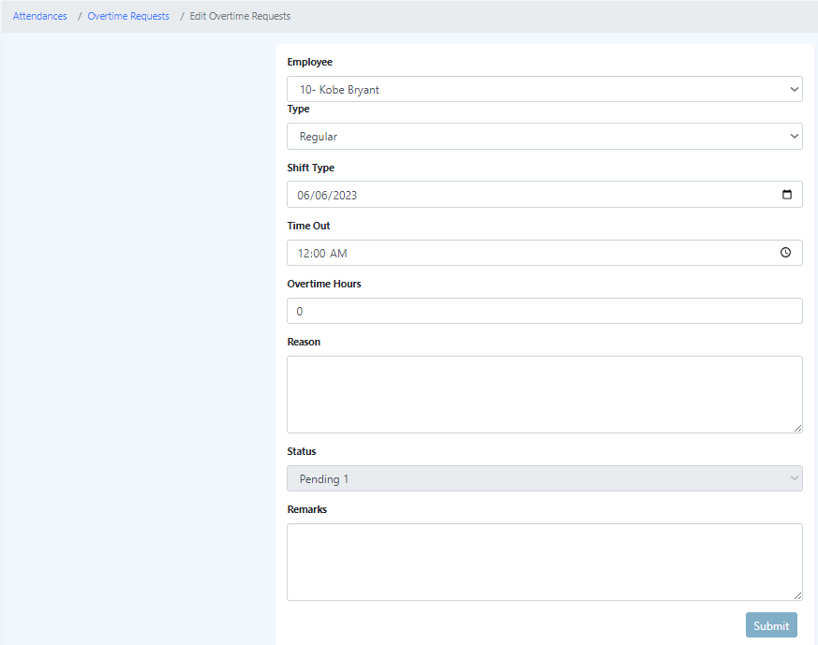

**Bulk Import of Overtime Requests**

**Procedure:**

* 1. Click the "Bulk Import" button.

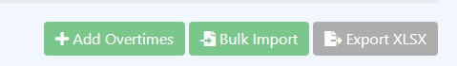

* 1. Follow the provided set of steps.

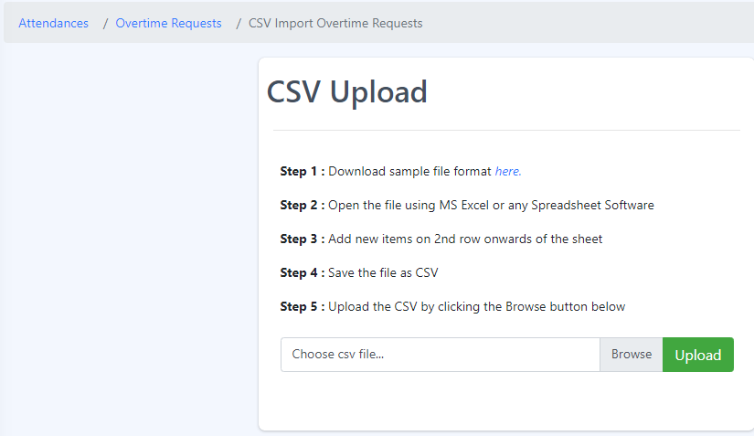

6.6 Time Adjustment List

The employee time adjustments feature within the HRMS allows authorized personnel to make changes or corrections to recorded employee time entries. These are the functionalities in the time adjustment:

1. Authorized Access: Only designated personnel, such as HR administrators or managers, with the appropriate permissions can access and make time adjustments within the HRMS. This ensures that adjustments are made by authorized individuals.

2. Types of Time Adjustments: The HRMS provides options for different types of time adjustments, such as:

- Clock-In/Clock-Out Corrections: Authorized personnel can adjust clock-in and clock-out times if there are errors or discrepancies in the original records. This helps to reflect the actual time worked by the employee accurately.

3. Documentation and Audit Trail: The HRMS maintains a record of all time adjustments made, including details such as the date, time, reason for adjustment, and the individual who made the adjustment. This documentation serves as an audit trail for transparency and accountability purposes.

4. Approval Workflow: Depending on the organization's policies, time adjustments may require approval before they are finalized. The HRMS can incorporate an approval workflow where adjustments are reviewed and authorized by designated personnel, ensuring proper oversight.

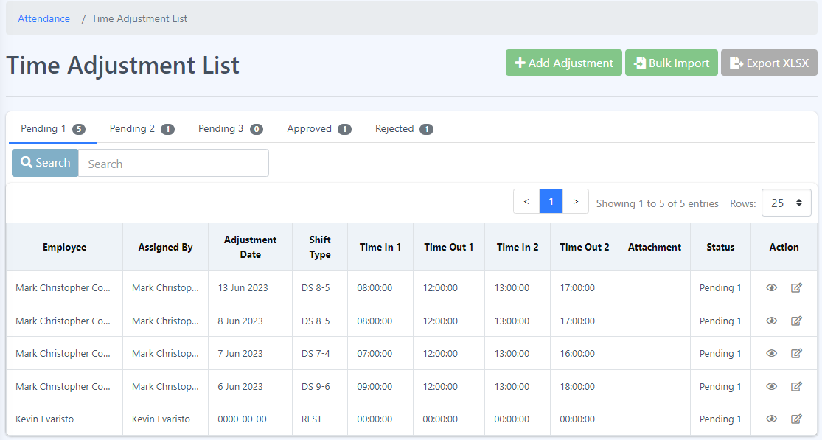

**How to Add Time Adjustment List?**

Step 1: Click the Adjustment button.

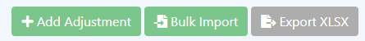

Step 2: Fill in the form and click the “Submit” button.

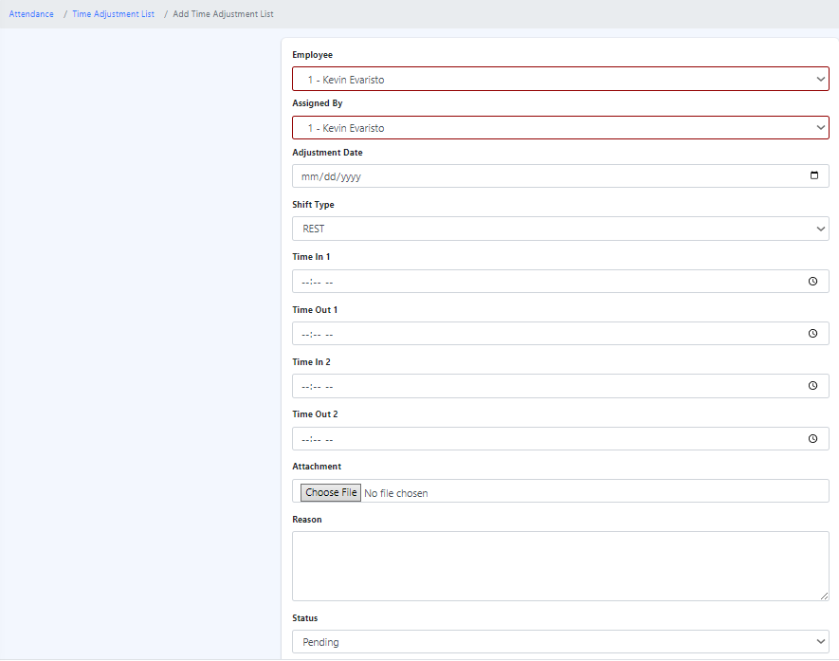

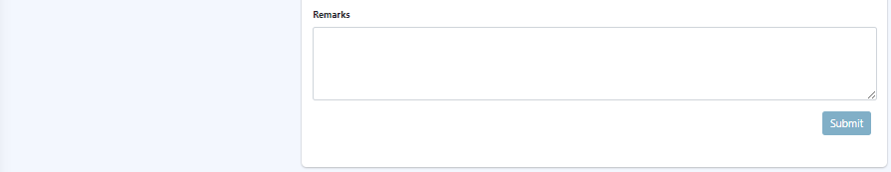

How to see more details about the Time Adjustment List?

* 1. Click on the eye icon located under the Actions column.



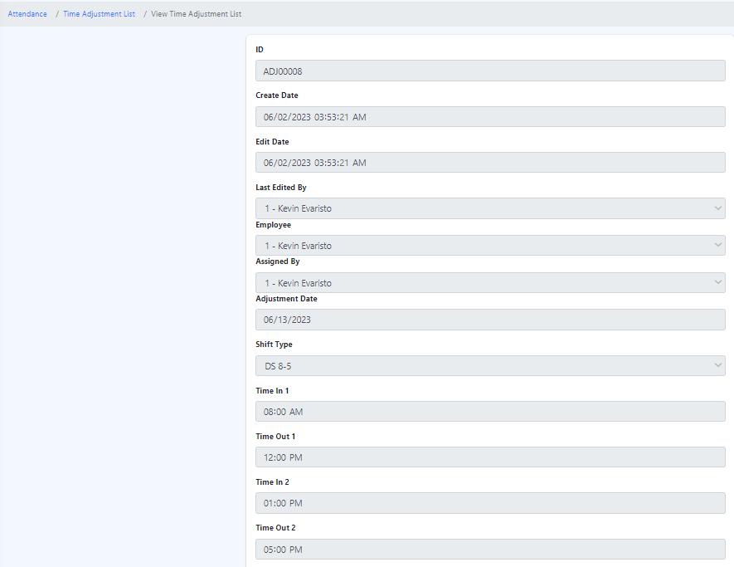

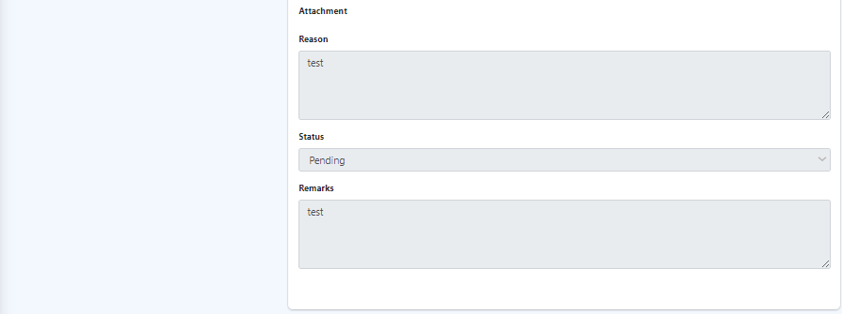

How to edit Time Adjustment List?

1. Click the edit icon under the Actions column. which is the icon next to the eye icon.



1. 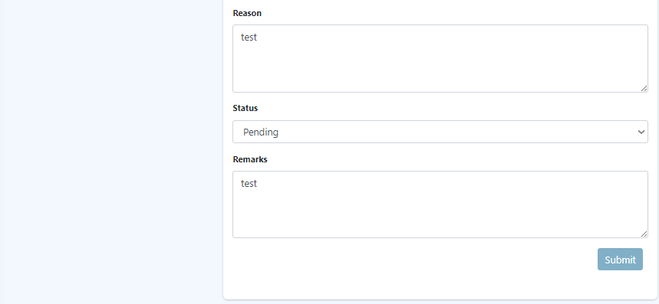Edit the required field(s) and click "Submit.

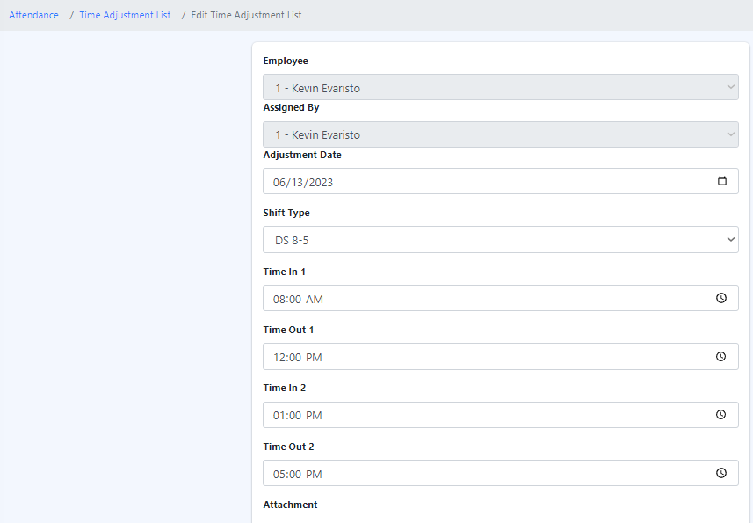

**Bulk Import of Overtime Requests**

**Procedure:**

1. Click the "Bulk Import" button.

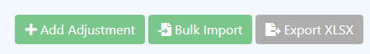

2. Follow the provided set of steps.

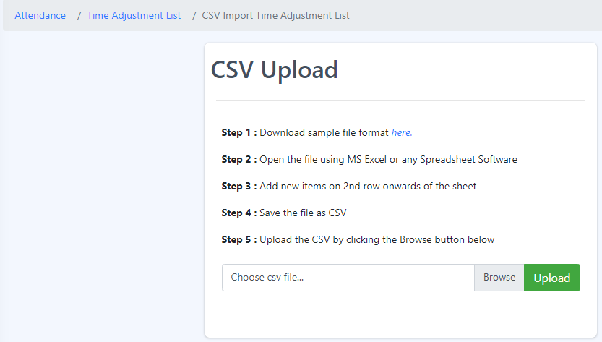

6.7 Overtime Approval Route

The overtime approval route in an HRMS (Human Resource Management System) refers to the defined workflow or process through which overtime requests are submitted, reviewed, and approved within the system. It outlines the steps and individuals involved in the approval process for overtime work.

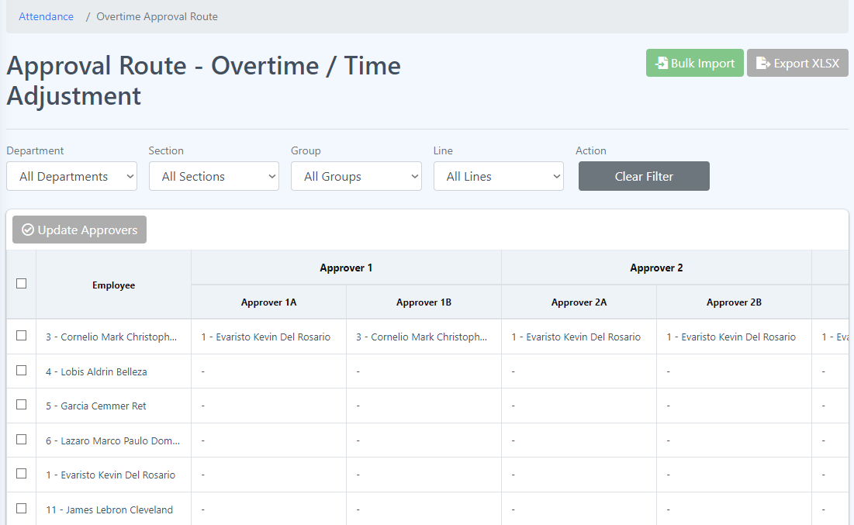

**Update approvers**

**Procedure:**

1. Select single or multiple employees to update approvers by clicking the checkbox beside the employee’s name.

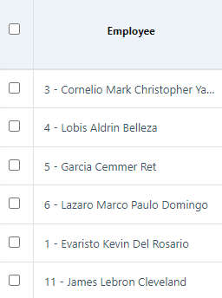

1. Click the Update Approvers button.

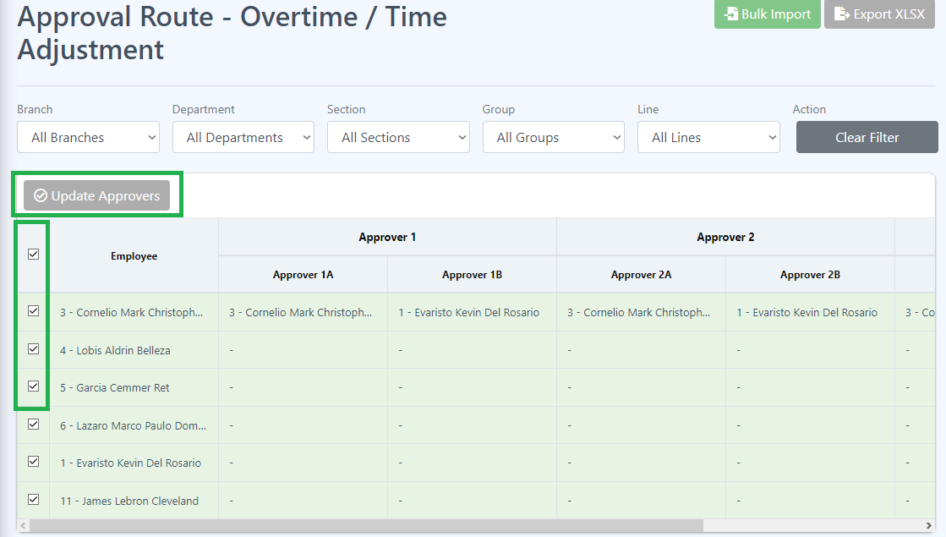

1. Update the time adjustment and overtime approver of each employee by clicking the dropdown and select the approver and click Save button.

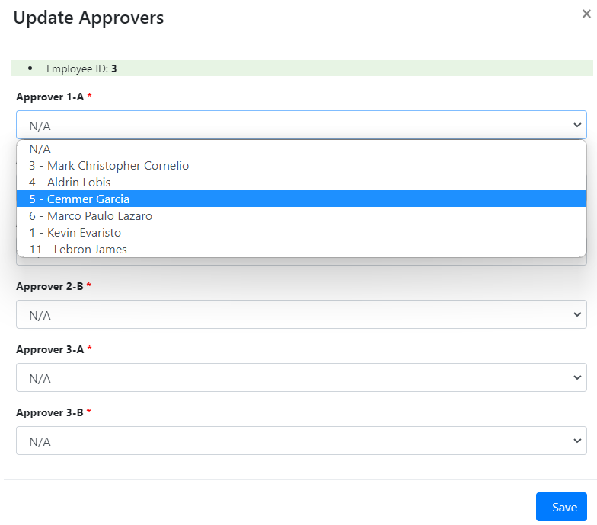

**Bulk Import of Overtime Approval Route**

**Procedure:**

1. Click the "Bulk Import" button.

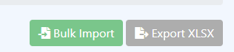

2. Browse and upload the data you wish to import.

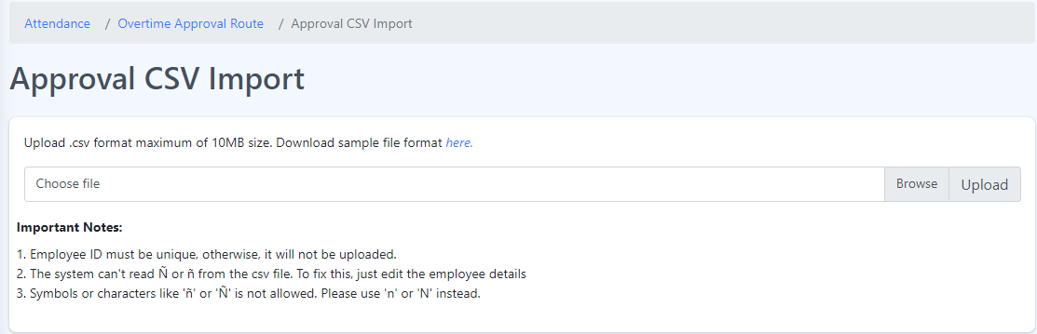

6.8 Zkteco Attendance

ZKTeco Attendance refers to the attendance management system provided by ZKTeco, a leading global provider of biometric and RFID-based security and time management solutions. ZKTeco Attendance offers advanced features and technologies to accurately record and manage employee attendance data.

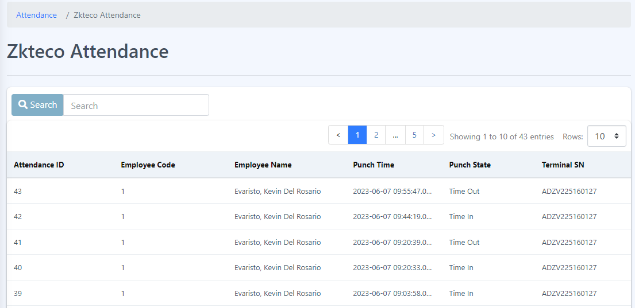

In ZKTeco Attendance, various attributes are used to identify and manage attendance records. These attributes include:

1. Attendance ID: The attendance ID is a unique identifier assigned to each attendance record. It serves as a reference number to distinguish one attendance entry from another.

2. Employee Code: The employee code is a specific code or number assigned to each employee within the organization. It serves as a unique identifier for each individual employee.

3. Employee Name: The employee’s name attribute represents the name of the employee associated with the attendance record. It helps identify the employee whose attendance is being recorded.

4. Punch Time: The punch time attribute denotes the specific time at which an employee performs a punch, indicating their check-in or check-out time. It captures the exact timestamp when the attendance event occurs.

5. Punch State: The punch state attribute indicates the state or status of the attendance punch. It signifies whether it is a check-in, check-out, break-in, break-out, or any other defined state. This attribute helps categorize and differentiate various attendance events.

6. Terminal SN: The terminal SN (Serial Number) attribute refers to the unique serial number assigned to the attendance terminal or device used for capturing attendance punches. It helps identify the specific device or terminal from which the attendance data originates.

These attributes collectively contribute to the accurate recording and management of attendance data in the ZKTeco Attendance system. By capturing and associating these attributes with each attendance record, the system can generate comprehensive reports, track employee attendance patterns, and facilitate efficient attendance management within the organization.

7 Leave Module

The leave module is designed to assist organizations in managing various types of employee leaves, such as vacation time, sick leave, maternity or paternity leave, and other types of approved time off. The module typically provides functionality for employees to submit leave requests, managers to review and approve/reject those requests, and the HR department to maintain accurate records of employee leave balances and histories.

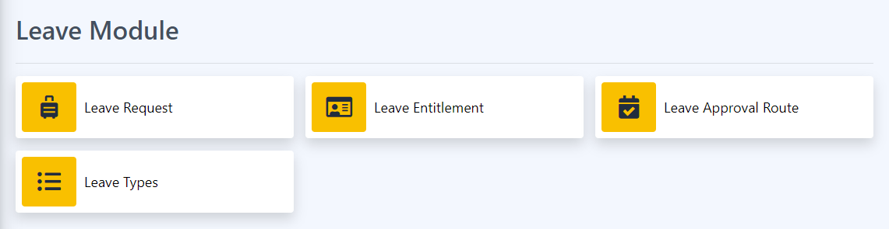

Some common features found in a leave module in an HRMS system include the following:

7.1 Leave Requests

The "Leave Requests" feature within Eyebox HRMS allows employees to view and manage their leave requests and applications. It provides a centralized platform for employees to track the status of their leave applications and access important information related to their requested time off. Here’s are the functionalities of this feature:

1. Leave Request Submission

2. Leave Application Status

3. Leave History

4. Leave Modification or Cancellation

5. Leave Documentation and Attachments

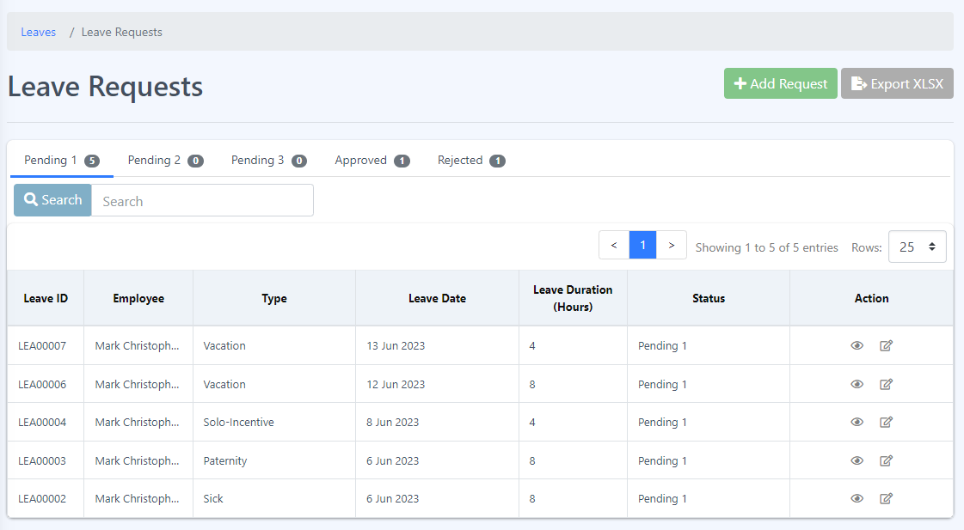

**Add My Leave Applications**

The "Add Leave Request Applications" Eyebox HRMS enables employees to submit their leave requests electronically. It provides a user-friendly interface for employees to enter their leave details and initiate the leave application process.

**How to add your Leave Requests Application?**

Step 1: Click the Add Request button.

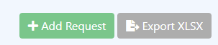

Step 2: Fill in the form then click the “Submit” button.

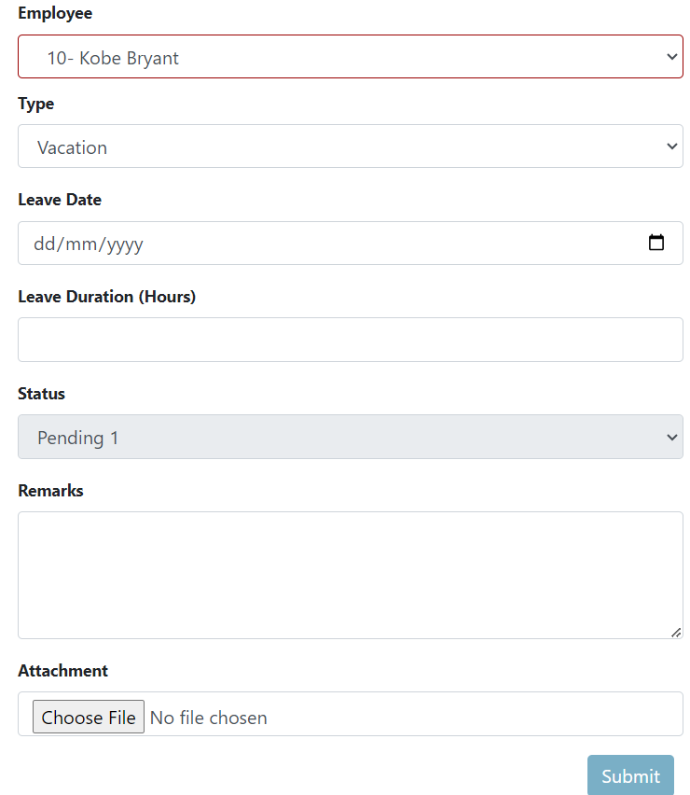

**View Leave Requests Applications**

This section allows users to fully view their leave application details.

How to see more details about the leave requests?

1. 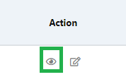Click the eye icon located under the “Actions” column.



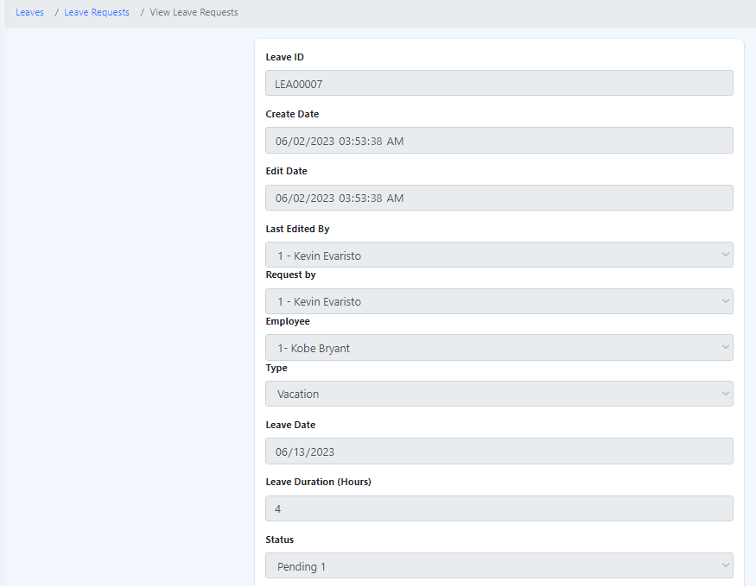

**Edit Leave Requests Applications**

This section allows users to fully view and adjust their leave application.

**Edit Leave Requests**

1. Click the edit icon located under the Action column, which is the icon next to the eye icon.
2. Edit the required field(s) and click "Submit".

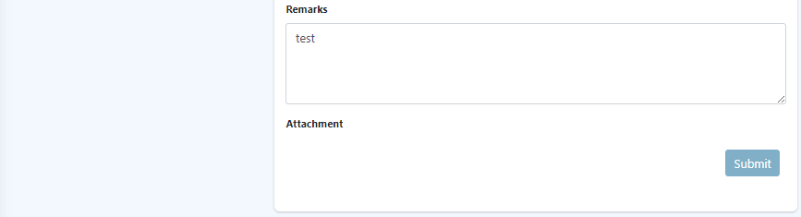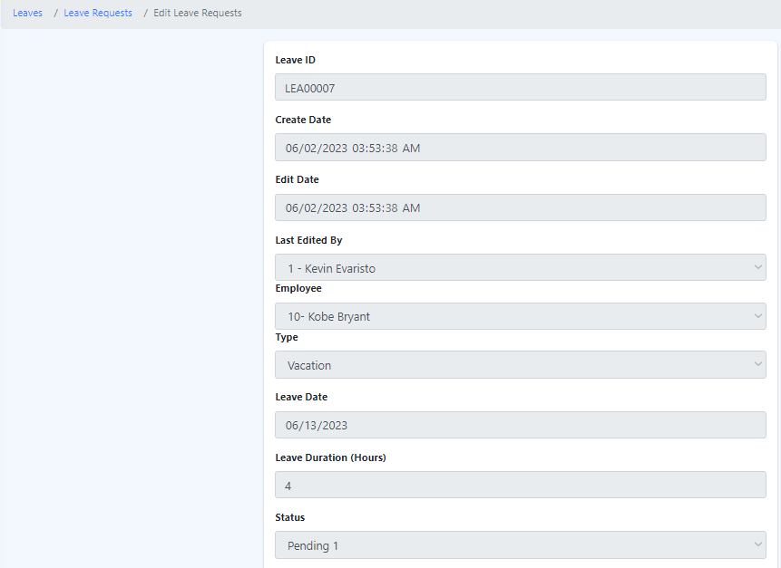

7.2 Leave Entitlement

The "Leave Entitlement" feature within Eyebox HRMS refers to the number of paid or unpaid leave days an employee is entitled to based on their employment status, length of service, and any applicable labor laws or company policies. It represents the allocation of time off that employees can utilize for various purposes, such as vacation, personal reasons, illness, maternity/paternity leave, bereavement, or other approved absences from work. Leave entitlement ensures that employees can maintain a healthy work-life balance while meeting their personal and professional needs. The specific calculation and rules for leave entitlement may vary depending on the organization's policies and local regulations.

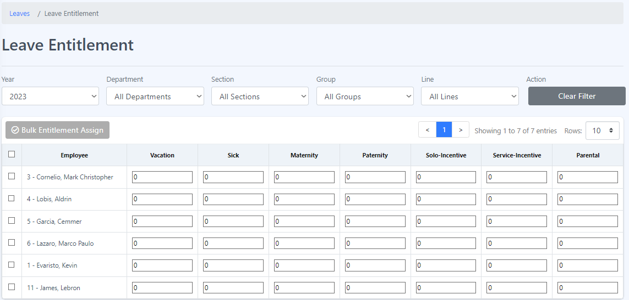

**How to assign bulk entitlement?**

To bulk assign entitlements, follow these steps:

1. Navigate to the leave entitlement section.
2. Click on an employee or select all employees that you want to perform a bulk entitlement assignment on.

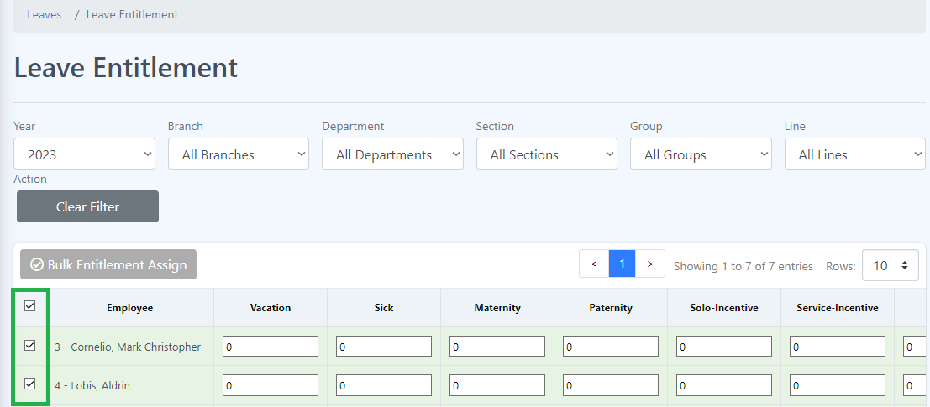

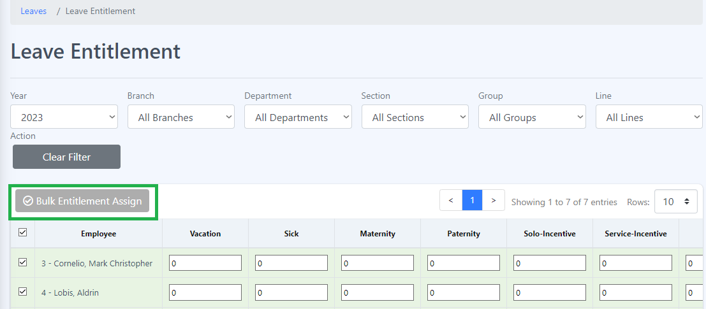

1. Look for the option or button labeled "Bulk Entitlement Assign" that allows for the bulk assignment of entitlements.
2. Click on the bulk entitlement assign button to initiate the process.
3. You will likely be presented with a form or template to input the necessary information for bulk assignment.

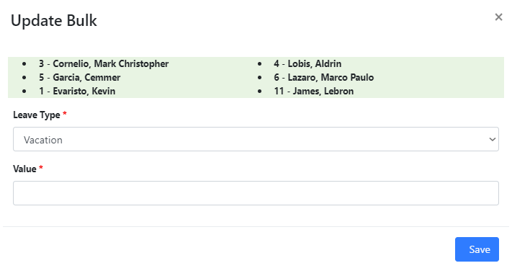

1. Fill in the required information in the form or template.
2. Once you have filled in all the necessary details, review the information to ensure accuracy.
3. Click the "Save" button to initiate the bulk entitlement assign process.

7.3 Approval Route - Leave

The "Approval Route - Leave" feature within Eyebox HRMS refers to the predefined process or workflow that determines the path through which a leave request travels for approval. It outlines the hierarchy or sequence of individuals or departments responsible for reviewing and approving leave applications submitted by employees.

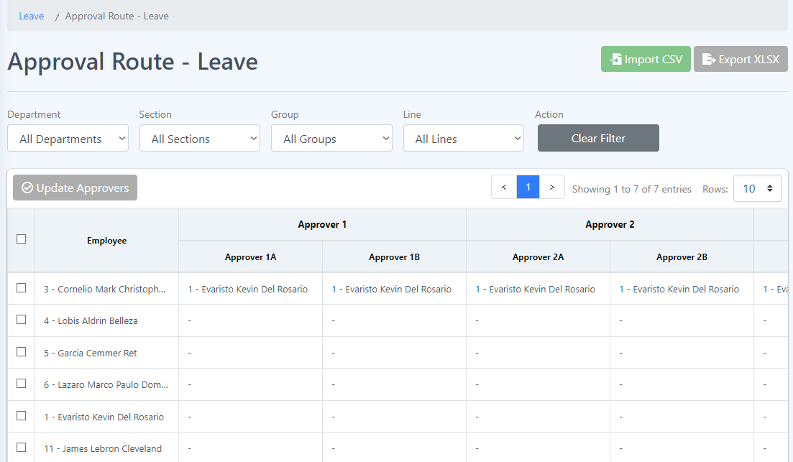

**How to assign approvers?**

1. Select an employee or more by clicking the checkbox beside the employee’s name.

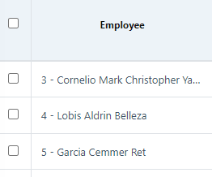

1. Click the Update Approver button to make an update.

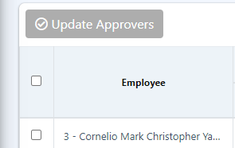

1. Update the approver of the selected employee by clicking the dropdown and select an approver, then click Save.

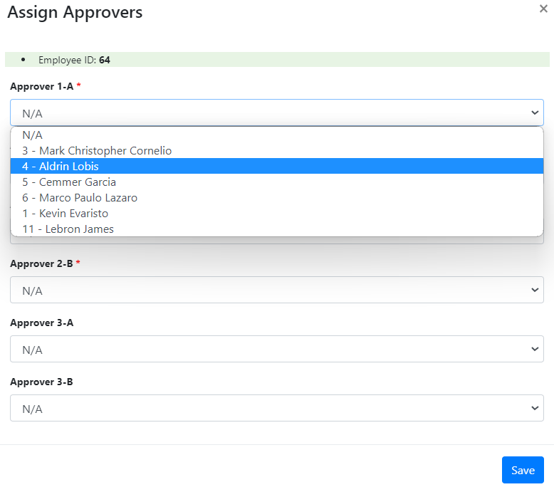

**Bulk import**

**Procedure:**

1. In “Approval Route - Leave” click “Import CSV” button at the upper right corner of the page.

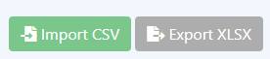

2. Follow the step given before uploading the CSV.

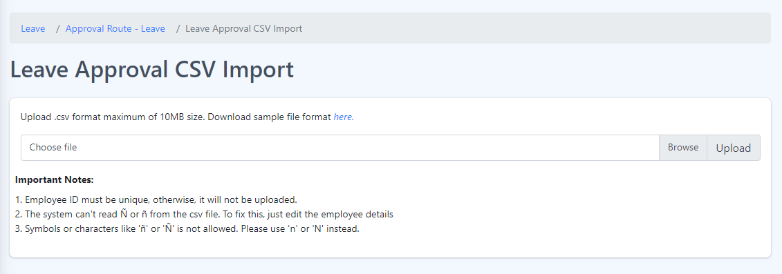

7.4 Leave Types

In Eyebox HRMS “Leave types” refer to the different categories or classifications of time off that employees can take from work. These leave types are typically defined by the organization's policies and may vary depending on the jurisdiction and industry. Here are some common leave types:

1. Annual Leave/Vacation Leave: This is a type of leave that provides employees with a specified number of days off for rest, relaxation, and personal activities. It is usually accrued based on the length of service and can be taken in full or partial days.

2. Sick Leave: Sick leave is granted to employees when they are ill, injured, or need to attend medical appointments. It allows employees to take time off to recover without losing pay. The number of sick leave days can vary, and some organizations differentiate between paid and unpaid sick leave.

3. Maternity/Paternity Leave: Maternity leave is granted to expectant mothers to recover from childbirth and bond with their newborn. Paternity leave allows fathers to take time off to support their partner and care for their newborn. The duration and benefits of maternity/paternity leave can vary based on local laws and organization policies.

4. Solo incentive Leave: is a unique or specific leave category that may be specific to your organization or industry. To provide a better understanding, it would be helpful to provide more context or details about the specific purpose and guidelines of "solo incentive leave" within your organization.

5. Service Incentive Leave: also known as SIL or Service Leave, is a type of leave provided to employees as a form of recognition for their continuous service to an organization. It is a benefit mandated by certain labor laws or regulations in some countries.

It's important to note that leave types and their specific policies may differ between organizations. Employees should refer to their organization's leave policy or employee handbook for detailed information about the available leave types, their eligibility criteria, and any specific rules and procedures for applying for and utilizing them.

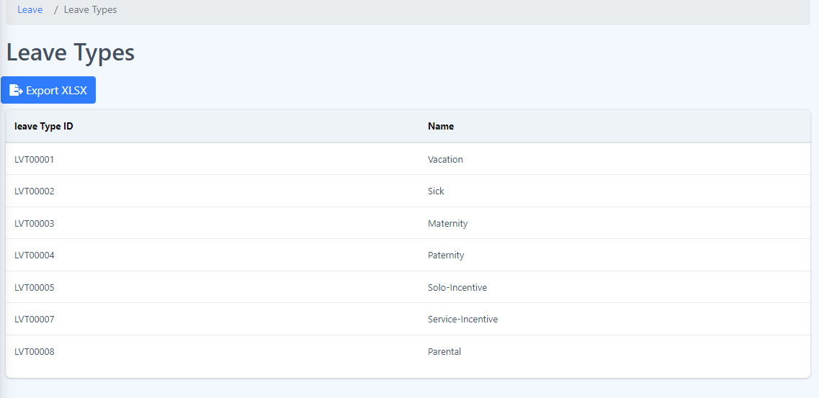

8 Administrator Module

These are the components of administrator module. The Administrator Module is a powerful tool designed to empower administrators with comprehensive control and management capabilities within a system or software. It provides administrators with the necessary permissions and functionalities to configure system settings, manage user accounts, and oversee various aspects of the application or platform. With the Administrator Module, administrators can efficiently handle tasks such as user access control, system configurations, and overall system maintenance, ensuring smooth operation and optimal functionality of the system.

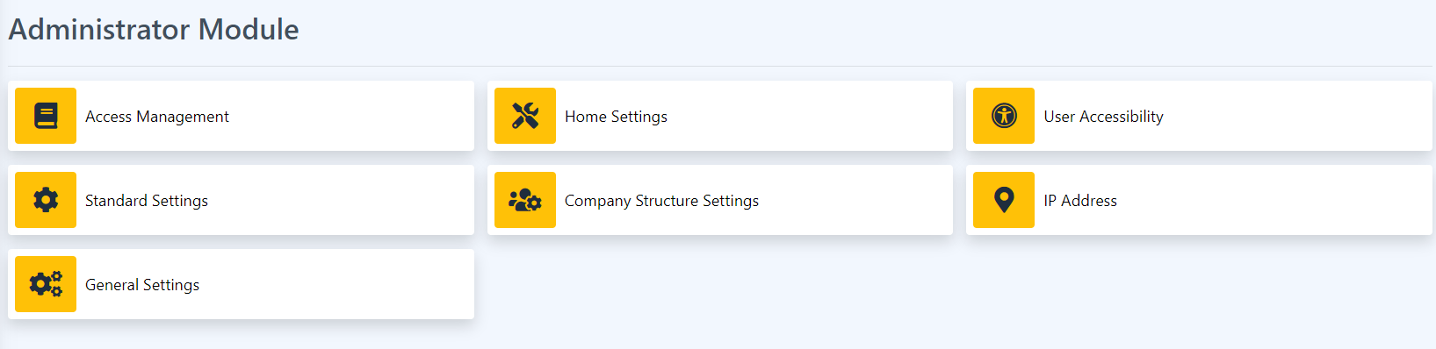

8.1 Access Management

This page is where all access is being managed. In this page the authorized user can reset the password of an account to default, change the user access type of an account and more.

How to Update the Access Management?

1. Click the dropdown on the employee you want to update. For example, user access.

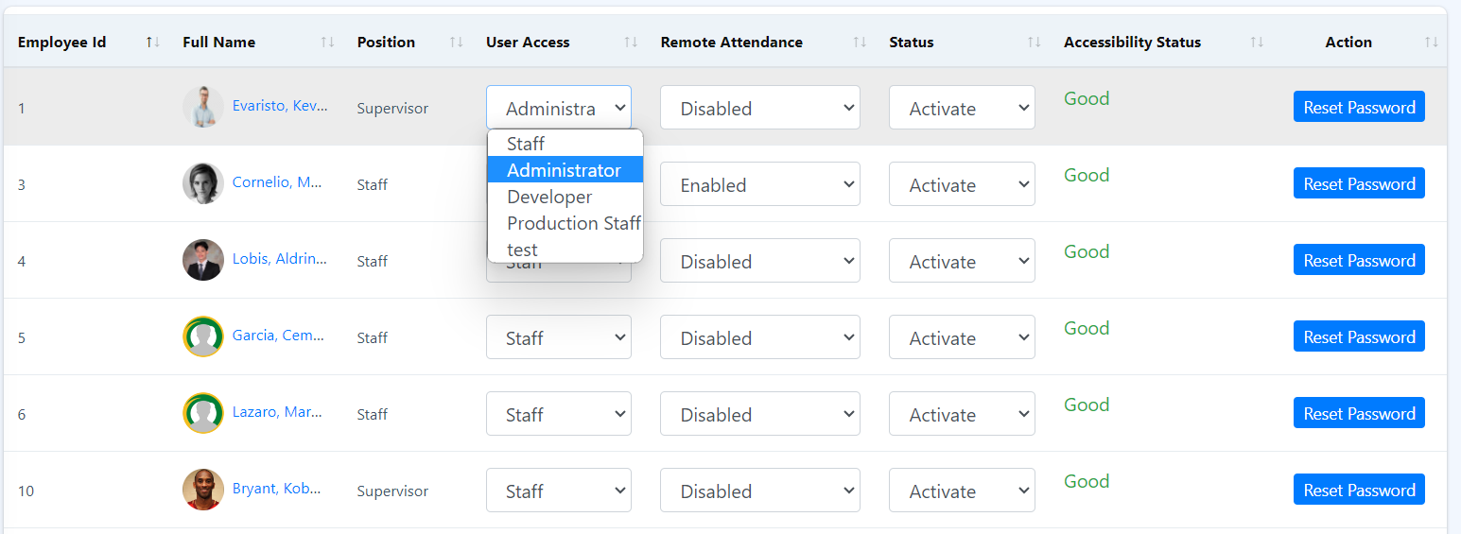

1. Select a user access type for that employee.
2. To save the changes made, just click the Save Changes button

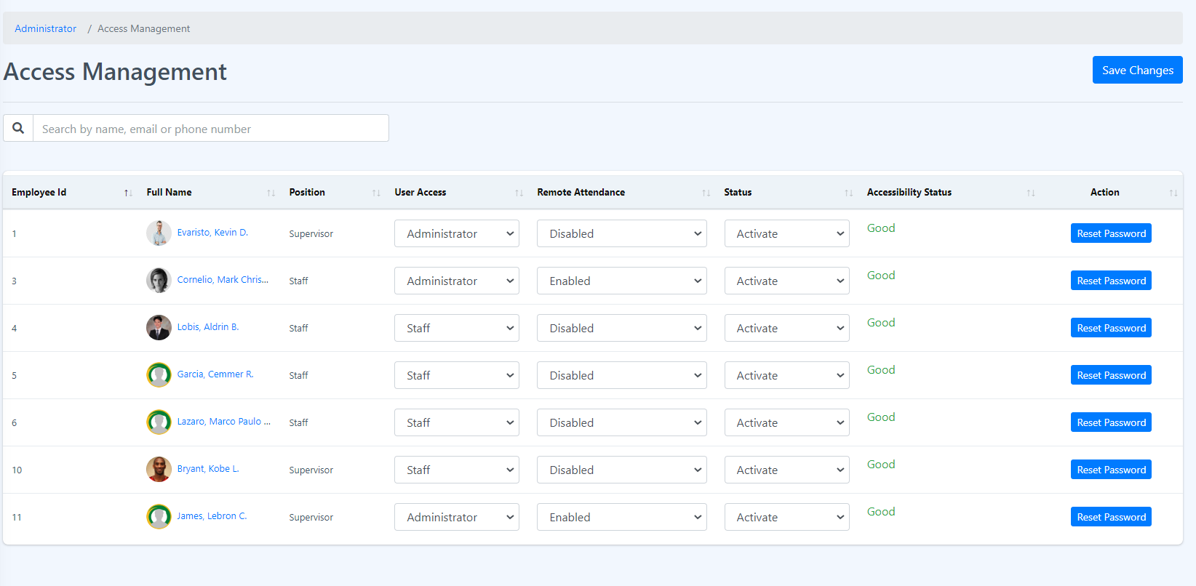

1. A success message will be displayed just right above the Save Changes button. Click the close button to remove the message.

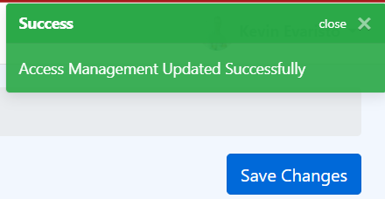

8.2 Home Settings

This page manages what to show or display in the home page. To change just click the switch button.

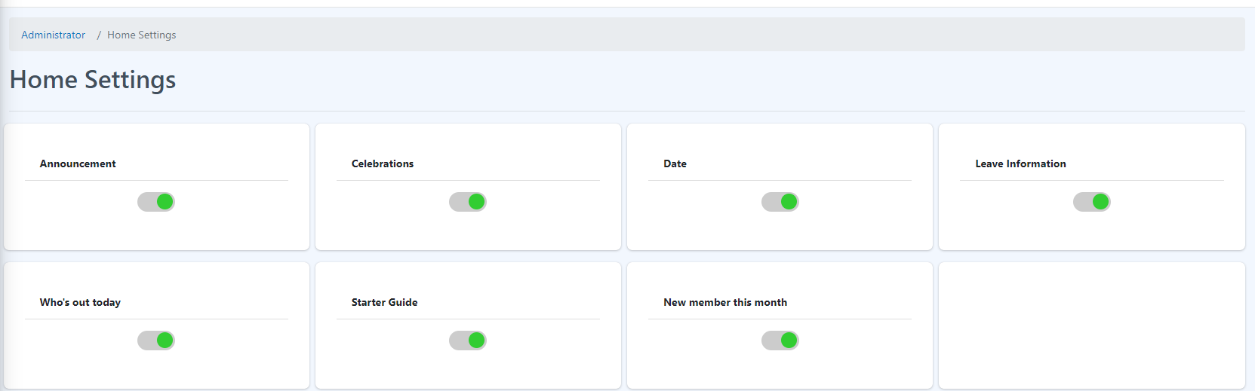

8.3 User Accessibility

This page manages all modules access according to the user account access type. The admin can change the modules that can be accessed by a specific position title. An admin can also add or update the user access.

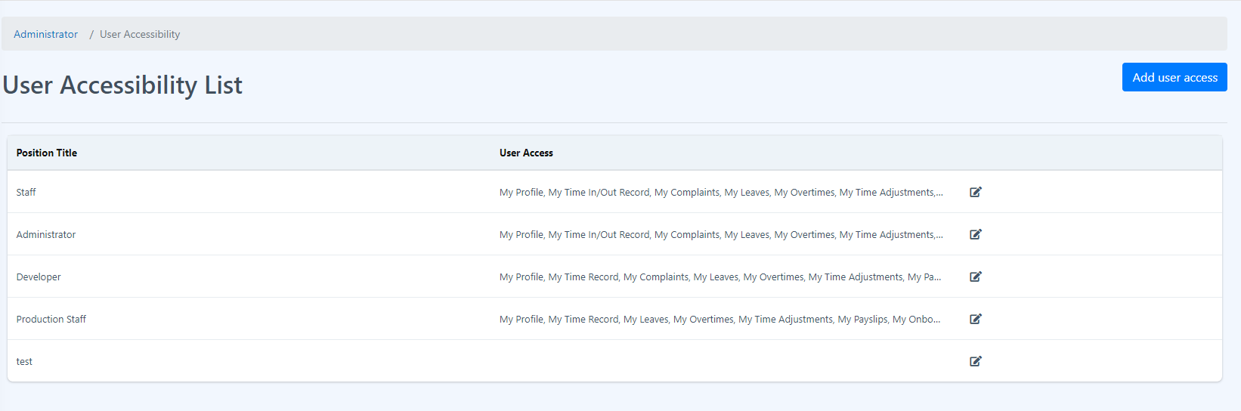

**How to add new User Access?**

1. Click the Add user access button.



1. Insert the Name of the new user access and select all the modules that are allowed for the access type and click submit button.

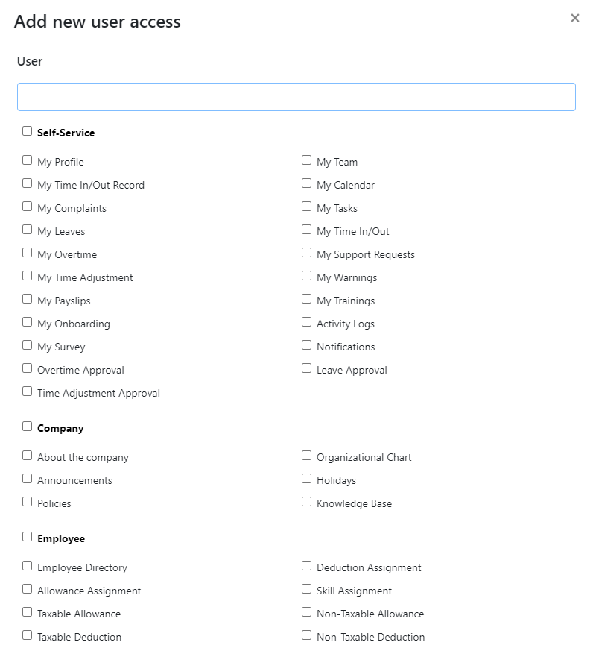

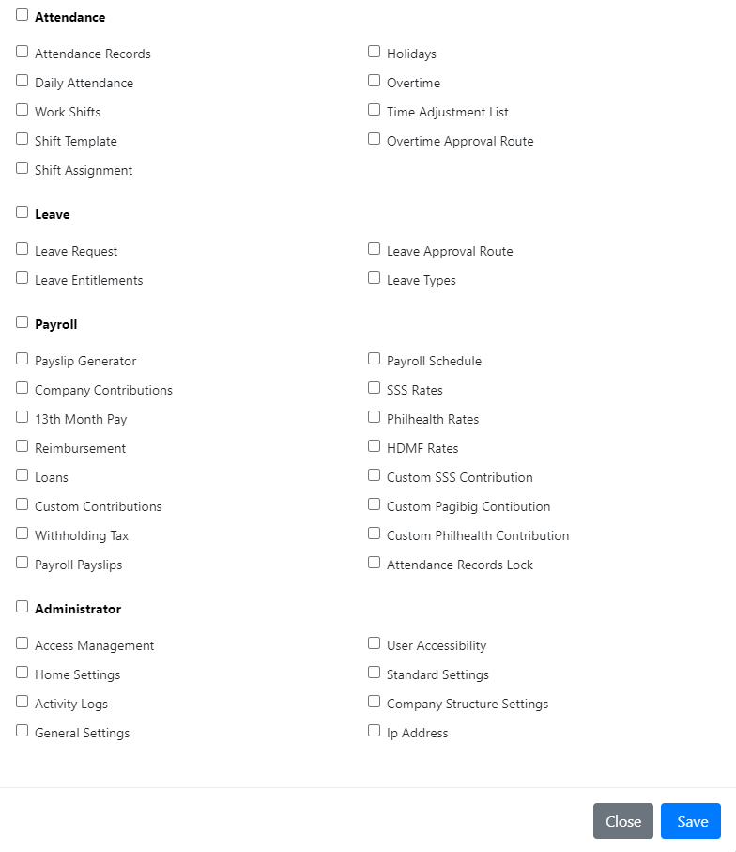

**How to edit User access?**

1. Select the user access that you want to update.
2. Click the edit icon beside it, located at the end of the user access.



1. Select or unselect all the modules allowed for that user access and click Save button.

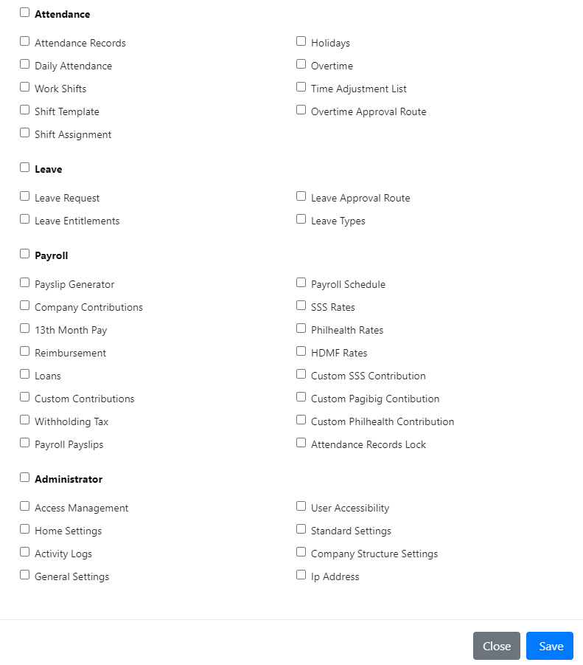

8.4 Standard Settings

This setting sets all the standards for each module and components. This page allows you to manage the components of the page such as adding types of taxable allowance and many more. This setting usually manages the other functions that are not available on other pages.

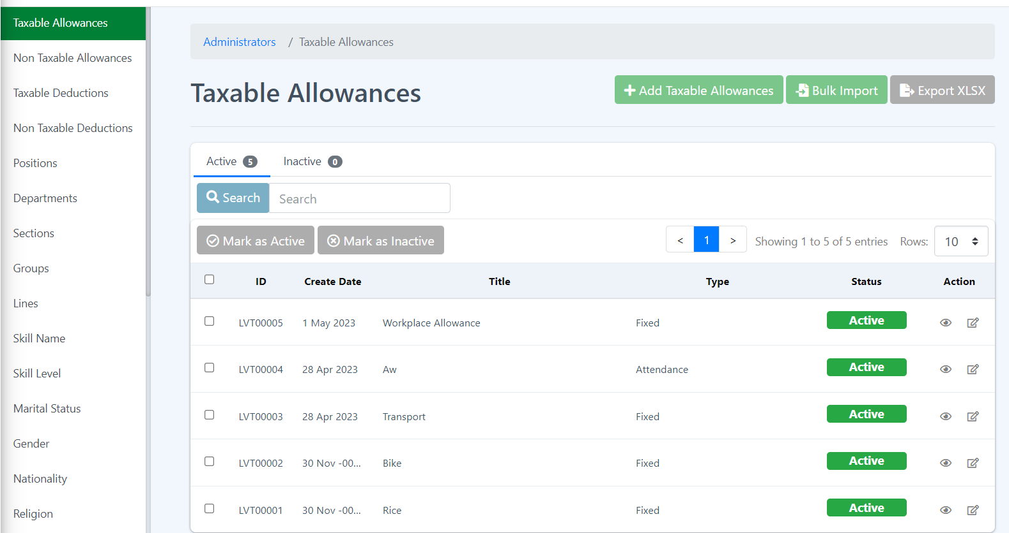

**How to add a new Taxable Allowance?**

1. Click the Add Taxable Allowance button.

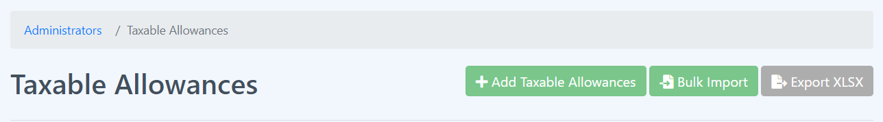

1. Fill all the required fields and click Submit button.

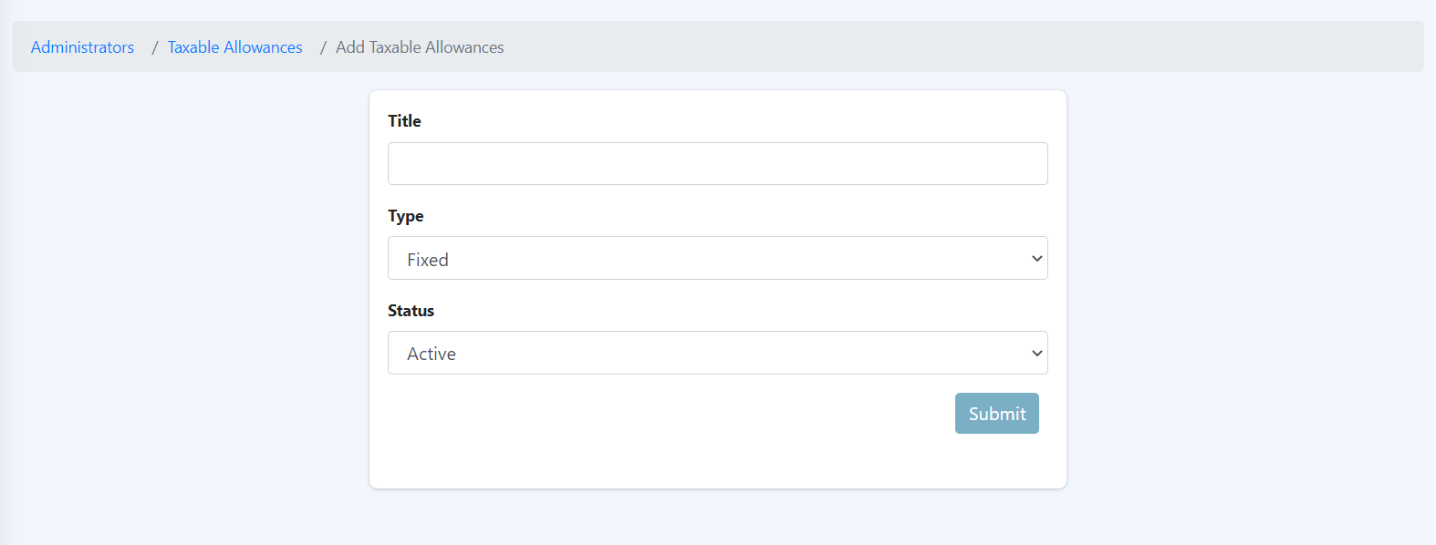

Note that this page is where you can add new taxable allowance but not the amount. Stating the amount for each employee is different. If you want to add amount, then please go to the Taxable Allowance in the Employee Module and look for Taxable Allowances page.

**How to Bulk Import Taxable Allowances?**

1. Click the Bulk Import button.



1. Follow the given set of rules.

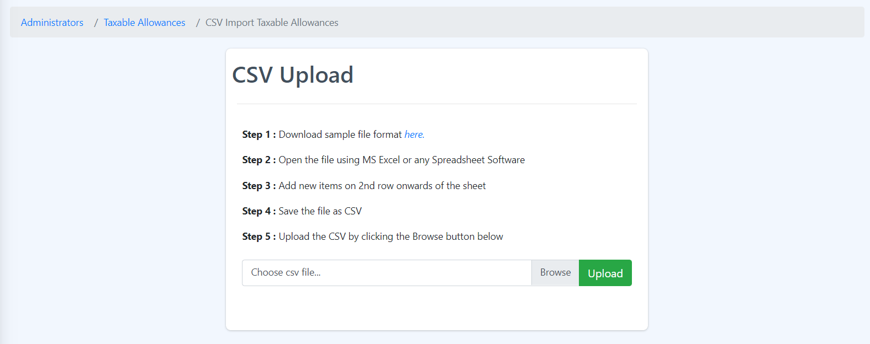

**How to export or download the taxable allowances table?**

1. Click the Export XLSX button.



1. It will directly or will instantly download the Taxable Allowances table.

How to change the status of the taxable allowances to Active or Inactive?

1. Select single or multiple rows by clicking the checkbox on the table - to select all the rows then just click the checkbox in line with the table header.

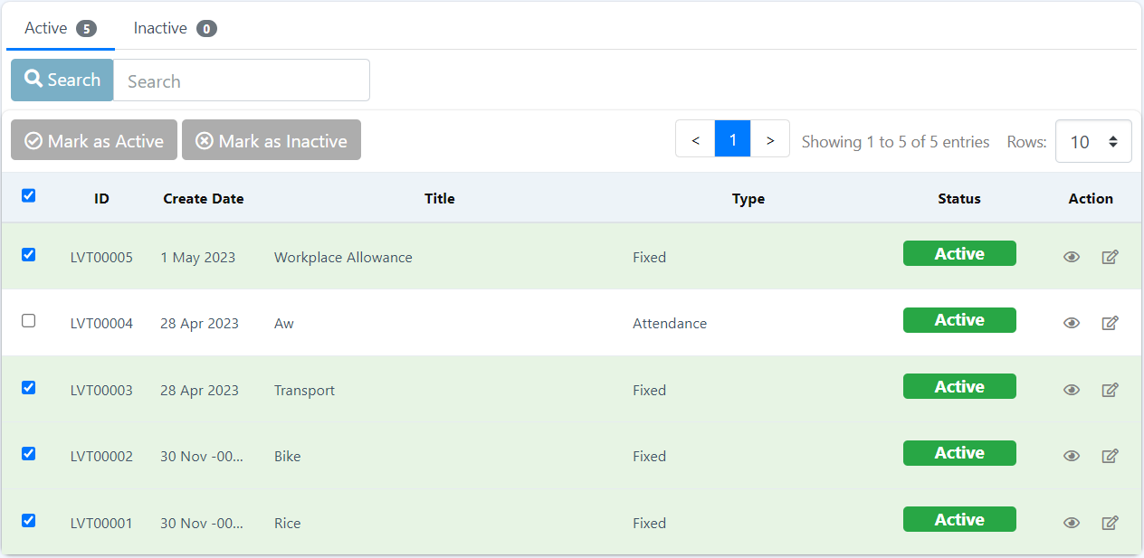

1. Click Mark as Inactive button.



1. A confirmation box will pop up, click the Submit button to make changes.

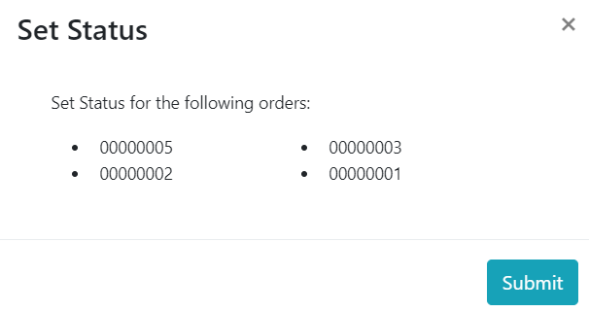

1. To change the status of the taxable allowances to Active, click the Inactive tab just right above the Mark as Inactive button.



1. Repeat Step 1 -3, in step 2 instead of Mark as Inactive click the Mark as Active button.

How to search?

1. Type a word in the search box.

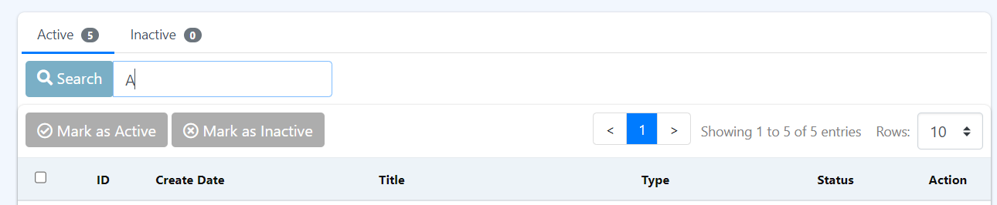

1. Click the Search button.

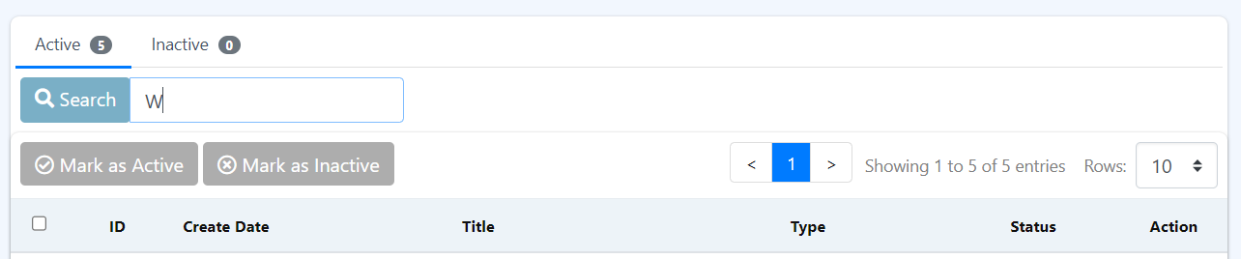

1. It will only search the Title column of the table.

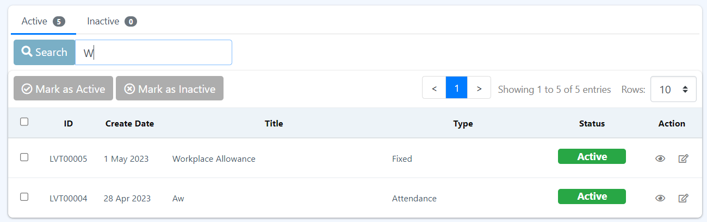

**How to see more details about the Taxable Allowance?**

1. Click the eye icon under the Action column on the row you want to see more details about it.



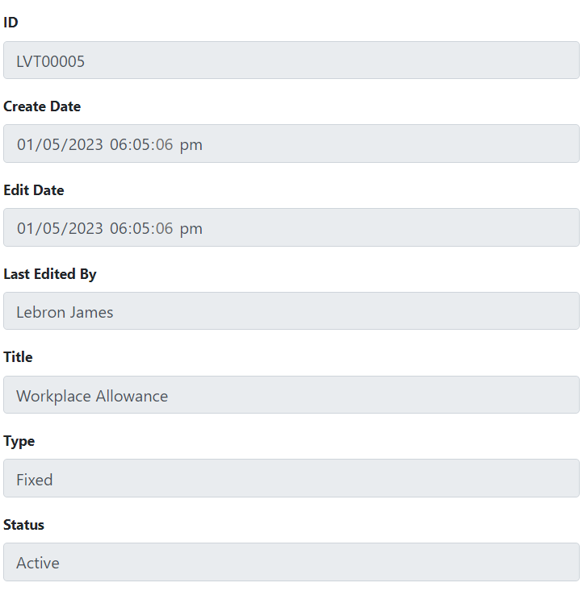

**How to edit or update Taxable Allowance data?**

1. Click the edit icon beside the eye icon under the Action column on the row you want to edit.



1. Fill all the required fields and click Submit button.

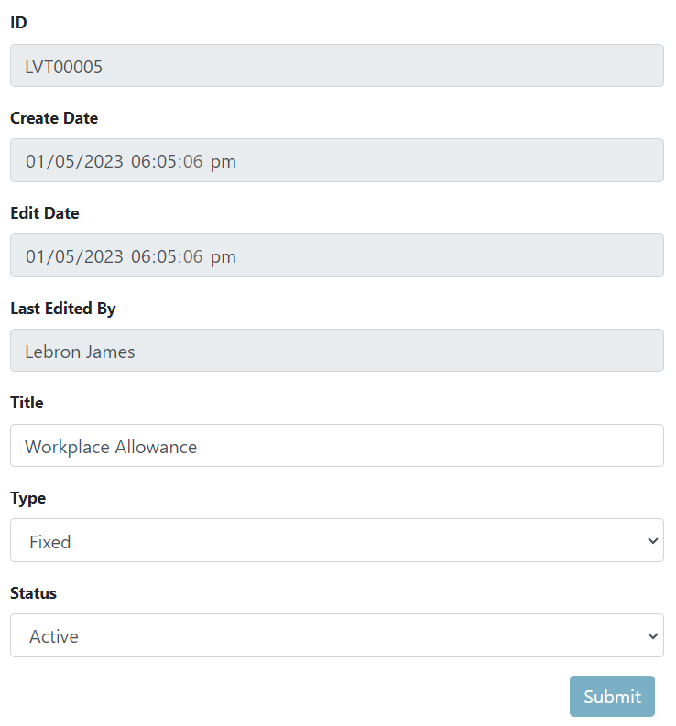

**Note! \***

Since all the settings have a standard template, please follow the steps given in the Taxable Allowance page, the difference is just you need to access the different pages by clicking the link provided at the right side of the screen.

8.5 Company Structure Settings

This sets the structuring of the company based on listed settings. His settings allow the user to filter the employees base on the active settings.

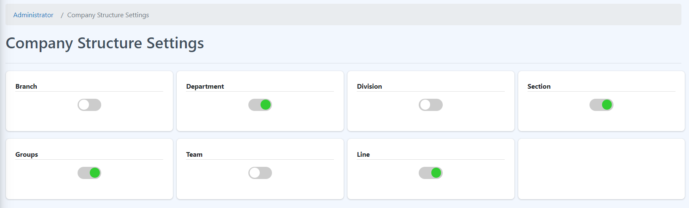

How to change the status of the company structure settings?

Just click the switch button to activate or deactivate the selected company structure settings. All Activated settings will be used as Filters to group the employees.



8.6 IP Address

**This page shows the list of all available IP Addresses.**

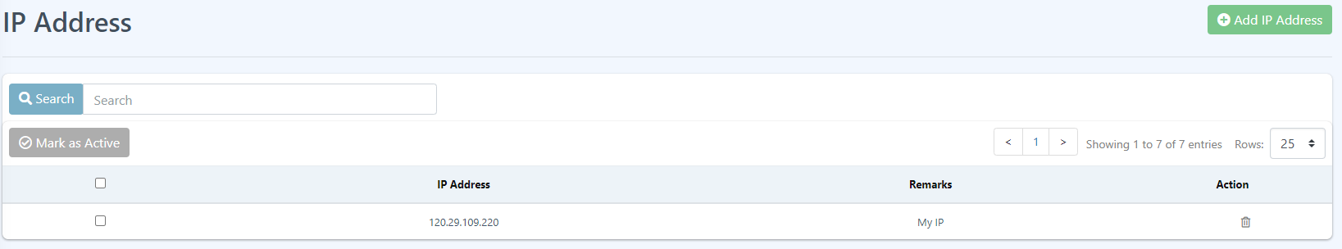

**How to Add new IP?**

1. Click the Add IP Address button.

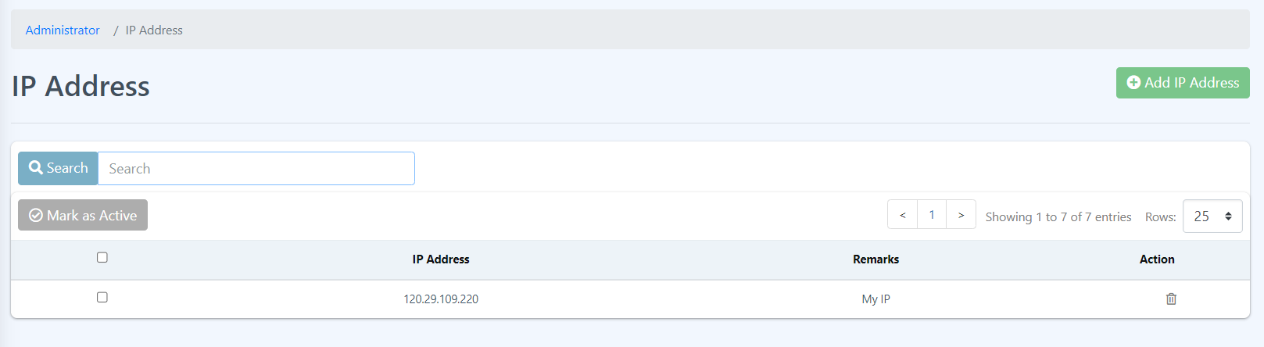

1. Fill all the fields required.

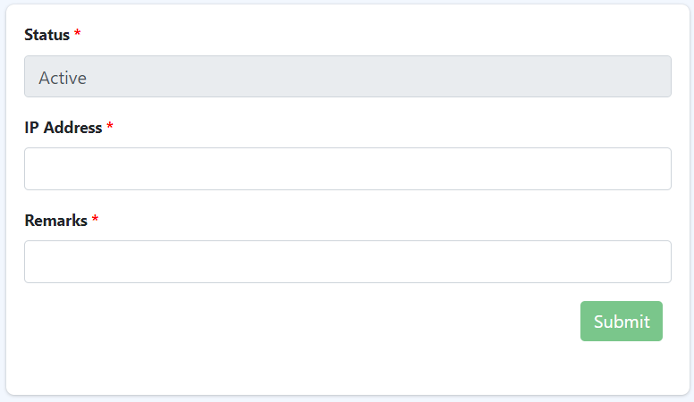

1. Click the Submit button.

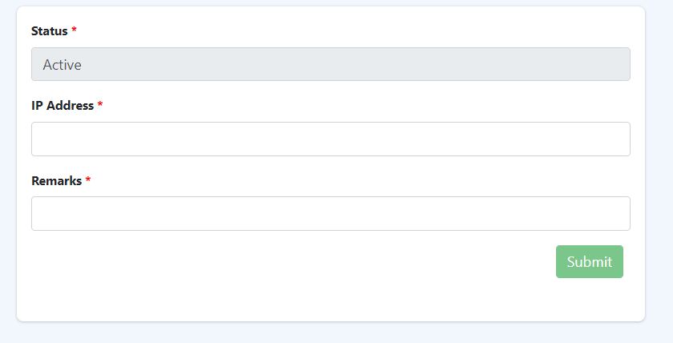

1. All added IP Address will be displayed in the IP Address page table.



**How to delete IP Address?**

1. Click the bin icon under the Action column on the row you want to delete.



1. Click the Yes, delete it button on the confirmation box.

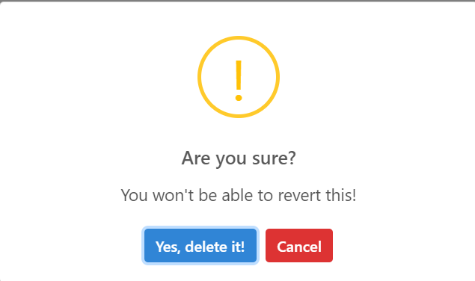

8.7 General Settings

This page is where you can change the general settings of the page such as Company Name and the Company Logo.

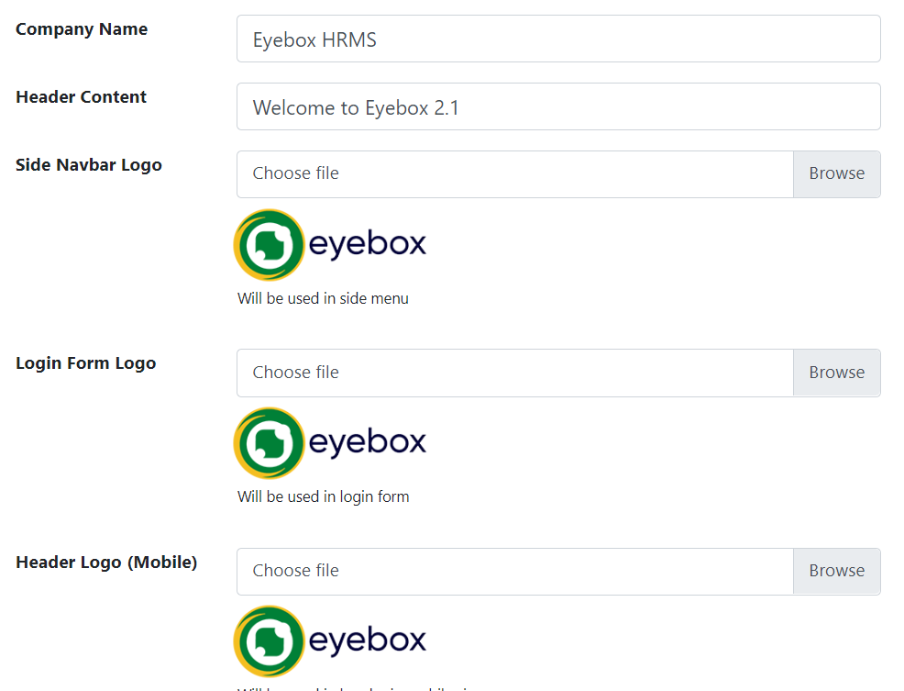

How to Update the general settings?

1. First identify which part is to be updated. For example, all are to be updated.
2. Clear the Company Name and enter a new name.



1. Clear the Header Content and enter a new header content.



1. Click the Browse button or Choose file field and select your desired logo for Side Navbar.

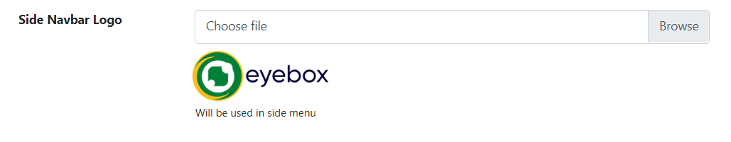

1. Click the Browse button or Choose file field and select your desired logo for Login Form Page.

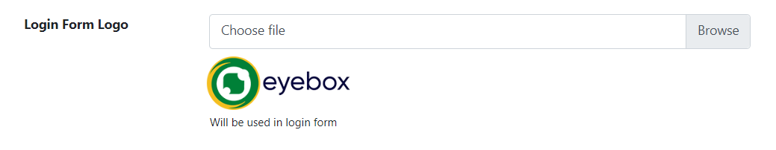

1. Click the Browse button or Choose file field and select your desired logo Header Logo (Mobile).

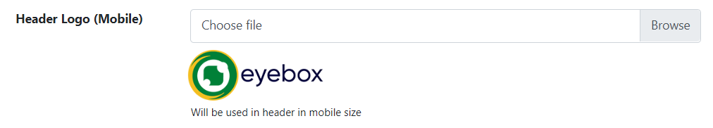

1. Click Update to save the changes.

